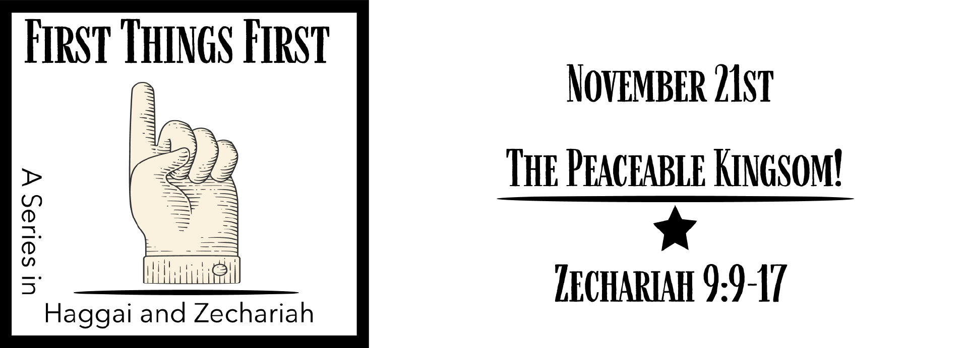
Study Questions for FIRST THINGS FIRST: THE PEACEABLE KINGDOM

Read Zechariah 9:9-17

God’s Story
- In Zechariah 9:9, the prophet tells the people of Jerusalem to rejoice. What is the reason for their joy?
- What will the promised king do that seem atypical of what kings normally would do, according to Zechariah 9:10?
- Zechariah 9:11-12 announces some promises that the king brings. What are those promises?
- In what ways will the promised king be a different kind of warrior, according to Zechariah 9:13-14?
- Zechariah 9:15-17 paints a picture of the future. What will be happening in the future according to the vision?

My Story
- Think about the season we are entering. For what do you have reason for rejoicing?
- When you think of worldly power, who seems to be ruling the world today? Explain your answer.
- When someone promises something what do you normally expect. What determines the level of your assurance that the person will do as they say they will do?
- Look up the word warrior in a dictionary or online. What are the characteristics of a warrior? How is Jesus as warrior the same as that and how is he different?
- What do you hope for in the future? Where do you find assurance that what you hope for will occur?

Answer to Last Week’s Study Questions
FIRST THINGS FIRST: The Surprise Gift!
(Zechariah 8:9-13, 20-23)

- In Zechariah 8:9 the Lord Almighty encourages the people to strengthen a part of their bodies to build the temple. What body part needs to be strong, according to this passage? Answer: Their hands
- There were no ways to make a living or safe business upon the return to Jerusalem from exile. According to Zechariah 8:10, why was that? Answer: The Lord commanded it
- After the angel of the Lord has spoken to Zechariah, God decided to change how he dealt with his people according to Zechariah 8:11-13. In what ways did God decide to change his dealings with the people? Answer: Sowing peace and granting abundance after a period of trouble and want
- The Lord Almighty presents a vision of the new Jerusalem for the future in Zechariah 8:20-22. What does God foresee for the city of Jerusalem? Answer: People will come from everywhere because they hear God is with the people of Jerusalem.
- God’s vision presents an international picture of the impact of Jerusalem on the world in the future. What will people of other nations think of Jerusalem in the years to come? Answer: It will be a place of favor, a desirable place to live

