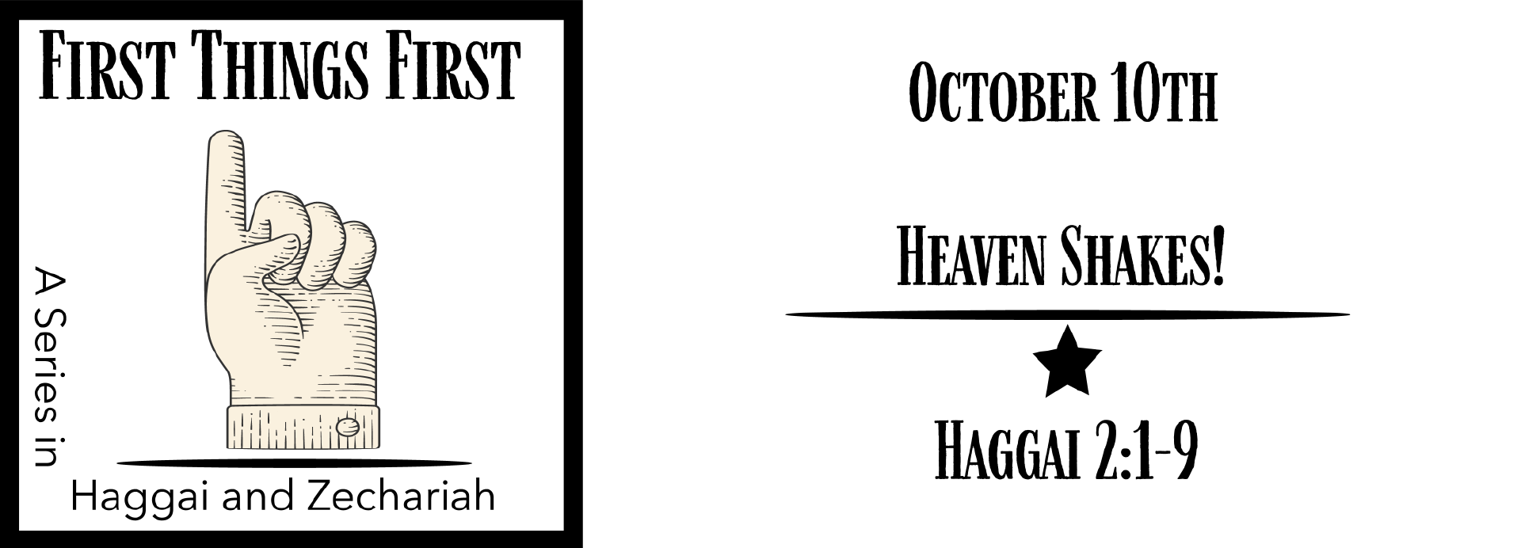
Study Questions for First Things First: Heaven Shakes!

Read Haggai 2:1-9

God’s Story
- On what month and day in the second year of King Darius did the word of the Lord come to Haggai a second time according to Haggai 2:1?
- In Haggai 2:4 Haggai tells two people to take courage. Who does he encourage?
- Since God’s Spirit abides with these two leaders, what are they encouraged not to do according to Haggai 2:5?
- The Lord of hosts promises to do something according to Haggai 2:6-7. What is the Lord of host about to do?
- Haggai 2:8-9 says the splendor of house of the Lord being built by Ezra and Nehemiah will be greater than the Temple built by Solomon. What gift of God’s will be the evidence this splendor?

My Story
- Have you ever thought God was speaking to you? If so, describe the situation and the moment. Why do you think that was the moment God chose to speak to you?
- In what situation in your current life do you need courage? How might a word from God help you? Try applying Haggai’s encouragement in Haggai 2:4 to your situation.
- Why is Haggai’s message in Haggai 2:5 a message that is appropriate for all people of God?
- What comfort and empowerment do you derive from the knowledge that God is with you?
- In what ways is your prosperity dependent upon God?

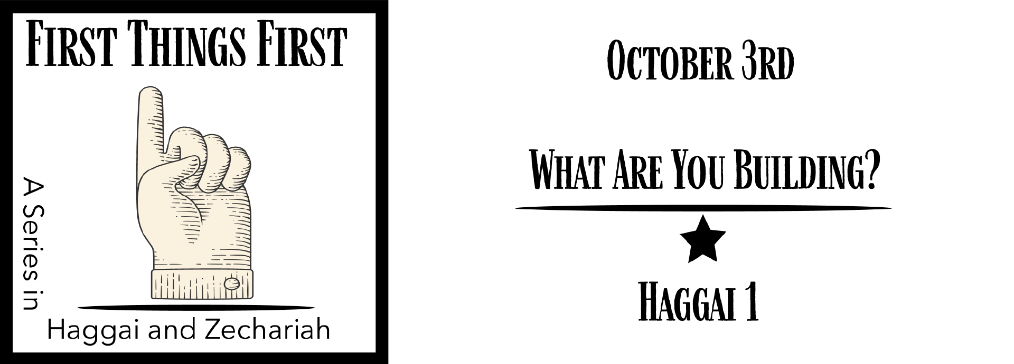
Answer to Last Week’s Study Questions
First Things First: What Are You Building? (Haggai 1:5-15)

- In what year did the Lord come to Haggai, according to Haggai 1:1? Answer: The second year of King Darius
- According to Haggai 1:2, what were the people saying? Answer: The time has not yet come to rebuild the Lord’s house.
- What did God tell Haggai, according to Haggai 1:3-4? Answer: It is time to rebuild the house of the Lord.
- Haggai 1:5-6, describes something that would frustrate most people. What situation does Haggai describe? Answer: Working hard but gaining nothing.
- The Lord Almighty instructed Haggai to tell the people to do something according to Haggai 1:8. What did the Lord command them to do? Answer: Go to the hills for lumber to begin rebuilding the Temple.

