Counseling Wives Who Have Been Abused
2021 Pacific Northwest Counseling Conference
Wendy Wood

Definitions
“A pattern of abusive behavior in any relationship that is used by one partner to gain or maintain power and control over another intimate partner. Domestic violence can be physical, sexual, emotional, economic, or psychological actions or threats of actions that influence another person. This includes any behaviors that intimidate, manipulate, humiliate, isolate, frighten, terrorize, coerce, threaten, blame, hurt, injure, or wound someone.”

“An abuse of power, manifested through selfishly motivated patterns of behavior intended to exercise or maintain control over one's partner."

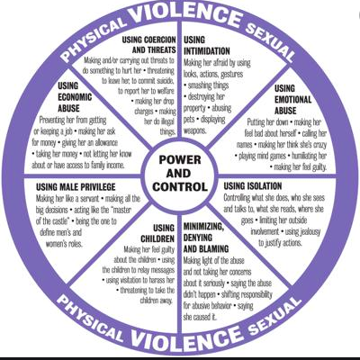
- 1. Physical Force
  - Psalm 11:5 The Lord tests the righteous, but his soul hates the wicked and the one who loves violence.

- 2. Intimidation
- Psalm 34:15-16 The eyes of the Lord are toward the righteous
and his ears toward their cry. The face of the Lord is against those who do evil,
to cut off the memory of them from the earth.

- 3. Ridicule
- Ephesians 4:29 Let no corrupting talk come out of your mouths, but only such as is good for building up, as fits the occasion, that it may give grace to those who hear.

- 4. Isolation
- Ecclesiastes 4:12 And though a man might prevail against one who is alone, two will withstand him—a threefold cord is not quickly broken.

- 5. Denial and Blame
- Proverbs 28:13 Whoever conceals his transgressions will not prosper,
but he who confesses and forsakes them will obtain mercy.

- 6. Using the Children
- Matthew 19:14 but Jesus said, “Let the little children come to me and do not hinder them, for to such belongs the kingdom of heaven.”

- 7. Male Privilege
- Ephesians 5:25 Husbands, love your wives, as Christ loved the church and gave himself up for her,

- 8. Economics
- 1 Timothy 5:8 But if anyone does not provide for his relatives, and especially for members of his household, he has denied the faith and is worse than an unbeliever.

- 9. Coercion and Threats
- 1 Corinthians 13:4-5 Love is patient and kind; love does not envy or boast; it is not arrogant or rude. It does not insist on its own way; it is not irritable or resentful

- 10. Spiritual Abuse/Misuse of Scripture
- 2 Timothy 2:15 Do your best to present yourself to God as one approved, a worker who has no need to be ashamed, rightly handling the word of truth.

- 11. Sexual Abuse
- Hebrews 13:4 Let marriage be held in honor among all, and let the marriage bed be undefiled, for God will judge the sexually immoral and adulterous.

In the beginning (Pre-Counseling):

- 1. Listen - with extreme patience.
- Listen to her story. Every oppression or abuse case is different. There are certainly similarities, but every woman will have a different experience and will interpret her situation differently.

- Most women are trying to figure out
- “Where is God in my suffering?”
- “Why did God allow this to go on for so long?”
- “Why did God create marriage to be so miserable for women?”

- 2. Ask Questions - listen with extreme patience
- Ask about the feel of their home.
- Ask what it feels like when she knows her husband will be home from work in half an hour.
- Ask about her husband’s tone of voice.
- Ask about her friends and if she is free to see other women when she wants to.
- Ask about how finances are handled. Does she have freedom to spend money on her own.
- Ask about the division of labor in her home. Every marriage does this a little differently, but is she “the maid” or is she a wife.
- Build some trust with her but at some point ask, have you been forced to do sexual activities that make you uncomfortable.

- 3. Is she safe? Don’t get ahead of where she is at!
- Counselors shouldn’t be the determining factor in whether a woman leaves or not.

- 4. Health

Counseling:

Pray!

- 1. Salvation - Does this oppressed woman truly know the Lord?
  - Does she know Christ as Savior?
  - Does she understand grace for justification and sanctification?
  - Does she recognize God’s supreme authority in her life?

- 2. Heart - **Help her understand the heart biblically.
- Emotions - Teach her the danger of living off emotions. When she is reacting to how she feels, she is most likely not honoring God but just responding to feel better. In addition to not honoring God, she is also giving in to the manipulation her husband is using. He wants her to feel scared, guilty, hurt, etc because when she reacts to alleviate these feelings, he most likely gets what he wants. She needs to learn to identify her emotions and take them to God.
- Psalms - Help your counselee identify and relate to emotions in Psalms and how the Psalmists take those emotions to God in faith.

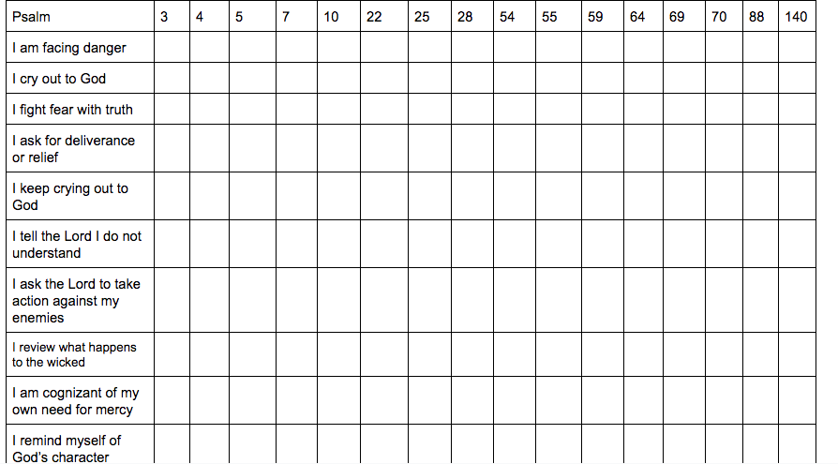
(chart is taken from Amy Baker’s teaching at Faith Conference in 2016)
- Biblical Lament
- Complain to God- this shows faith - she is talking to God because He is Sovereign and good and merciful and compassionate.
- Ask for help - God invites us to ask for help, for deliverance, for endurance. Jesus asked that the cup be taken away from him (asking to not go to the cross) and surrendered to God’s plan. “Not my will but Your will be done”
- Commit to trust God - the psalms have a turning point - “but” I will trust in you.

Thoughts - She needs to learn to take her thoughts captive to truth.

Desires - She’s been responding to her situation out of what she wants most.

- 3. Heart Idols (Later in counseling. Don’t start with her sin, help her do some healing first and reorient her thinking about God, self, others.)
- Possible Heart idols
  - Peace
  - Marriage
  - Fear of Man

- 4. Study God
- Study God’s attributes
- Study God’s promises
- Study God’s purpose and plan for suffering / Study Jesus’ suffering

- 5. God’s View of Abuse
- Abuse comes from the abusers heart (Luke 6:45)
- God is not punishing you. (Romans 8:1) Christ took all the punishment for sin. He chooses not to remember your sins so He can’t punish you! God’s love is not earned.
- God hates violence (Psalm 11)
- God sees your situation (Eccesliastes 4:1)
- God know and sees (Isaiah 53:3,7)
- God is rescues (Ezekiel 34:22, Exodus 3:7, Luke 4:18, Psalm 140:1)
- Jesus fled from danger at times (Matthew 2:13-14, John 11:53-54, John 8;58-59)
- But he was surrendered to God’s will for when not to flee (Mark 14:34)

- 6. Identity in Christ (Emphasize what Christ has done!)
- What does it mean to be “in Christ”
- Treasured possession - Deuteronomy 7:6
- Chosen and holy - Colossians 3:12
- Beloved - Deuteronomy 33:3
- Child of God - 1 John 3:1
- Friend of God’s - John 15:15
- Holy and Blameless - Ephesians 1:4
- Redeemed - Ephesians 1:7

- 7. Understanding Oppression/Abuse Biblically
- “The Self-Centered Spouse” by Brad Hambrick and Darby Strickland’s booklet on “Abuse - Help for the Sufferer”.

- Abuse Cycle - “tension” - “incident” - reconciliation/“winning back” - “calm/honeymoon”

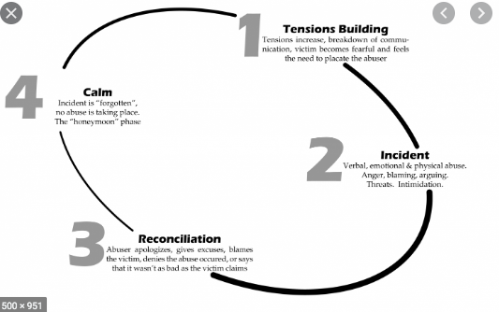

- Manipulation - help her understand that manipulation is about toying with emotions.
- Proverbs 26: 4-5
Answer not a fool according to his folly,
lest you be like him yourself.
Answer a fool according to his folly,
lest he be wise in his own eyes.

- Misuse of Power - Show her the self-sacrificing love of Christ to the church. This is God’s beautiful picture of marriage. Help her understand and love God’s design and grieve and mourn over her own experience. God wants “power under” leadership where a husband esteems his wife and lifts her up to accomplish who God made her to be.

- God’s view of Marriage
- Teach what male leadership should look like.
- Both spouses are called to “die to self”
- Teach what submission really is and what it is not.

- Deceit - Her husband probably pretends to be a very upright, Christian man in public and then treats her badly at home.

- Blame shifting - it started with Adam and Eve.

- Self-Love - 2 Timothy 3:1-5 “But understand this, that in the last days there will come times of difficulty. For people will be lovers of self, lovers of money, proud, arrogant, abusive, disobedient to their parents, ungrateful, unholy, heartless, unappeasable, slanderous, without self-control, brutal, not loving good, treacherous, reckless, swollen with conceit, lovers of pleasure rather than lovers of God, having the appearance of godliness, but denying its power. Avoid such people.”

- 8. Shame and Guilt
- Guilt is having sinned, broken God’s Word.
- Shame is
- feeling like there is something intrinsically wrong with you
- taking responsibility for your spouse’s sin
- Caring what others think of you too much

- Point her to Christ - He endured shame - betrayal by friends and family, hung naked on the cross, mocked, spat upon. Christ is the sympathetic high priest who knows how she feels and took that shame to the cross so that she does not need to bear it anymore.
- Jesus despised the shame of the cross looking forward to eternity. Hebrews 12:2
- Some shame is put on us by other people, and if divorce happens, women will be looked down upon by some in the church. This is real. Others are judging a situation they don’t know much about. But, she needs to not give in to fear of man and care more about what others think than God thinks.

- 9. Emotions
- Loneliness
- Worry
- Doubt/Confusion
- Anxiety
- Sadness/Depression

- 10. How to Suffer Well
- Being sinned against
- Guard against bitterness
- Trust in God’s sovereignty and providence
- Seek to learn from your suffering
- Grow in your dependence and humility

- God’s view of suffering
  - James 1:2-3 - count it all joy - God is making you mature and complete in faith
  - 1 Peter 1:6-12 - the testing of faith will prove it genuine and result in glory to God
  - Romans 5:1-5 - suffering produces endurance, character and hope

- Forgiveness/Repentance
- Vertical Forgiveness
- Horizontal Forgiveness
- Repentance (2 Corinthians 7:10)
- Reconciliation

- How has she sinned in response to her husband’s sin?
- Anger or bitterness?
- Disrespectful toward husband?
- Unwholesome speech?
- Distrusting God? Unbelief in God’s attributes?
- Excusing sin or ignoring sin?
- Has she joined in sin?

Ephesians 4:22-24 Depending on what she struggles with, help her “put off” her sin, renew her mind in truth, and ‘put on’ Christlikeness.

- 11. Endurance
- Studying/Meditating - Make sure she knows how to learn from God’s word – she is in the process of sanctification too.
- Community - Is she connected to other solid believers in bible study or life group?
- Serving - How is she using her gifts to benefit the body of believers?
- Friendships - Is she invested in other women’s lives
- How will she speak of her husband/marriage?

- 12. Sowing and Reaping Principle
- Galatians 6:7-9 “Do not be deceived: God is not mocked, for whatever one sows, that will he also reap. For the one who sows to his own flesh will from the flesh reap corruption, but the one who sows to the Spirit will from the Spirit reap eternal life. And let us not grow weary of doing good, for in due season we will reap, if we do not give up.”

Examples:

- 11. Parenting
- The big question tends to be, “how do my kids honor their father who is unrepentant and abusing or oppressing them?”
  - It might be praying for him
  - It might be not talking negatively about him
  - It might be praying for and working toward having a forgiving attitude toward him
  - It might be choosing to have conversation when it is easier to be silent
  - It might be cutting off contact (in cases of church discipline) as a means of calling sin sin

- Kids need to learn to “aim to please God” and glorify Him above all else.
- Kids also need to learn about emotions and that they need to respond based on the truth of who God is and what His word says, not out of fear, or guilt, or anger.

- 12. Long term - things you may be assisting with
- Helping her figure out schooling/training for work
- Applying for jobs
- Legal proceedings
- Church discipline for husband
- Financial assistance/planning
- Safety plan - where to go if not safe in the future

