DEAR PARENTS:
We realize that you, as parents, are the primary faith influencers in your child’s life. The best disciple making takes place when students’ parents take the lead. That’s why we’ve created this helpful guide for you to use at home with your child. It is designed to give you some basic information about what is being taught at church through the Intersections curriculum, along with some helpful tools, suggestions, and questions to help you reinforce this learning at home. Intersections focuses on God’s movement toward us on a daily, lifelong, and eternal level, and how these intersections change the way we view ourselves and the world. These four lessons (Wise) dig into what it looks like to pursue godly wisdom rather than the earthly wisdom.

MAIN TOPICS AND SCRIPTURE COVERED
FOR YOU TO KNOW: | FOR YOU TO ASK:
1: God’s X-ray Wisdom (1 Samuel 16:1–13)  In this lesson, students will see their need for a heavenly perspective. By looking at examples from the prophet Samuel and some 17th-century believers, they’ll see how God’s wisdom pushes past appearances, inspiring us to challenge the status quo. A fun game will drive home the idea that without the context of God’s wisdom, it’s hard to look past appearances to see the world clearly. | - Let me tell you about a time when I made a choice based on earthly wisdom instead of heavenly wisdom…  - What about you? When have you decided something using earthy wisdom?
2: Request Granted (James 1:5-8 and 3:13–18)  This lesson will help students define heavenly wisdom, and see that God offers wisdom to anyone who asks. From James’ words and one family’s experience, students will learn to tell wisdom by its fruit. Instead of relying on knowledge, they’ll be challenged to ask God for more wisdom. | - Let’s share and then pray about one area of life where we each need more wisdom…
3: True Value (Luke 18:18–30)  This lesson will show students the wisdom in valuing our eternal relationship with Jesus more than the temporary things we cling to. Coming face-to-face with Jesus forces the rich ruler and a 16-year-old boy to examine what they value, centuries apart and with mixed results. A hands-on activity will challenge them to examine what they value most through the lens of God’s wisdom. | - What things, even good things, compete with Jesus for room in your heart?  - Here’s what I have the hardest time setting aside to make room for Jesus…
4: Don’t Be Fooled! (Proverbs 9:1–8)  From this passage in Proverbs, students will learn how to recognize heavenly wisdom and avoid being fooled by earthly wisdom, which sometimes look and sound the same. By seeing how a master detective developed his skills, and trying to build the strongest structure, students will be challenged to remain teachable and continue building a strong foundation of God’s wisdom. | - Some of the people who have modeled God’s wisdom in my life are…  - What about you? Where have you seen wisdom modeled in your life?

ACTIVITIES YOU CAN DO TOGETHER
Movie Wisdom

Invite your child to watch a favorite movie or TV show with you, one that you’ll both enjoy. Challenge them to keep track of every silly or bad decision that the characters make, and also look for any decisions they think were smart or wise. You’ll do the same. At the end of the movie/show, debrief about the decisions that were made, the results, and whether these were examples of earthly wisdom or heavenly wisdom.

TAKE TURNS ANSWERING THESE QUESTIONS:
- Name a few of the silly or bad decisions you noticed. What happened as a result of these decisions?
- Some bad decisions were very obvious at the time, but others didn’t seem so bad at first. What finally clued you in that they were bad decisions?
- Did any of the smart or wise decisions reflect heavenly wisdom? In other words, would they produce good fruit (e.g., peace, joy) and make the character more Christ-like?
- Did any of the smart or wise decisions seem less wise after comparing them with God’s wisdom?

MEMORY VERSES
Each lesson has a corresponding verse to memorize or meditate on.

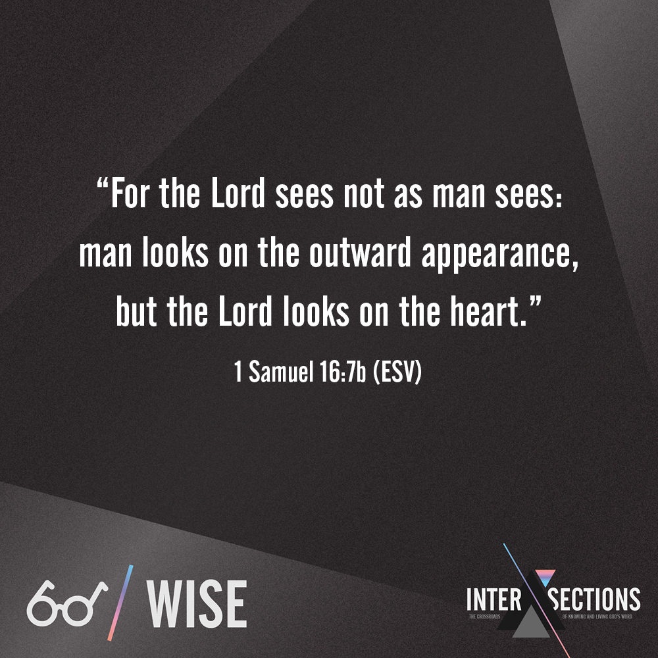  WISE 1: God’s X-ray Wisdom | 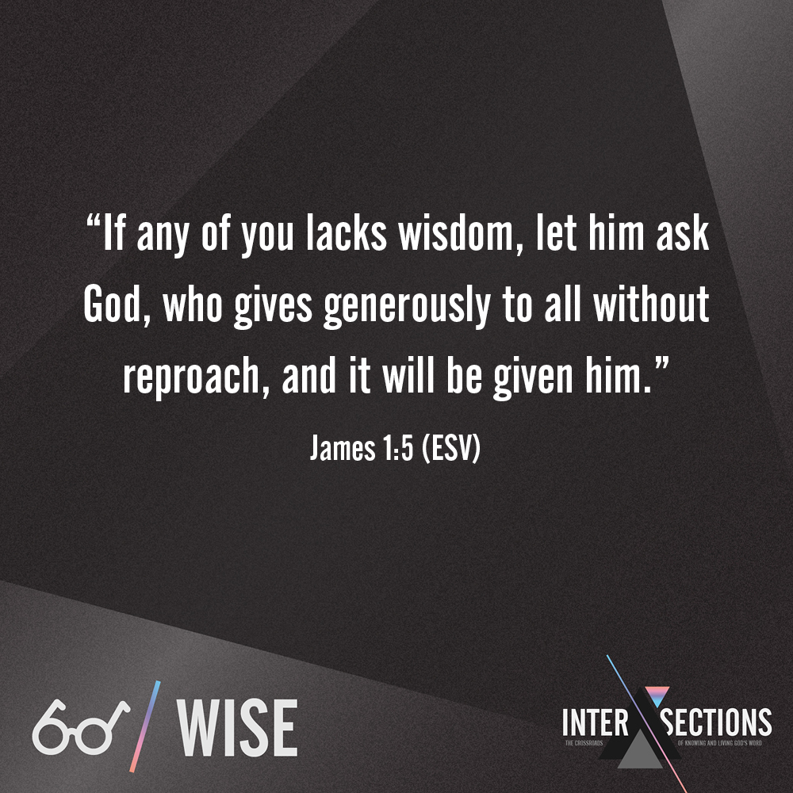  WISE 2: Request Granted
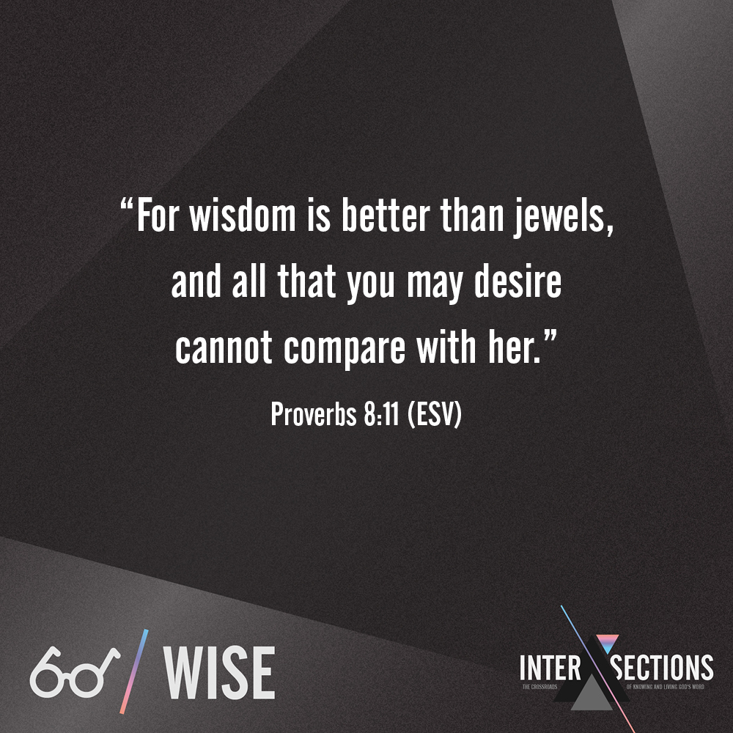  WISE 3: True Value | 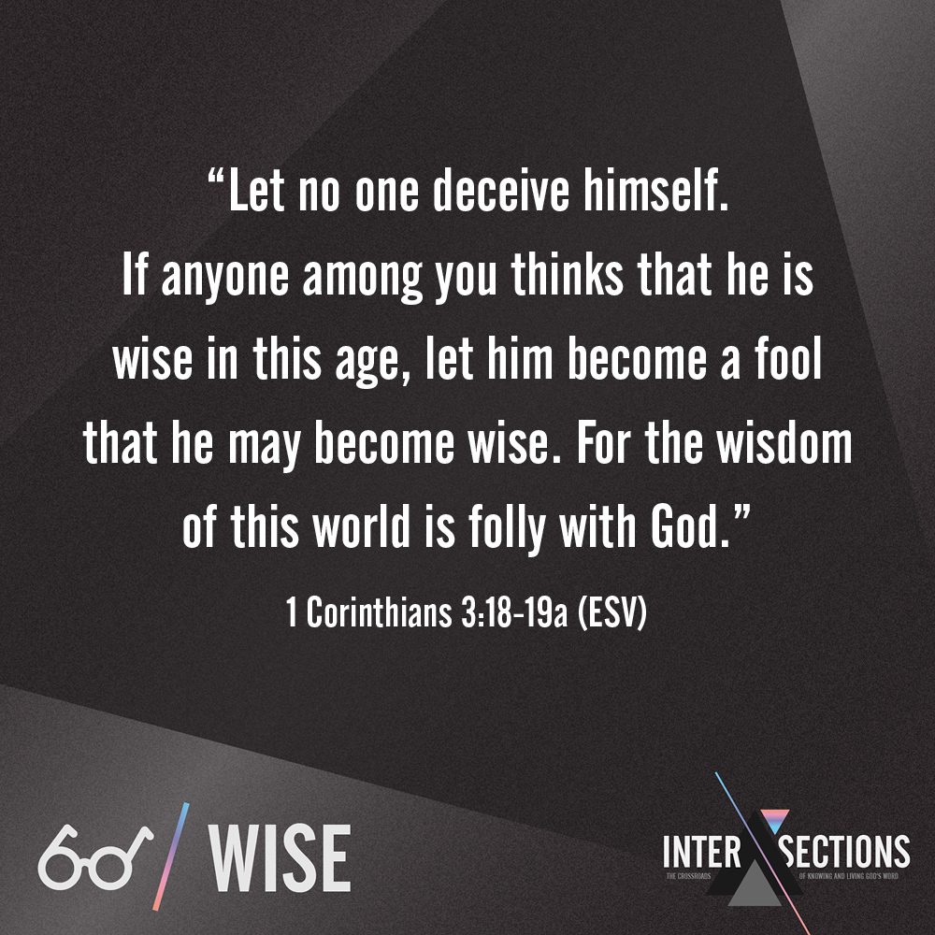  WISE 4: Don’t Be Fooled!

