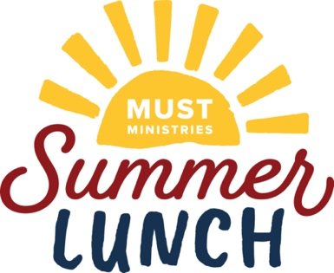
Hillside UMC - Summer Lunch Kit Instructions

The MUST Summer Lunch program helps to ensure that children in our community do not go hungry when the school year ends. You can be a part of this mission by providing a combination of Drink and Snack Kits and Breakfast and Lunch Kits or by providing any quantity of one type. Please take however many labeled bags that you plan to fill and return to Celebration Hall lobby or outside of the Sanctuary before May 31st.

Guidelines

- Wash your hands before preparing the Kids’ Kits.
- Please be sure that the preparation area is wiped down with disinfectant cleaner and dried before preparing Kids’ Kits.
- Please use new paper bags provided when putting the Kids’ Kits together.
- Please fill each bag according to the label and instructions below.

Kids’ Kits Preparation

- Use room temperature juice boxes
- Place juice boxes into the bottom of bags. Then put other items into the lunch bag (heaviest /non-crushable items first).
- All items need to be non-perishable. Please do not use food that is close to its expiration date.
- Please do not include tracts or other religious materials in the bags.
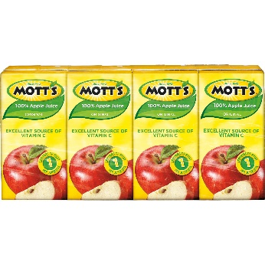
- Each child will receive a Drink and Snack Kit (10 drinks, 10 snacks) and a Breakfast and Lunch Kit (5 lunch items, 5 breakfast items)

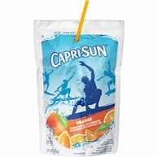
Kit Instructions

Drink and Snack Kit:
- 5 Capri Sun pouches
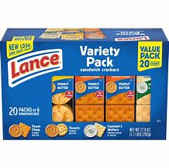
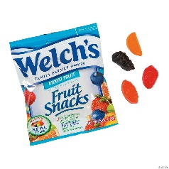
- 5 Motts Apple Juices
- 5 packages of fruit snacks
- 5 packages of sandwich crackers

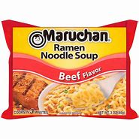
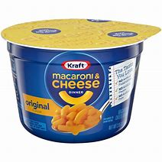

Breakfast and Lunch Kit:
- 2 Mac and Cheese cups
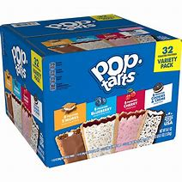
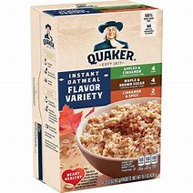
- 3 Ramen Noodles
- 2 packages of Pop-Tarts
- 3 packages of oatmeal

