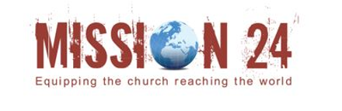
Mission24 Gift Aid Declaration

Gift aid is reclaimed by Mission24 from tax paid by you for the current tax year. By filling in this form, Mission24 will receive an additional 25p for every £1 donated at no extra cost to you. Thank you.

In order to Gift Aid your donation you must tick the box below:
☐ I want to Gift Aid my donation of £ and any donations I make in the future or have made in the past 4 years to Mission24.
Your address helps to identify you as a current UK taxpayer, therefore, please fully and clearly complete the information.

Name:

Surname:

Full Address:

Email:

Tel/Mob No:

Signature:

Please notify the charity if you:
- want to cancel this declaration
- change your name or home address
- no longer pay sufficient tax on your income and/or capital gains
If you pay Income Tax at the higher or additional rate and want to receive the additional tax relief
due to you, you must include all your Gift Aid donations on your Self-Assessment tax return or ask
HM Revenue and Customs to adjust your tax code.
Mission24, PO Box 160, Bourne, PE10 1EP
Email: info@mission24.co.uk
Tel: +44(0) 1778 487267

Mission24 is an outreach of Valley Life Trust Ltd
Registered in England: No.5648030, Registered Charity: no. 1113359

