Do you know your Spiritual Gift pt 4
Various Scriptures

“As God’s children, we are not to be observers; we’re to participate actively in the Lord’s work. Spectators sit and watch, but we are called to use our spiritual gifts and serve continually.” -Charles Stanley

Last week we defined and discussed each spiritual gift in the ______________ category. Today we will be observing these gifts in ________________.

Remember our goal is to move from passive learning to active learning!
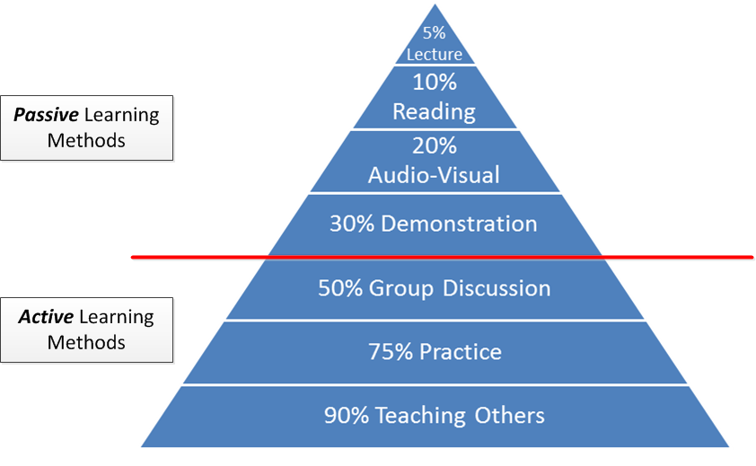
Discussion time?
Out of all the spiritual gifts we defined and discussed last week, which one(s) peaked your interest and why? Answer below:
_______________________________________________________________________________________________________________________________________________________________________________________________________________

Service Gifts in action:

Leadership Standing before or out front/guiding a church, family or ministry in the way that the Lord would have them to go. (Peter and John) These two disciples were arrested for ____________ and _______________ the resurrection of Jesus from the dead. In chapter 3, they had also prayed for a lame man to be healed. However,when they heard and saw what Peter and John were doing in the name of Jesus, the religious leaders commanded them not to speak or teach in the name of Jesus. (Acts 4:18); So what did they do? Acts 4:23-31

*They went and ___________ the other believers *They had ___________

*They expressed their ____________ in God’s Word.

What happened as a result of their leadership? Verse 31…

Remember everything rises and falls with leadership. So what do you think would have happened if they didn’t do anything or followed the commands of the religious leaders? Matthew 10:28

Helps: Those who are blessed with this gift are always looking for ways to volunteer and serve in various ministries within the church.
(Tabitha) Acts 9:36;39; This disciple of Jesus was skilled in making __________ and ____________.
(Stephanas) 1 Corinthians 16:15-18; He and his household helped and ___________ the saints. They also _____________ Paul’s spirit.
(Tychicus) Ephesians 6:21-22; Colossians 4:7-8 He was a beloved brother and faithful ___________ in the Lord’s work.

What else do you notice about these 3 examples?
__________________________________________________________________________________________________________________________________________

Giving: Those who possess this gift have a strong sense of sacrificial sharing. They are willing to give whatever they have to help others who don’t.
(Church Jerusalem) Acts 2:44-46; How did they give? By giving their _________ possessions.
(Church at Philippi) Philippians 4:14-16; They gave financially to support Paul as often as they could.

What ways does this challenge your perspective of giving today?
__________________________________________________________________________________________________________________________________________

Mercy: Those who have this gift not only actively show sympathy and sensitivity towards people who are in need, but they are also willing to endure with them. (Barnabas) His name is translated Son of Encouragement (Acts 4:36) Acts 9:26-27; After Saul’s encounter with Jesus, he tried to join the disciples but they were afraid of what he might try to do.

How did Barnabas show mercy to Saul? By speaking _____________ of him in the presence of the apostles.
Once they welcomed Saul, he started preaching boldly the name of Jesus. This again caused him grief and danger because they tried to kill him. So they sent him out to Tarsus.

Acts 11:25-26; Time goes by, more people follow Jesus, Barnabas goes _______________ for Saul. Once he finds him, he brings him to Antioch, assembles a church and began teaching a great amount of people for an entire year.

How did Barnabas show mercy to Saul? By serving the Lord _________ him in the presence of the entire congregation.

Faith: Those who have this gift have a strong trust and confidence in God’s Word regardless of the circumstances. (Paul) Six times in the book of Acts either after being humiliated, beaten or persecuted Paul remains steadfast, defends his __________ in God, and the calling on his life over and over again. (Acts 22:1-21; Acts 22:30-23:10; Acts 24:10-21; Acts 25:1-12; Acts 26:1-29; Acts 28:17-29)

People who have the gift of faith are also able to _________________ and encourage others to consider God’s plan of salvation for their own lives. (Acts 26:24-29)

Why do you think this gift is so important in the Body of Christ?

Discernment: Those who have this gift are able to identify deceptive spirits and erroneous doctrines. (Bereans) Acts 17:10-13; Here is an example of discerning right from _________. The Berean Jews not only heard Paul and Silas’ testimony of salvation through Jesus Christ, but they ______________ the scriptures for themselves.

Cross References: Luke 16:27-31; John 5:39; Revelation 2:2

“Every relationship is a gift exchange”
-Marianne Williamson

