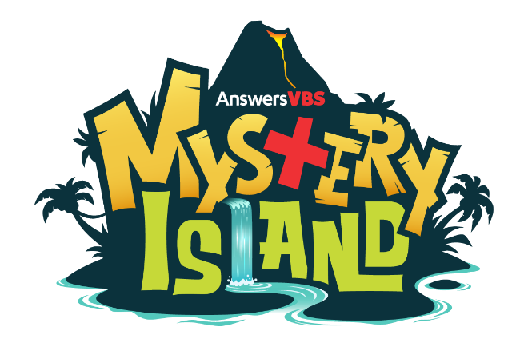
VBS Registration Form

Calvary Chapel of Palm Harbor
32676 US Hwy 19 North, Palm Harbor, FL 34684
Phone: 727-786-7969

www.ccpalmharbor.org

Child Name: ________________________________ Age: _____ Date of Birth: ___/___/___

Street Address: ______________________________________________________________

City: ____________________________________State: __________ZIP: _________________

Phone: (_____)___________________ Grade ENTERING Fall 2021 - PK4 K 1 2 3 4 5

Legal Parent/Guardian Names: ___________________________________________________

Allergies or Special Needs: ______________________________________________________

____________________________________________________________________________

Permission Slip

As the legal parent/guardian of the child named above, I hereby give my permission for this child to participate in all Vacation Bible School activities at Calvary Chapel of Palm Harbor.
Date: July 12, 2021 to July 16, 2021
I give permission to the leaders of the above VBS to render First Aid, should the need arise. In the event of an emergency, I also give permission to the physician, selected by the adult leader in charge, to hospitalize, secure proper anesthesia, order injection, or secure other medical treatment, as needed.
I further agree to hold the above named church and its leaders blameless for any accidents that might occur during this activity except for clear acts of negligence or non-adherence to church policies and guidelines.
In case of emergency, I can be reached by phone at ____________________ or ___________________
If I cannot be reached, please contact _______________________________ at ___________________
In addition to Parent/Guardian, I authorize the following ADULTS(s) to sign my child out from this event:
___________________________________________________________________________________

Signed: ___________________________________________ Date: _____________________
(Legal Parent/Guardian)

