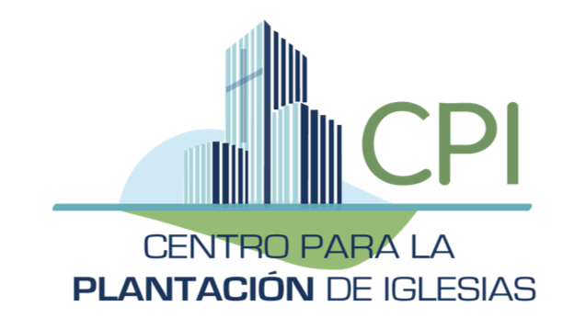

AND IT CAME TO PASS....
Let the Construction Begin!
Del Sur held a dedication service on the new land prior to the beginning of construction of their new building, PTL!
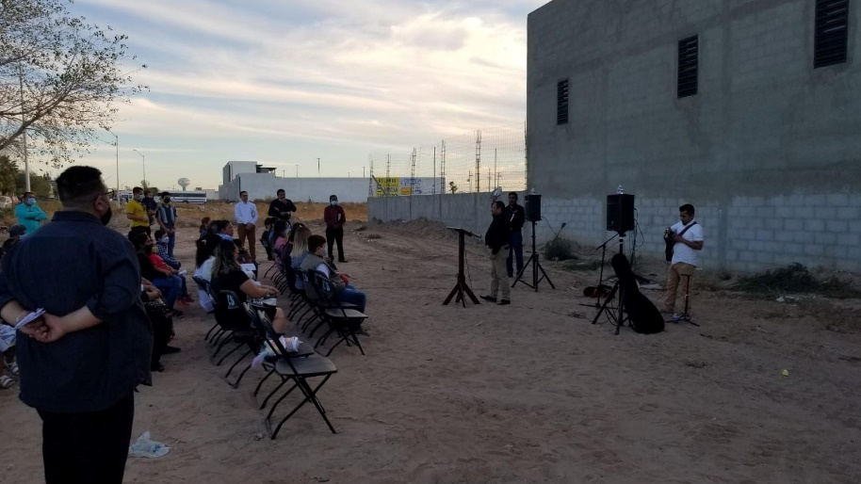
In early November after lots of patience and much effort the construction began!
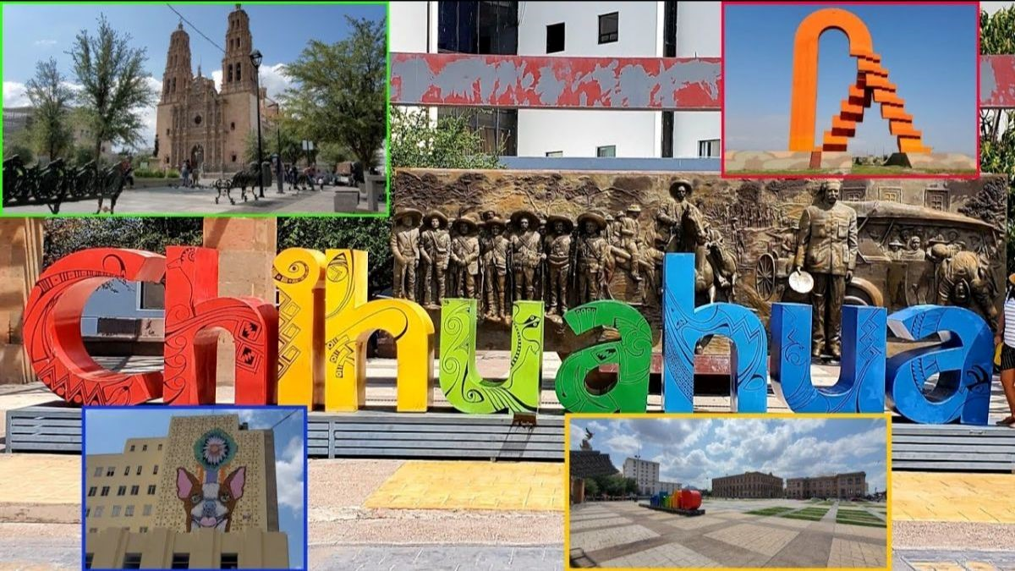NEW CHURCH PLANT!!
CPI is laying the ground work for a new church plant in the city of Chihuahua, the capital of the state of Chihuahua. Some of you might recall that it was a desire of the Juarez team to some day plant a church there. CPI has offered to work more closely with Ministerios in the future to assist them as they continue the work in Juarez!

Prior to starting renovations Pastor Juan Ramon had already began reaching out to the community surrounding the Casa de Paz y Buena Voluntad facility. On Tuesday and Thursdays there are sewing classes in the mornings for ladies and after school tutoring for kids.
The border was finally opened in early November, previous to that I had already started crossing a couple days a week to help Pastor Jaun Ramon with the renovations at the Casa de Paz facility in Reynosa. We stared by fixing a water supply issue. Later we began constructing classrooms for the kids after school program.
I have also been working at Valle del Rey a couple days a week using the funds leftover from our summer team to continue improving the facilities there. Installing new T1-11, installing soffit & facia boards, painting, and installing new dimensional shingles to the sanctuary roof.
Keeping with the traditions of the season Kathy and I were invited to the CPI Christmas party in Monterrey. It was the first time, due to Covid, we got to gather with our entire new team. We shared meals together, fellowshipped, and talked about future plans for new church plants and short term missions possibilities.

Seizing an opportunity to firm up some of the details for the coming 2022 summer teams coming to Monterrey, Kathy and I arrived a couple days early. We met with Jorge and Madai, the couple planting City of Hope Church in a suburb of Monterrey, we had dinner at the Davidson's home. The following day the 4 of us were joined by Pastor Teo to discuss further our plans for the summer. Jorge and Madai are leading the youth at Vida Nueva, Kathy and I had the privilege of meeting with them!
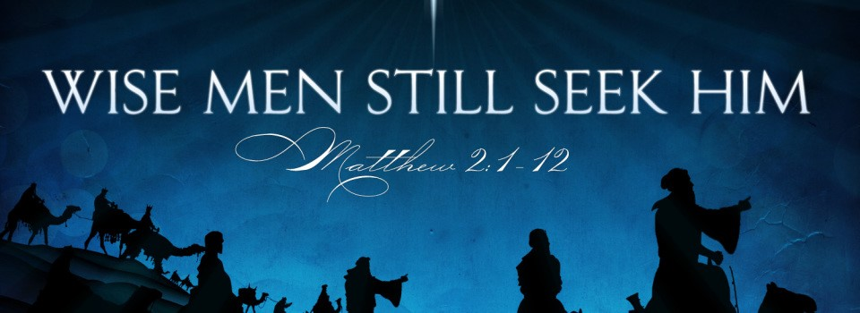
If you think this banner looks familiar you're right, it's one of my favorites. It says in Proverbs 9:10, "The fear of the Lord is the beginning of wisdom: and the knowledge of the Holy One is understanding." You see the truth never gets old and it never, ever, ever changes! Kathy and I are so grateful for all your prayers and support, we're praying His blessings upon you and your's during this Advent Season!

