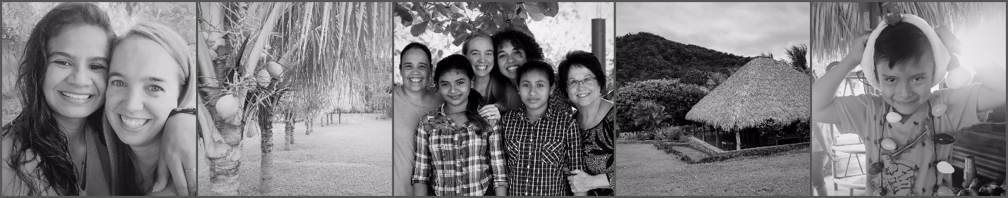
Dear Friends,

What a joy it is to sit down and take a moment to share with you all the Lord has been up to here In Nicaragua. It's a lot - so buckle up for the ride! ;)
Since February, we've been back in-person here in Nicaragua and ministry has blasted off - high speed! Let me start with sharing with you my typical weekly schedule to give you a glimpse of how my days are filled.
• Sundays - Help my local church with kids ministry and enjoy Christian fellowship.
• Mondays - My lovely day off (most of the time).
• Tuesdays - English classes in Ticuantepe & Los Rios.
• Wednesdays - Work on Trauma Healing from the World Renew office (Lots of meetings!)
• Thursdays - 1/2 day Gender Course, 1/2 day Trauma Healing planning.
• Fridays - Youth Trauma Healing Groups in Leon
• Saturdays - Planning for English Ministry and Church kids ministry.
English Ministry
In April we were able to start registration for the English classes and we started classes in May. I didn't know how long we would be able to have in-person classes with the pandemic and political unrest, but felt called to try - so we did! So far we've had three months of English classes with minimal interruptions - what a miracle!
Currently we are meeting in two churches and have four different levels of English classes with 43 students in all. This is such an encouragement to me as we had fewer students online last year. I've also been able to have many students who have been in classes previous years and it's such a joy to see them growing and learning.
Two classes are kids classes (grades 3-6) and these classes still meet in the Los Rios valley. I have been SUPER impressed as they learn so quickly and are doing so well. Two classes are youth classes that meet up in Ticuantepe. These "youth" are high school - college aged. Several of these students haven't gone to college yet and it's been so cool to be a small part of encouraging them to take steps to better their lives through English. We've also been able to have some great discussions about God's love and purpose for their lives, which is such a blessing to help them think through.
I absolutely LOVE teaching these students and partnering with local churches to reach youth in their communities. Thank you for partnering with us in this, too!

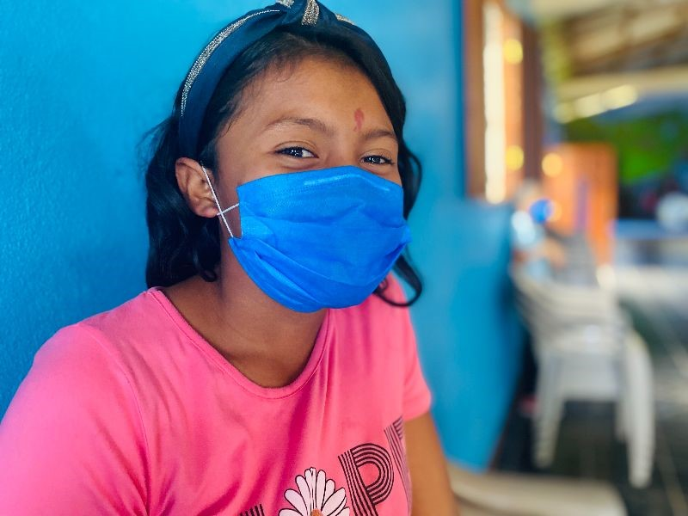
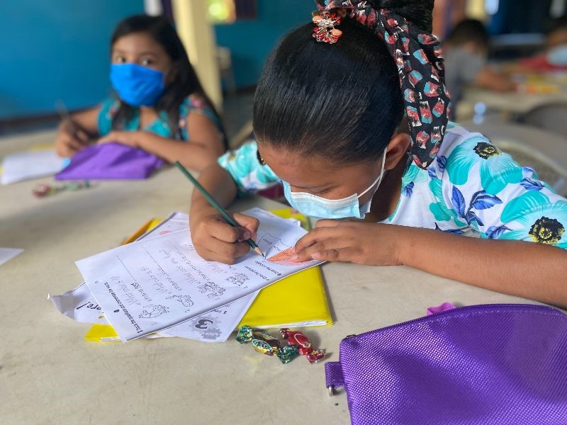

Trauma Healing Ministry
This year I've also had the privilege of doing many in-person and some virtual Trauma Healing trainings and events, in addition to all the normal, weekly Trauma Healing work. We continue to do a lot with Beyond Disaster, a program to help people affected by disaster begin to understand and process their trauma. Back in March I was able to go up to WASPAM to train 24 facilitators of the Beyond Disaster materials. In June I was able to go back to Puerto Cabezas to train 32 more facilitators of the same program. These facilitators will go on to train 24 more in another town. It amazes me how much impact these trainings have in families and communities.
This past training, there was a father in my group who was particularly engaged and excited to learn. At one point, while we were talking about the trauma that children have experienced since the two hurricanes and how they react he got very solemn. When it came time to share he shared the following;

"Ever since the hurricanes my little boy has been wetting the bed. That's not acceptable and so I hit him for discipline. However, now I understand that it's the trauma that has caused him to do this and not something he does on purpose. Now I know not to hit him, but instead to help him express what he's experienced, just like we've done here."
This impacted me as I saw how these trainings were impacting not just the adults that attended, but the families they go back to - and their communities as they share what they learn with others. How powerful!
As I have experienced exhaustion from this crazy busy time in ministry, hearing stories like this encourage me to keep going. God is beginning His healing process. God is brining hope. By His grace, we get to be a part of this. Thank you for empowering these hurting Nicaraguans with vital information about trauma and its effects on them and their families. Thank you for helping them have the space to express their pain and bring it to Jesus.
In addition to Beyond Disaster, I've also been a part of starting up the Youth Trauma Healing program weekly, Community of Practice virtual meetings, supporting our associate ministries as needed and heading up an online Advanced Training for the adult program. I also became a Master Facilitator in the Trauma Healing Program for adults - which I've been working on for 2.5 years! This will allow us to do trainings here in Nicaragua without needing to fly someone in from someone else - AMAZING!
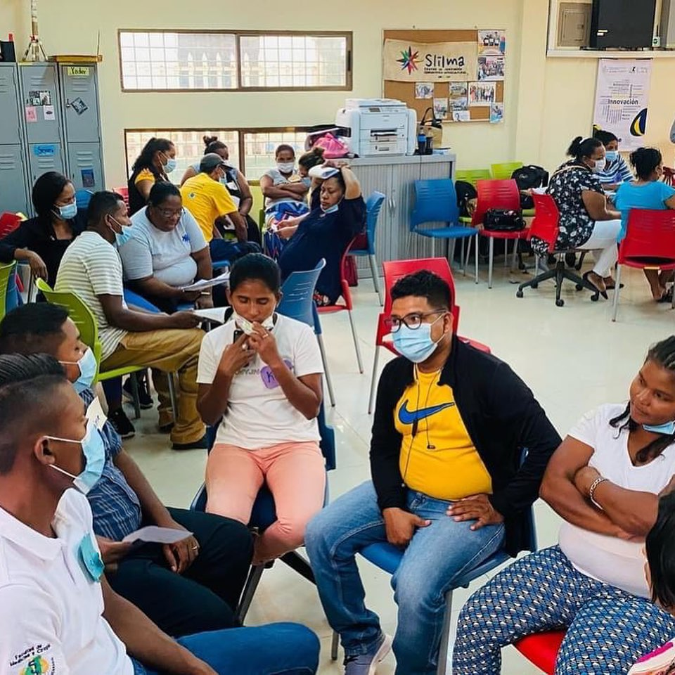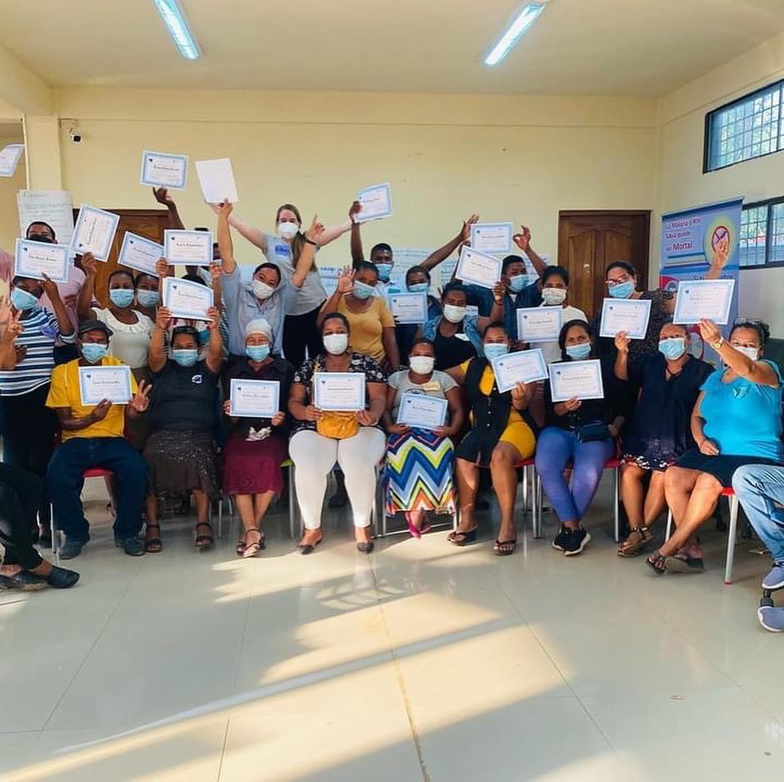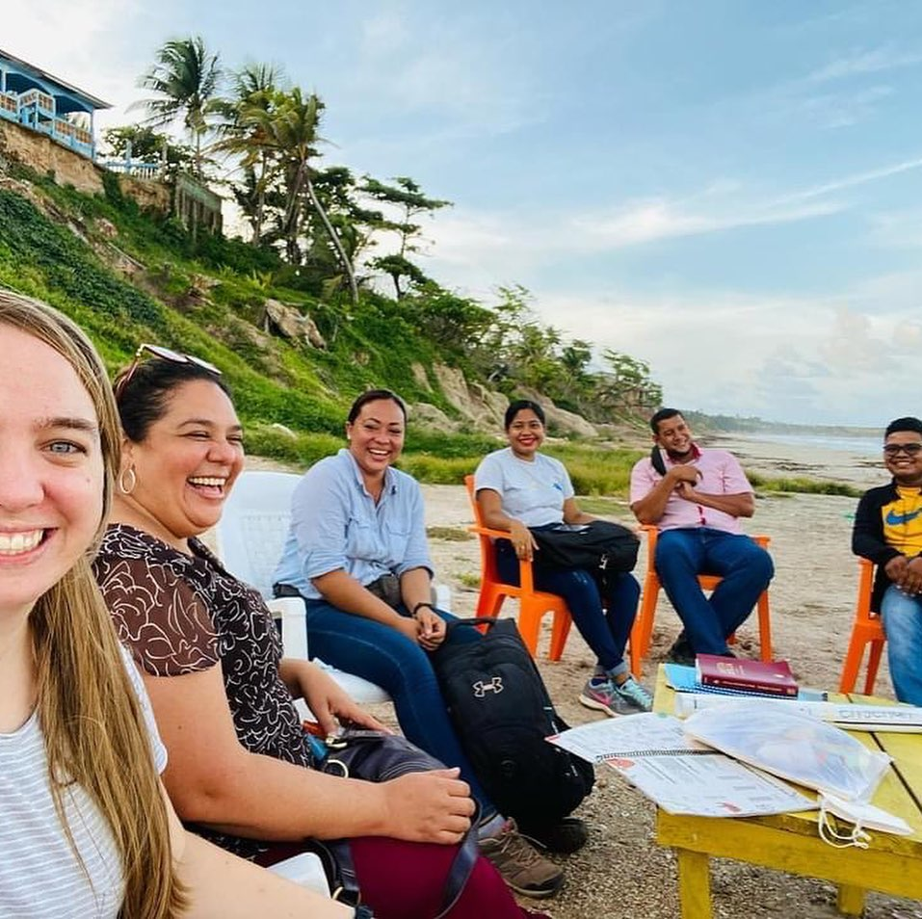

As you can tell, ministry has been in full swing this year. I am so grateful to continue to be able to coordinate the English Program and the Trauma Healing Program. God has shown Himself so faithful as I, many times, have felt so overwhelmed.
Back in April, in an effort to get back into exercising, I hurt my knee and had to be in "descanso" (rest) for about 3 weeks. Although I haven't tried to run again yet, so far it hasn't caused me more issues. Praise Jesus!
Also, I've been without my car for about 3 months. I took it in with a strange sound and haven't seen it since. This has caused an additional HUGE stressor as I have to daily figure out how to live life (in a pandemic) without a car. God has been faithful to provide rides here and there - but it has been HARD. Although it has provided many adventures... PLEASE join me in praying that my car can be fixed SOON so that this stressor can be taken away and I can be free to visit people and do ministry without this hindrance.
Last week, I had the privilege to return to the United States for a week to get my vaccine (as it doesn't look like I'll have access to one here anytime soon and cases continue to rise). I was able to take advantage of being in the States and see my family and some close friends who I haven't seen in a year and a half! What a huge blessing that was. Although I am saddened that the Nicaraguan people continue to be unprotected from so much (pandemic and political), I am thankful that I could get the vaccine to do what I can to protect those I serve.
Please join me in continuing to pray for the Nicaraguan people in this election year as political tensions are high and for wisdom with ministry in the midst of it all. Thank you once again for your constant encouragement and prayers as we continue to seek that there might be No Person Without Hope here in Nicaragua. To God be the glory - great things He has and IS doing!

Blessings,
Bethany Joy

