Hi there,

What a tumultuous and trying time we have come through, and are still going through, since we heard about a new virus, SARS Cov which produces COVID 19. So much confusion and misinformation has surround this virus. Fear of this virus and it’s effects have changed our world in a very short period of time.

Here I will present some information about what has been discovered since March 2020. Knowledge can help us stem fear and show us how to go forward. There is so much miss information it is hard for many to sort what is really helpful and true.

Nothing we have been told is genuine and honest – Dr Mike Yeadon https://www.bitchute.com/video/P3hvpulNTdN5/

Putting things into perspective
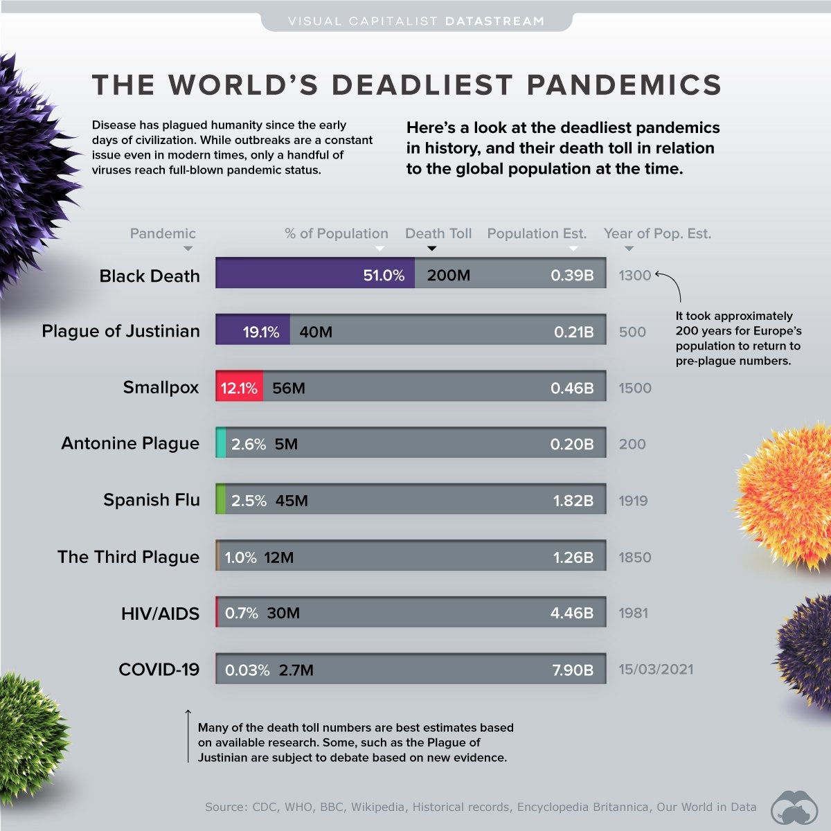

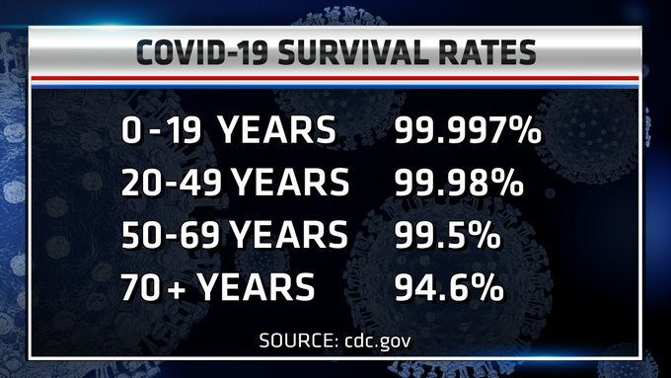

Did you know?
- 1. The FDA did not approve Moderna or Pfizer mRNA gene therapeutics they dubbed "vaccines". It simply authorized them. Fauci confirms. 19 doctors warned the world of the dangers. AstraZeneca is being dropped by 24 countries. Johnson & Johnson is a Viral Vector(1) vaccine that was given Emergency Use Authorization on Feb. 27, 2021. Several States have halted its distribution due to formation of blood clots. The CDC confirms. It also confirms(2) the Pfizer & Moderna jabs are the deadliest of all "vaccines"
- 2. The clinical trials will be completed in 2023, and there are 12 vaccine companies working on profiting from vaccine sales
- 3. The FDA & CDC have not revealed to the public over 20 adverse effects, including Death, related to Covid19 vaccines, which were discussed in an October 2020 meeting. 2,602 deaths from Covid19 vaccines are reported by the National Vaccine Information Center as at 4/8/2021, and one-third of the deaths occurred within 48 hours
- 4. The mRNA jab delivers a synthetic, inorganic molecule (medical device) that programs your cells to synthesize pathogens in the form of the spike protein that your immune system will constantly have to fight off for the rest of your life. Molecular Biologist & Immunologist, Professor Dolores Cahill explains. NCGI article elaborates. Fauci confirms. Others call it Information Therapy that hacks the software of life, according to Moderna's [mode RNA] chief scientist. You essentially become a GMO. Dr. Sherri Tenpenny has mapped out eight mechanisms of how the Covid jab is going to kill people
- 5. The mRNA jab does not prevent you from contracting Covid19 or from transmitting it. Dr. Steve Hotze elaborates. Fauci confirms. The CDC graph underscores that reality, proving vaccines are ineffective and vaccine passports are totally useless

Did you also know?
- 6. The CDC inflated the death rate for Covid19 by instructing medical practitioners in its March 24, 2020 directive to ascribe the cause of death as Covid19 for all deaths, irrespective if patients were tested positive for Covid19 or if they had other comorbidities, so as to ramp up the fear, and doctors have publicly stated they are being pressured to mark Covid19 on death certificates, here is a list:
- Dr. Dan Erickson
- Dr. Scott Jensen
- Infectious Disease Director Kris Ehresmann
- and that 60,000 Americans have been dying weekly, consistently, before and after the covid scare - more data - while deaths by influenza and other diseases have plummeted
- 7. The CDC later admitted that 94% of deaths had underlying conditions. That means that of the 527,000 deaths reported as Covid19, only 6% were caused directly by Covid19, or 31,620. That brings the true case fatality rate to 0.12% out of the 27 million cases
- 8. The survival rate for Covid19 is, therefore, roughly 99.9%. When using the state population as the denominator, the death rate is even lower, ranging from 36 to 247 deaths per 100,000. As at March 19, 2021, even with the doctored numbers and faulty tests, the CDC arrived at the following survival rates:
- Ages 0-17 99.998%
- Ages 18-49 99.95%
- Ages 50-64 99.4%
- Ages 65+ 91%
- 9. The CDC lumped pneumonia, influenza, and Covid19 into a new epidemic it called PIC in order to inflate Covid19 deaths. The CDC stats for week of July 3, 2020 confirm that pneumonia and influenza combine with Covid to inflate the death rate. The Feb. 5, 2021 report does the same. The duplicity is underscored in the search results page, where only "(P&I)" is mentioned, but PIC graphs appear upon clicking the links
- 10. Hospitals are paid $13,000 for every Covid19 admission, and $39,000 for every patient that is put on a ventilator. More proof

Are you aware that...
- 11. The PCR tests do not detect SARS-CoV-2 particles, but particles from any number of viruses you might have contracted in the past, and that a lawsuit for crimes against humanity is being launched by a German attorney for this fraud. Even Fauci admits PCR tests don't work. The WHO backs him up. In this CDC document, testing guidelines state that false negatives and positives are possible - page 39. The PCR test cannot rule out diseases caused by other bacterial or viral pathogens - page 40. But most importantly, on page 1, SARS-CoV-2 was never isolated in the first instance: "Since no quantified virus isolates of the 2019-nCoV were available for CDC use at the time the test was developed and this study conducted, assays designed for detection of the 2019-nCoV RNA were tested with characterized stocks of in vitro transcribed full length RNA". Neither the CDC can provide samples of SARS-CoV-2, nor can Stanford and Cornell labs, and in a CNN interview Fauci said he was not getting tested and there is no need to test asymptomatic people. He reiterates that asymptomatic people have never been the driving force of a pandemic. Again, the WHO backs him up
- 12. There are class action lawsuits in the works, naming Anthony Fauci as defendant, amongst others. Here's a partial list :
- - a lawsuit against the CDC was filed for illegally withholding information under FOIA
- - the WHO has a lawsuit brought against it by German lawyer, Dr. Reiner Fuellmich, for crimes against humanity. Here is an update
- - nurses are suing a hospital CEO for covering up the Covid fraud
- - California teachers are suing for being pressured to get an experimental vaccine, the press release
- - the government of Norway is facing a crimes against humanity lawsuit
- - the Canadian Government is facing a legal battle from the best Constitutional attorney, Rocco Galati, who wants to see Bill Gates jailed
- - Florida is suing the Federal Government and the CDC
- - doctors plead guilty to biotest fraud
- - Human Rights attorney, Leigh Dundas, is going after California for trying to vaccinate children without parental consent
- - a British law firm is fighting against 'No Jab, No Pay, No Job'
- 13. Therapeutics and profylactics, like Hydroxychloroquine, have been approved in WHO, CDC and NIH websites, but were intentionally kept out of the public eye in order to fast track vaccines. Now, some doctors are pleading that Ivermectin be used as a sure cure
- 14. Front Line Doctors who try to explain the benefits of proven therapeutics are being silenced, and some have had their license suspended. A concise summary by Dr. Simone Gold, who is also an attorney and founder of America's Front Line Doctors, is a must watch. Also, the British Medical Journal has broken rank and is citing corruption and suppression of science
- 15. Fauci and the CDC has flip-flopped on masks, contaminated surfaces, asymptomatic spread, testing, and has only recently acknowledged that herd immunity is achieved when antibodies are spread by those who beat the disease (the 99.9%), but still recommends social distancing, only now from 6 feet to 3 feet, resulting in this lockdown map

... and that
- 16. Injuries and deaths by mRNA jabs keep rising. VAERS reports 8,285 serious injuries as at 4/8/21. In the first quarter of 2021 there has been a 6000% increase in vaccine deaths from the same period a year ago
- 17. The CDC at one time recommended DDT for in home use, and used the same fear tactics to sell vaccines for H1N1
- 18. Documents prove that the media was to be the key player in creating the hype leading up to the promotion of vaccines, that a VACCINATE WITH CONFIDENCE paper by the CDC exists, and that lockdowns are used as a carrot
- 19. Politicians are caught on camera talking about the theater of wearing masks, and the NCBI, a division of the NIH, published a paper on the complete ineffectiveness of masks. Even the CDC warns of the dangers of masks
- 20. The CDC owns the patent for the coronavirus that is transmitted to humans; a patent for a Covid19 test was filed in 2015, and Covid19 test kits were being shipped around the world in 2018

... or that
- 21. The Covid19 Vaccine was developed in just a few hours
- 22. Vaccine companies cannot be sued for injuries
- 23. Bill Gates, who invested $10 Billion into vaccines, boasts at how he uses genetically modified organisms to inject kids with
- 24. Bill Gates is on record pushing for vaccine passports. Parenthetically, various domain names for "vaccinepassport" were filed in 2016 by an entity in Milan, Italy
- 25. Bill Gates is on record pushing for the right vaccines to lower the world population by 10% to 15%, and a call has been made for his arrest and trial at the International Criminal Court for crimes against humanity

Finally, did you know?
- 26. Covid variant vaccines are to be marketed without safety trials, Fauci confirmed it, and that antibodies/antigens to SARS-CoV-2 are found in saliva, making the use of masks counterproductive in achieving herd immunity
- 27. The CDC, that props itself up with statements like “The Centers for Disease Control and Prevention (CDC) is the agency Americans trust with their lives. As a global leader in public health, CDC is the nation’s premier health promotion, prevention, and preparedness agency. Whether we are protecting the American people from public health threats, researching emerging diseases, or mobilizing public health programs with our domestic and international partners, we rely on our employees to make a real difference in the health and well-being of people here and around the world.” buys and resells vaccines at a markup, about $4.6 Billion worth every year, and owns over 20 vaccine patents - according to Robert F. Kennedy Jr. - and is listed on Dun & Bradstreet
- 28. The consent forms in hospitals disguise vaccines as "biogenics", and blood brokers have paid up to $1,000 for blood samples of recovered Covid19 people
- 29. It's against the Nuremberg code to force vaccinations on a person, and informed consent overrides public policy. Federal law prohibits employers and others from using vaccines under EUA as a condition of employment. A Nevada attorney is ready to do battle
- 30. Donald Trump glories in the fact that he pushed Warp Speed and Biden gloats that he ordered 100 million doses

... or that
- 31. Time, again and again the WHO has discouraged the wearing of masks by healthy individuals, let alone children
- 32. Several "simulations" of a pandemic were held in:
- - May 2018 Clade X by John Hopkins University
- - September 2019. The WHO's Global Preparedness Monitoring Board established as one of its progress indicators the release of two lethal pathogens by September 2020. See pg 39
- - 2018. Bill Gates' INSTITUTE FOR DISEASE MODELING released a video modeling a pandemic starting at Wuhan, China
- - October 2019. Bill Gates sponsored a Global Pandemic Exercise Event 201, video, and Fauci sits in the Leadership Council of the Bill & Melinda Gates Foundation, which has contributed over $3.5 million to Fauci's NIH
- 33. The Pfizer, Moderna and J&J jabs contain fetal cell lines, that is, cells grown in labs originally obtained from aborted fetuses decades ago. The argument used by pro-vaxers is that these are not the original cells, but descendants or duplicates of the originals. The medical term is MRC-5. You have a right to decline any vaccine that was developed with or contains MRC-5
- 34. Lockdowns have had no effect on the death rate. Here's another report
- 35. On March 2020, the British Government discussed tactics it would use to ensure citizens complied with the loss of their rights and freedoms and these have included –
- Using media to increase the sense of personal threat
- Using media to increase the sense of responsibility to others
- Using and promoting social approval for desired behaviors
- Using social disapproval for those who do not comply
- Here is the document

https://nojabforme.info/

Questions that have been asked before you get the COVID Jab.

Here are 12 important questions and answers before considering getting vaccinated:

●"If I get vaccinated can I stop wearing a mask(s)?" Government: "NO"

●"If I get vaccinated will the restaurants, bars, schools, fitness clubs, hair salons, etc. reopen and will people be able to get back to work like normal? Government: "NO"

●"If I get vaccinated will I be resistant to Covid?" Government: "Maybe. We don't know exactly, but probably not."

●"If I get vaccinated, at least I won't be contagious to others - right?" Government: "NO. the vaccine doesn’t stop transmission."

●"If I get vaccinated, how long will the vaccine last?" Government: "No one knows. All Covid "vaccines" are still in the experimental stage."

● "If I get vaccinated, can I stop social distancing?" Government: "NO"

● "If my parents, grandparents and myself all get vaccinated can we hug each other again?" Government: "NO"

● "So what's the benefit of getting vaccinated?" Government: "Hoping that the virus won't kill you."

●"Are you sure the vaccine won't injure or kill me?" Government: "NO"

●"If statistically the virus won't kill me (99.7% survival rate), why should I get vaccinated?" Government: "To protect others."

●"So if I get vaccinated, I can protect 100% of people I come in contact with?" Government: "NO"

● "If I experience a severe adverse reaction, long term effects (still unknown) or die from the vaccine will I (or my family) be compensated from the vaccine manufacturer or the Government?" Government: "NO - the government and vaccine manufacturers have 100% zero liability regarding this experimental drug"

So to summarize, the Covid19 "vaccine"...

Does not provide immunity

Does not eliminate the virus

Does not prevent death

Does not guarantee you won’t get it

Does not stop you from passing it on to others

Does not eliminate the need for travel bans

Does not eliminate the need for business closures

Does not eliminate the need for lockdowns

Does not eliminate the need for masking

HOW TO LEGALLY REFUSE A VACCINE?

DO NOT refuse a vaccine right away.
OTHERWISE, you will be considered a belligerent. Instead, you can politely decline the service by doing the following:

Ask the doctor: - "does the vaccine contain MRC-5?" (They all do.) These are aborted fetal cells and other DNA. If the vaccine contains MRC-5, you have the RIGHT to refuse it.

You can also ask: - "is there a possibility of an IATROGENIC REACTION? (Iatrogenic compounds or drugs that interact with each other) (all of them do).

When the doctor says "yes, they contain" ... THAT is the way to LEAVE WITHOUT TAKING the vaccine !!! THANK THE DOCTOR FOR THE OFFER, AND GO AWAY!

Remember: the doctor has taken the HYPOCRATES Oath (which is NOT to cause harm) and MUST comply with it.

That's how we can, LEGALLY (AND RESPECTFULLY), refuse the services offered, there is absolutely nothing they can do about it. Now you know.

IF YOUR COMPANY REQUIRES YOU TO TAKE THE VACCINE:

You CAN AND MUST argue:

1) - Ask the company to DO IT IN WRITING AND SIGNED, with LEGIBLE names and surnames of those responsible, and the reason why they are told to use the vaccine. And, if there are consequences, such as threats of losing your job, this is already a criminal offense, coercion and threats, typified in Article 172 of the Penal Code.

2) - Demand to see the Civil Liability Insurance of those who oblige or the company that obliges.

We must sign an Insurance Policy that guarantees us a million dollar indemnity if something happens to us. They would certainly retreat.

We will demand a policy where it is very clear that they are RESPONSIBLE for anything that may happen to us.

Since the pharmaceutical companies have already said that they are NOT responsible ... What constitutes GENOCIDE ...

3) - Give us the name of the vaccine and the composition. If they have human tissue, we can always invoke the OBJECTION OF CONSCIOUSNESS.

INTERNATIONAL LAWS AND TREATIES THAT PROTECT US AGAINST 19 "mandatory" vaccinations:

➡️ HELSINKI TREATY
https://www.wma.net/.../declaracion-de-helsinki-de-la.../

➡️ Informed consent in CCyCN and Law 26.529 on Patient Rights
https://leyderecho.org/historia-del-consentimiento.../

➡️ UNESCO Universal Declaration on Bioethics
http: //portal.unesco.org /.../ ev.php-URL_ID = 31058 & URL_DO ...
San José Pact, Costa Rica

https: //www.oas.org /.../tados_B-32_Convencion ...

Carta️ International Charter on Human Rights
http: //tratadoseuropeos.eu /.../ Carta_Internacional_de ...
Nuremberg Code

http://www.facmed.unam.mx/_gaceta/gaceta/nov2597/codigo.html

Declaração️ Geneva Declaration
https://www.bioeticawiki.com/Declaraci%C3%B3n_de_Ginbra

Plataforma️ Digital Platform for Law, Social Sciences and Humanities

➡️ History of Consentimiento en el Derecho Internacional

note:
see Consentimiento en el Derecho Internacional,

Manifestation of Consent to Obligate by International Treaties and Consent in International Arbitration.

Join for ALL BRAZIL
@ PhoenixBrasil🇧🇷

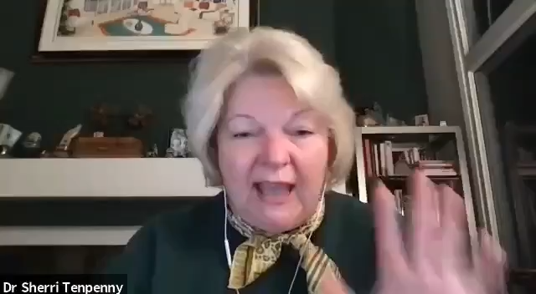
For those that have already taken the COVID shot: here is some advice from Dr.Tenpenny

There is a lot more information out there – please do your research! I am happy to talk to anyone that has questions and help you find answers. Blessings, Jenni

