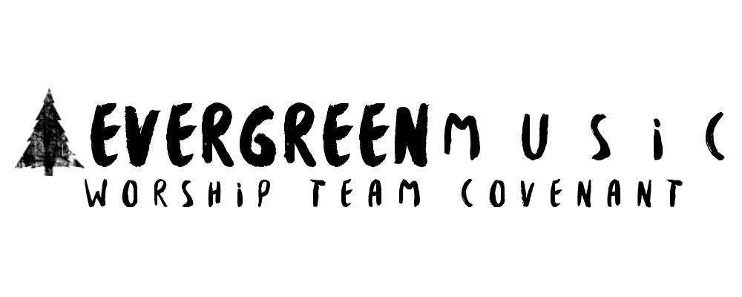
VISION

The vision of Evergreen Music is to be a fully engaged TEAM in our own mission and equipping the Body of Christ through the training of other worship teams.

MISSION (3 P’S & a B)

PRESENCE- A TEAM that pursues the presence of God
PRAYER- A TEAM devoted to boldly & fervently praying
POPULATE- A TEAM that is committed to multiplying/raising up new leaders
BATTLEFIELD- A TEAM of initiators walking onto the “Battlefield” together

VALUES (CASH)

COMMUNITY- We value meeting together as stated in Hebrews 10:24-25
AUTHENTICITY- We value authenticity in our worship/daily lives
SERVANTHOOD- We value serving each other, our congregation, and our community (Acts 2:42-47)
HUMILITY- We are a TEAM and a FAMILY. We value looking out for others before thinking of what’s best for us. We are also humble in our approach to worshiping God.
WORSHIP TEAM GUIDELINES
- Lifestyle/Integrity-
- I am aware that I must be a born-again believer in Jesus, having made Him my Lord and Master, and my lifestyle must reflect the decision I have made to follow Jesus, whether in real life or on social media.
- I agree to be actively pursuing God and going deeper with Him through reading/studying God’s word, prayer, giving/tithing, & serving.
- I will commit to “being clean spiritually” (Psalm 24:3-6) before stepping foot on any platform, and be able to express to the worship pastor if I am not. -- Perfection is not expected, but if you are in no place to lead others to the throne room of God, it is preferred that you do not participate in leading others until your heart is right.

- Commitment
- I know that to serve on the worship team at Evergreen, I must be an active member of our church.
- I commit to praying for the rest of the worship team.
- I commit to dress appropriately on and off stage (I represent Jesus and Evergreen Church everywhere I go). In other words, if what I’m wearing will potentially take someone’s attention and focus off of worshiping God, then I will be asked to go home and change.
- I will commit to develop my craft (musicianship/voice). (1 Chronicles 25:7) --- Although we recognize the importance of a pure heart, the musician and vocalist also need to have enough skill so that they can follow the leading of the Holy Spirit. --- (I will have an open heart/mind to receive advice, correction, & training. I do not need to be a professional musician to worship the Lord, but God honors discipline and preparation.)

- Rehearsals
- I know that attendance and punctuality are very important factors for being a member of the worship team.
- I know that Wednesday night rehearsals are required for every worship team member that will be serving on Sunday.
- I acknowledge that if I am unable to attend rehearsal, I should not expect to participate on the worship team the following Sunday (even in the case of emergency).
- The only exception to this will be students who are serving on the worship team in the student ministry.

- Schedule Conflicts, etc.
- If at any time I cannot attend a service/rehearsal, etc. that I have committed to (accepted in Planning Center), I will do my best to find my own replacement & notify the worship pastor in advance if at all possible so that proper adjustments can be made.

- New Worship Team Members
- We constantly seek to expand our worship team.
- Those seeking to join the worship team will be asked to attend several rehearsals to begin the process.
- In addition to attending several rehearsals, the prospective worship team member will need to set up a meeting with the worship pastor and others from the team. Prospective worship team members will go through a relaxed “get to know your heart” conversation with the worship pastor and other team members. During this time, you will also be asked to go through a brief informal audition with either your instrument or voice, or both with the song of your choice.
- After this meeting, the worship pastor along with the other present team members will take a week (or longer if needed) to pray about God’s direction regarding your involvement with the worship team.

- Prospect will receive an email from the worship pastor after much prayer to report back to you with the answer. If we feel that God is indeed leading you to be a part of the team, you will be asked to attend several more rehearsals before joining us in leading on Sundays. If we feel that God is giving us a “no” answer at this time, you will be given the opportunity to re-visit this process in 6 months.

- Expression in Worship
- I know that I will be challenged with expressing myself to God while on and off stage (during worship services). We recognize that expression does not come easy for most people. There are many Biblical expressions given to us. For example: Singing (1 Chron 16:23; Ps. 7:17), Shouting (Ps. 32:11; Ps. 33:3), Clapping (Ps. 47:1), Lifting Hands (Neh. 8:6; Ps. 28:2; Ps. 134:2), Dancing (WHAT???!! Yes. Dancing is a Biblical expression…2 Sam. 6:14; Ps. 149:3; Ps. 150:4), Bowing (Gen. 24:26; Ex. 34:8; 1 Chron. 29:0)
- God desires us to show expression and affection to Him. If we are truly worshiping Him, how could we not express our love and gratitude towards Him? This involves what’s going on on the inside of our hearts to come out in some sort of expression to Him.
- I’ll leave you with this quote from Zach Neese: “The cross is the physical expression of the posture of God’s heart toward me. He loved me…to death. How could I refuse to demonstrate the posture of my heart toward Him when He so thoroughly and passionately demonstrated the posture of His heart toward me?”

- Lastly, Open Communication is of Vital Importance
- If at any time I am confused, discouraged, depressed, or unhappy with the way things may be happening at a given time, I will speak directly with the worship pastor as soon as possible.
- I know the only way to deal with hurt feelings, resentment, confusion, etc. is to bring it out in the open so that the Lord can help us work through it. I also acknowledge that gossip will not be tolerated and may result in a suspension from the worship team.
- I know that if I am going through a struggle at home, at work, etc., that this worship team is a safe place to share. This is what the Church is for, and I will commit to being open with all of my teammates and worship pastor to allow them to pray for me and walk alongside me through my struggle.

ACCEPTANCE OF GUIDLINES

I ________________________________ understand, accept and agree with the guidelines stated in this covenant, and agree to conduct my actions according to the guidelines and promise to uphold the utmost integrity of ministry.

Signature__________________________________________________

Date______________________

Please Complete:
Contact Info (Email & Phone)___________________________________________
Birthday_______________________

Please explain why you feel you should be part of this ministry___________________________________________________________________________________________________________________________________________________________________________________________________________________________________________________________________________________________________________________________________________________________________________________________________________

