PRAYER OPPORTUNITIES AT RIDGECREST
- Pastor Search Committee
- Summer At Ridgecrest
- Growth Workshops
- Beautiful Feet mission trip – July 23rd-28th

Weekly Opportunities July 21st – 27th
Sunday: 7:30am Men’s Adventure (Room 103)
9:00am Life Groups (list at the Information Center)
10:30am Morning Worship – Matt Cloyd (Worship Center)
6:00pm Growth Workshops
Sunday Evening Service – Ira Singleton (Worship Center)
“Especially What?” 2 Timothy 4: 11 & 13
Students- MS Braves Game
Ridgecrest Kids- K-5th (3rd floor/The Knight Room) Preschool Hang Time – ages 3-5 (The Ark- Monkey Room)
Childcare - Infants - age 2 (The Ark- Elephant Room)
Women’s Ministry- Coffee, Cake & Comedy (Room 301)

Monday: 11:15am Lunch Bunch (off campus)

Tuesday: 6:30pm College Ministry (601-624-5549)
6:30pm Women’s Bible Study- (off campus)

Wednesday: 4:00pm Prayer Meeting (Choir Room)
6:00pm Family Field Day (on campus)

It Begins at the Heart

Isaiah 58: 6-11

Matt Cloyd

July 21, 2019

7469 Old Canton Road • Madison, MS • 601.853.1090 • ridgecrest.net

Matt Cloyd, Executive & Discipleship Pastor
Brian Wright, Pastoral Care & Connections Pastor
Greg O’Neal, Worship & Sr. Adults Pastor • Tim Blocker, Stewardship Director
Michael Estes, College Pastor •Logan Ellzey, Student Pastor
Stacie Albritton, Preschool & Children Ministry Director
Stephen Collier, Media Coordinator
Hillery Johnson, Ridgecrest Preschool Director
Babbe May, Weekday School Age Ministry Director
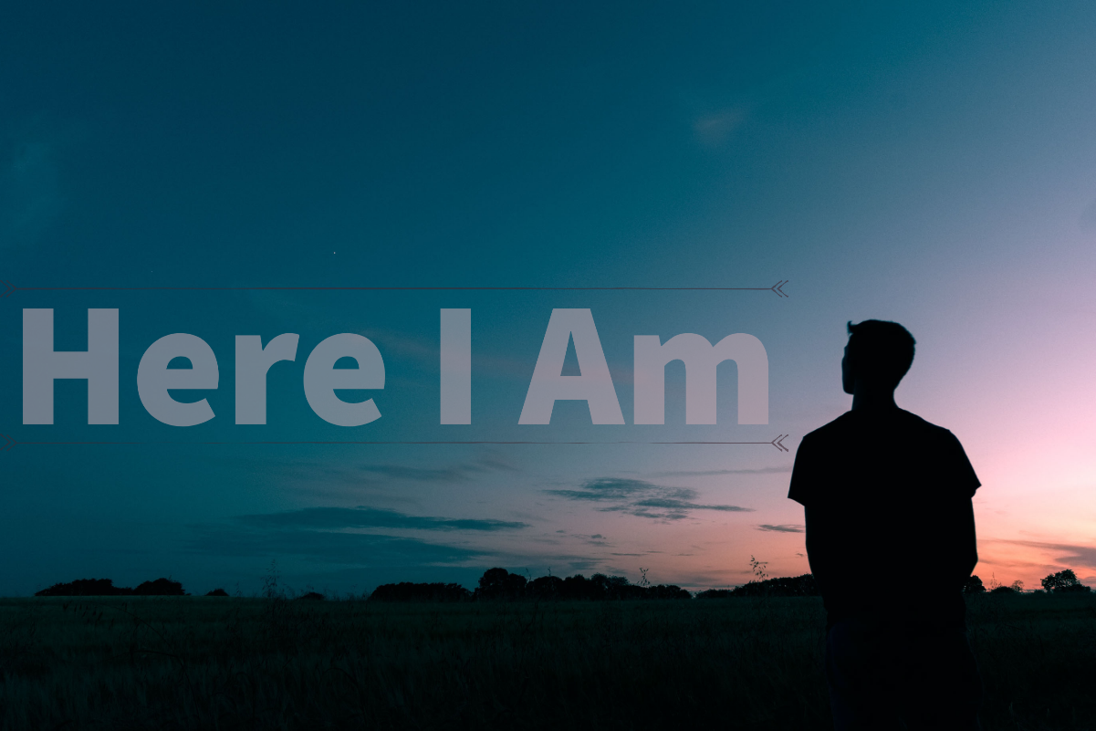

WELCOME GUESTS! We’d like to get to know you and let you know about Ridgecrest opportunities. We ask you to fill out the Connect Card (s) in the pew rack and return it to the Information Center as you leave today. We’re glad you are worshipping with us this morning!

Lunch Bunch for 60+ will be this Monday, July 22nd, at Strawberry Café in Madison at 11:15am. Please RSVP to Jane at 601-853-1090, ext. 35, by 9:00am tomorrow if you would like to join us.
Community Picnic- Mark your calendars! Your families are invited to our community picnic on Sunday, August 4th at 6:00pm on our campus. This is a great opportunity to invite your neighbors and to get to know more of your Ridgecrest family.
Back-to-School Prayer Emphasis August 4th-9th: As we begin a new school year, we want to make sure we cover our students, parents, and educators in prayer. We will be providing several opportunities and resources the week of August 4th-9th, including a special prayer time during the church-wide picnic on August 4th and an additional time set aside on Wednesday, August 7th from 5:00-7:00pm to come by the church to pray for this school year and write notes of encouragement to our area educators. We will also provide printed prayer guides for individuals to use during their personal prayer times that week.
Fall Kick-Off/Next Steps U: We begin our first 8-week Wednesday fall session August 14th and it will run through October 2nd. We will continue our Adult Life Group leader training and offer other options for all ages. We will have a complete list available soon.

Women’s Ministry:
-Plan to join us tonight for a night of coffee, cake & comedy! Laugh with us as we enjoy some sweet treats and fellowship. We will meet at 6:00pm- in Room 301.
Our ministry is preparing a cookbook featuring favorite recipes from our church family. Please submit up to five of your favorite recipes. We have a display table across from the Coffee Corner where you can get forms and instructions for your recipes. For more information contact us at rbcwomensministryteam@gmail.com.
Ridgecrest Preschool is our half-day weekday ministry for toddlers to 4s. We are looking for dedicated and loving teachers for our upcoming 2019-2020 school year. For more information, email Hillery at director@ridgecrestpreschool.net or call 601-853-9100.

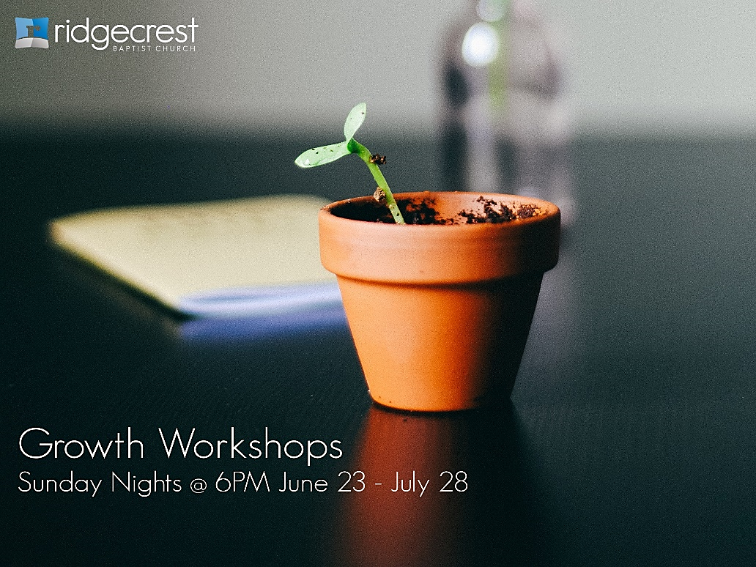

Growth Workshops are a six-week focus this summer on Sunday evenings through July 28th as we give opportunities for all ages to grow in their relationship with God. High School students will meet at the Craig’s home. Middle Schoolers will meet in the Chapel. Grades 1st-5th will have Kids Worship in The Knight Room.
Options for adults include:
- Engage: Lessons on Raising Your Kids in a Social Media Generation, facilitated by Dave Thomas and Kirk Cameron – Room 103
- God in the Mirror: Discovering Who You Were Created to Be, a Women’s Ministry study led by Dianne Washington – Room 105
- Launch: Overview of the Book of Acts led by Brian Wright and Michael Estes – Choir Room
- Sew Missions: Beginner Knitting and Crochet classes – Room 104
- Sunday Evening Service featuring traditional hymns and a brief message – Worship Center

