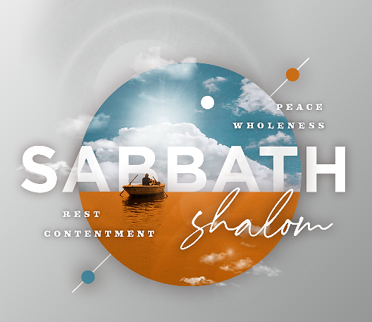
i
May 9, 2021

WELCOME! Let us know you are here! Please text “CHECK” to 601-853-1090. We are excited this morning to be worshipping with you on campus and in your homes. We have many new opportunities for your family to participate in, as well as additional opportunities to serve the church.
To our guests, we welcome you and are glad you have joined us. It is our desire to share with you about Ridgecrest opportunities that promote our vision to Know God, Serve Others, and Reach Our World. Please visit our website at ridgecrest.net. We are glad you are worshipping with us this morning!

Pastor Michael Estes
Sabbath Reminders – Colossians 2:13-17
Reminder that Sabbath Points to Jesus

- We are reminded that salvation is an invitation into a new family. (v. 13-15)
  - Paul points to the practice of circumcision as an identifying feature of those who were in the family of God.
  - Then, he refocuses that identifying feature to be faith in Jesus, who then circumcises our heart with the Holy Spirit.
  - This leads us to become members of the family of God through the doorway of baptism.
  - As we settle into our new family life, we cast off our old “bodies of flesh,” which were put into place by the rulers and authorities that Jesus has disarmed and triumphed over.

- We are reminded that Sabbath was never intended to save us. (v. 16)
  - Paul makes mention of food and drink, which was a reference to things that make one clean or unclean.
  - He also makes reference to the Jewish calendar of temple worship (annual, monthly, weekly progression).
  - He makes it clear that entry into the family of God isn’t based on these things.

- We are reminded that Sabbath was a shadow that points us to the reality of Jesus. (v. 17)
  - Sabbath was supposed to supply us with physical rest.
  - This physical rest was supposed to help us understand the deep need for soul rest.
  - Therefore, Sabbath was supposed to be a signpost to the One who can ultimately satisfy this deep spiritual need for rest.

GIVING As we continue to Know God, Serve Others, and Reach Our World during this time when we are not all gathering together, we continue to rely on the generosity of the church to support the ministry of Ridgecrest. Giving is not payment for activities conducted at the church, but an act of worship conducted by the Church as overflow of what God has provided us. We encourage you to give online, on our church app, or by texting the word "GIVE" to 601-853-1090. For those worshipping on campus, giving stations are available as you exit the building. Thank you for your faithful, continued support!

“She is clothed in strength and dignity and she laughs without fear of the future. When she speaks her words are wise and she gives instruction with kindness.” Proverbs 31:25-26. We celebrate our mothers today! God has entrusted us to be mothers in many ways and in different walks of life. We ask God to bless you on your day in a special way!

Michael Estes, Senior Pastor • Matt Cloyd, Executive & Discipleship Pastor
Brian Wright, Pastoral Care & Connections Pastor • Greg O’Neal, Worship & Senior Adults Pastor
Tim Blocker, Stewardship Director • Logan Ellzey, Student Pastor
Stacie Albritton, Preschool & Children Ministry Director • Stephen Collier, Media Coordinator
Hillery Johnson, Ridgecrest Preschool Director • Babbe May, Weekday School Age Ministry Director

