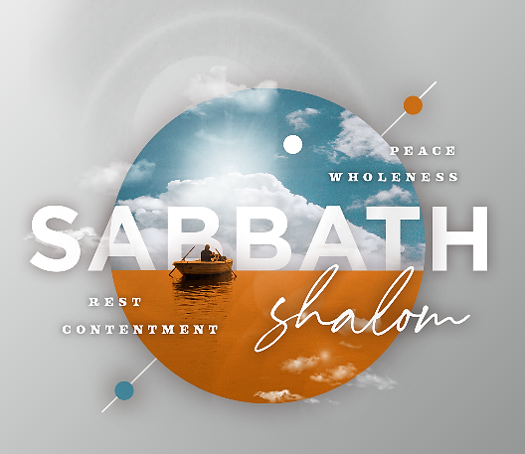
i
May 2, 2021

WELCOME! Let us know you are here! Please text “CHECK” to 601-853-1090. We are excited this morning to be worshipping with you on campus and in your homes. We have many new opportunities for your family to participate in, as well as additional opportunities to serve the church.
To our guests, we welcome you and are glad you have joined us. It is our desire to share with you about Ridgecrest opportunities that promote our vision to Know God, Serve Others, and Reach Our World. Please visit our website at ridgecrest.net. We are glad you are worshipping with us this morning!

Pastor Michael Estes
Sabbath Reminders – Sabbath as a Day to Do Good Matthew 12:1-14

- We need to remember that Sabbath was given to us as a gift and not as a burden. (v. 1-7)
  - Over time, leaders had created a tradition of regulations around Sabbath-keeping called the Halakah.
  - One of the regulations was that there would be no reaping, threshing, winnowing, or preparing of food.
  - The disciples had not broken any specific Old Testament prohibitions, only the added traditions of the Halakah.

- We need to remember that Sabbath is a day of freedom to care for those in need. (v. 9-14)
  - It can be easy to slide into an understanding of Sabbath as primarily a space where we focus on what we don’t do.
  - Jesus corrects that understanding and permits us to do good on the Sabbath.
  - Seeing opportunities to love others is often only possible when we stop to spend time with God.

- We need to remember that through the Sabbath Jesus makes audacious claims about himself. (v. 8)
  - We see that Jesus connects himself to David, the great king.
  - We see that Jesus connects himself to the priests and the Temple, claiming to be even greater than the Temple itself.
  - We see that Jesus connects himself to the Creator God, the One who made the Sabbath for man.

GIVING As we continue to Know God, Serve Others, and Reach Our World during this time when we are not all gathering together, we continue to rely on the generosity of the church to support the ministry of Ridgecrest. Giving is not payment for activities conducted at the church, but an act of worship conducted by the Church as overflow of what God has provided us. We encourage you to give online, on our church app, or by texting the word "GIVE" to 601-853-1090. For those worshipping on campus, giving stations are available as you exit the building. Thank you for your faithful, continued support!

Today we recognize our High School Seniors! Join us as we celebrate their success! We pray for God’s blessing on them as they face new beginnings in their lives. Please take a walk down our hallway to see their life highlights displayed in our Hall of Memories.
Seniors: Caleb Cameron, Anna Catherine Crawford, Evelyn Eubanks, Cameron Kuriger, Mary Allyn McIntosh, Nathan Pittman, Alex Ray, Matt Spell, Will Spell, Grayson Walker, Preston Wright

Kyle & Shelby McCullouch welcome their new daughter, Clara Jane McCullouch, born April 27, 2021. She weighed 6 lb. 8 oz and was 18” long.

We invite you to a drive-by baby shower for Leigh Alison and Jake Jones. Join us this afternoon from 2:00-3:30pm at the circle drive next to the steeple. They will welcome their new baby boy in a few weeks!

Our Compassion International display table is in the main hallway with opportunities about how you can be involved and make a difference in a child’s life. Many of our church family sponsor children in different countries and it is a rewarding way to be the hands and feet of Jesus. Compassion International is an organization that is Christ-centered, church-based, and child-focused. The life and teachings of Jesus guide how they love people, respect comunities and cooperate with nations. Please stop by our display table to choose children you have an opportunity to sponsor. For your convenience and for more information, you can also use our custom weblink for Ridgecrest at http://cintl.us/ridgecrest

Michael Estes, Senior Pastor • Matt Cloyd, Executive & Discipleship Pastor
Brian Wright, Pastoral Care & Connections Pastor • Greg O’Neal, Worship & Senior Adults Pastor
Tim Blocker, Stewardship Director • Logan Ellzey, Student Pastor
Stacie Albritton, Preschool & Children Ministry Director • Stephen Collier, Media Coordinator
Hillery Johnson, Ridgecrest Preschool Director • Babbe May, Weekday School Age Ministry Director

