

**Weekly Opportunities January 12th – 18th**

**Sunday:** 7:30am Men’s Adventure (Room 103)

9:00am Life Groups (lists at the Information Center)

**10:30am Morning Worship - Michael Estes (Worship Center)**

5:00pm Student Choir – Choir Room

**6:00pm PM Worship - (Worship Center)**

Adult Open Life Groups

(Horn-Room 103; Thomas-Room 105)

Students (High School & Middle School-Chapel)

Ridgecrest Kids (Choir Room)

Preschool - 3s through K5 (The Ark-Monkey Room)

Childcare-infants through 2s (The Ark-Elephant Room)

**Monday:** 5:30pm Bible Study - Precept (Rooms 102, 105 & 106)

**Tuesday:** 6:30pm College Ministry (601-624-5549)

**Wednesday:**  **4:00pm Prayer Meeting (Gym)**

4:45pm Wednesday Fellowship Meal

(Baked Chicken, Spaghetti w/Meat Sauce, Green Beans, Garlic Toast and Salad Bar)

6:00pm Next Steps U (lists at Information Center & hallway kiosk)

7:00pm Worship Choir & Band (Choir Room)

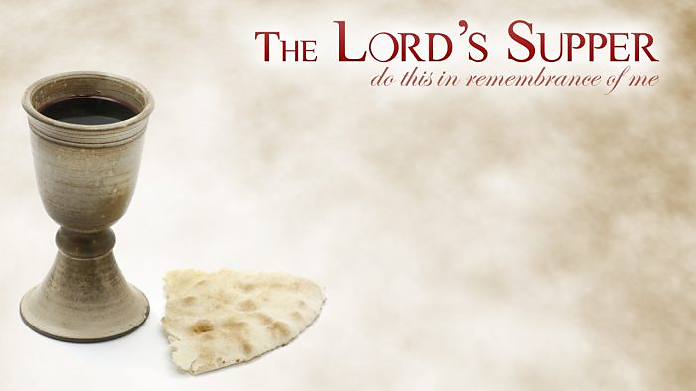

Sermon Title

Esther (scripture)

Pastor Michael Estes

January 12, 2020



7469 Old Canton Road • Madison, MS • 601.853.1090 • ridgecrest.net

Michael Estes, Senior Pastor   
Matt Cloyd, Executive & Discipleship Pastor

Brian Wright, Pastoral Care & Connections Pastor

Greg O’Neal, Worship & Sr. Adults Pastor • Tim Blocker, Stewardship Director

Logan Ellzey, Student Pastor • Stacie Albritton, Preschool & Children Ministry Director

Stephen Collier, Media Coordinator

Hillery Johnson, Ridgecrest Preschool Director

Babbe May, Weekday School Age Ministry Director

**WELCOME GUESTS!** We’d like to get to know you and let you know about Ridgecrest opportunities. Please fill out the Connect Card (s) in the pew rack and return it to the Information Center as you leave today. We’re glad you are worshipping with us this morning!

**Student Choir** begins this evening at 5:00pm in the Choir Room. Students please come join us!

**PRECEPT** classes meet on Monday evenings at 5:30pm. **Carolyn Hogan/Room 102** - *“Prepare to Meet Your God”* a study of Amos **Carolyn Craft/Room 105** - continuing Romans; February begin *“The Essentials of Effective Prayer”*

**Fawn Smith/Room 106 -** continuing *“John, Part 3”*

**Next Steps U** It’s not too late to be a part of the great opportunities for Growth we offer on Wednesdays as a part of Next Steps U. We meet Wednesdays, at 6:00pm with many ways to Know God through relational discipleship.  This 8-week session for adults includes a Women’s Ministry study, Men’s Adventure, Sew Missions, Sign Language classes, English as a Second Language, and ServePrep: How to Find Your Best Fit in Service.  We’ll also offer activities for all age groups. We have complete lists at the Information Center and the hallway kiosk. If you have questions, please contact Brian Wright at [bwright@ridgecrest.net](mailto:bwright@ridgecrest.net)

**Keenagers** will meet Tuesday, January 14th at 11:00am in the RAC. If you are 60+ please plan to join us for a great time of good food and fellowship.



**2019 Contribution Statements** are ready to be picked up by the Information Center beginning today.  If they are not picked up by Sunday, January 19th, they will be mailed.

**Tuesday Morning Bible Study-** Ellen Wallace will lead a study of Francis Chan’s study of The Gospel of Mark. She will begin on January 21st at 9:00am in Room 105.

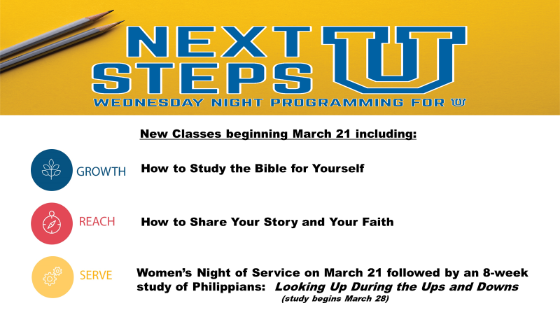 Ridgecrest has been a church that has placed an emphasis on missions as we desire to Know God, Serve Others, and Reach Our World. We want to engage our local, national, and international circles with the Gospel. To do this, we have intentionally drawn circles around local, national, and international regions in which we fully partner financially, through prayer, and send teams to serve. Below are listed several local ministry opportunities for you to be involved.

**Special Olympics** – We have an opportunity to partner with Special Olympics who will be having weekly basketball practices in our gym. Practice is on Thursday evenings from 6:15-8:15pm. If you are interested in volunteering to help, please contact Brian at [bwright@ridgecrest.net](mailto:bwright@ridgecrest.net)

**Baptist ICU –** We provide lunches each Monday to families who are waiting their turn to visit their loved ones in the Intensive Care Unit at Baptist Hospital. Volunteers provide sandwiches, chips, desserts and fruit on a rotating schedule. The schedule usually requires a volunteer to donate one item once a quarter. People are very appreciative of this ministry outreach. To volunteer, contact Charlane Wall at [charlane.wall@gmail.com](mailto:charlane.wall@gmail.com)

**Jackson Street Ministry-**The Jackson Street Ministry team is a group of individuals who are dedicated to sharing the grace of God to the disenfranchised and homeless of Jackson, MS. Our aim is to boldly follow Jesus where He leads and humbly engage people of the street in His love and grace. We meet at the First Baptist Church Parking lot on the corner of Mississippi and North Streets in downtown Jackson, every Wednesday night, and leave to minister by 6:30pm. For more information contact Brian Wright at [bwright@ridgecrest.net](mailto:bwright@ridgecrest.net).

**Prison Ministry-**Many of the women inmates at the Madison County Jail have come to know Christ through this ministry. They look forward to the music during their worship time and the Bible studies that change their hearts. It ministers to them and they begin their new life in Christ which leads to new opportunities when they are released. To be part of this ministry, please contact Ronda Webb at [ronda.webb@yahoo.com](mailto:ronda.webb@yahoo.com) to get started. You can go as partners or as a group.