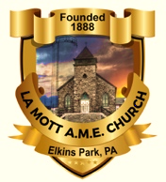
This Means War
1/7/2020
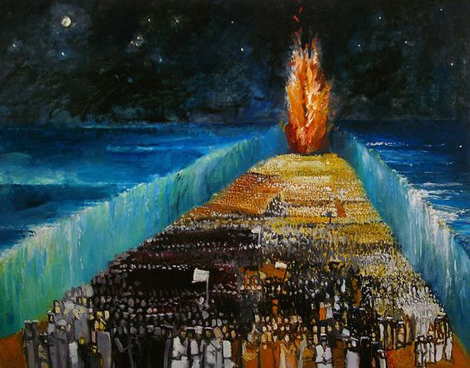
All are Welcome to Bible Study
Assembles at 7:15 p.m.
Blessed by 7:35 p.m.
Homework Read Exodus 2:19-25 Why did God look at the suffering Israelites?
LaMott A.M.E. Church
1505 W. Cheltenham Ave. Elkins Park, PA 19027
By: Rev. Dr. Louis P. Attles, Pastor

Instruction: Read the text in your bible. Answer the question, there is no wrong answer. The questions are designed to help you see what God is doing in your life. Think about what God is saying to you?
The Blood Covering
Blood over the door kept the death angel from coming in and killing the most valuable in the family. The firstborn son was tasked with caring for the family and maintaining the parent’s inheritance to honor the family name. The firstborn son was given a double inheritance and was the one who would inherit his father’s role as head of the family. So, the blood covering was to stop the God’s angel of death from killing what was most valuable to a family. The people are enslaved, and God is in the process of having their captives change their minds and let them go. God is going to free you.

1. God was telling Moses how to .
The LORD said to Moses and Aaron in Egypt, ² "This month is to be for you the first month, the first month of your year. Exodus 12:1-2 (NIV)

2. God uses the sacrifice to identify .
Tell the whole community of Israel that on the tenth day of this month each man is to take a lamb for his family, one for each household. Exodus 12:3 (NIV)
3. God has requirements for the sacrifice, .
The animals you choose must be year-old males without defect, and you may take them from the sheep or the goats.
⁶ Take care of them until the fourteenth day of the month, when all the people of the community of Israel must slaughter them at twilight. Exodus 12:5-6 (NIV)
A) Can you sacrifice something you don’t value or love?

B) What happens to you when you make a sacrifice?

4. The covering of the door was a .
Then they are to take some of the blood and put it on the sides and tops of the doorframes of the houses where they eat the lambs. Exodus 12:7 (NIV)

5. God is putting you in position to be .
That same night they are to eat the meat roasted over the fire, along with bitter herbs, and bread made without yeast. Exodus 12:8 (NIV)
6. You need to eat with the expecting .
This is how you are to eat it: with your cloak tucked into your belt, your sandals on your feet and your staff in your hand. Eat it in haste; it is the LORD's Passover. Exodus 12:11 (NIV)

A) Are you ready to move before you know where you are going?

B) Can you see how God prepared you for the move?

7. God was collecting an offering for .
"On that same night I will pass through Egypt and strike down every firstborn--both men and animals--and I will bring judgment on all the gods of Egypt. I am the LORD. Exodus 12:12 (NIV)
8. The blood was protection from what .
The blood will be a sign for you on the houses where you are; and when I see the blood, I will pass over you. No destructive plague will touch you when I strike Egypt. Exodus 12:13 (NIV)

9. This problem is for your .
"This is a day you are to commemorate; for the generations to come you shall celebrate it as a festival to the LORD--a lasting ordinance. Exodus 12:14 (NIV)
10. God told them to remember how .
"Celebrate the Feast of Unleavened Bread, because it was on this very day that I brought your divisions out of Egypt. Celebrate this day as a lasting ordinance for the generations to come. Exodus 12:17 (NIV)

Your Confession is:
I am faithful
³⁸ Now the just shall live by faith; But if anyone draws back, My soul has no pleasure in him." Hebrews 10:38 (NKJV)
I am Loving
²² But the fruit of the Spirit is love, joy, peace, longsuffering, kindness, goodness, faithfulness, ²³ gentleness, self-control. Against such there is no law. Galatians 5:22-23 (NKJV)
I am a Giver
³⁸ "Give, and it will be given to you: good measure, pressed down, shaken together, and running over will be put into your bosom. For with the same measure that you use, it will be measured back to you." Luke 6:38 (NKJV)
I am a Believer
²³ Jesus said to him, "If you can believe, all things are possible to him who believes." Mark 9:23 (NKJV)
I am prosperous
² Beloved, I pray that you may prosper in all things and be in health, just as your soul prospers. 3 John 1:2 (NKJV)
You can Text Your Questions to (973) 449-1104

Answer Key
1. God was telling Moses how to free his people .
2. God uses the sacrifice to identify His children .
3. God has requirements for the sacrifice, you must care for it .
4. The covering of the door was a sign of protection .
5. God is putting you in position to be full .
6. You need to eat with the expecting to move .
7. God was collecting an offering for their sin .
8. The blood was protection from what was planned .
9. This problem is for your good .
10. God told them to remember how they got free .

Instruction: Read the text in your bible. Answer the question, there is no wrong answer. The questions are designed to help you see what God is doing in your life. Think about what God is saying to you?

