**Milestone 3**

**Books**

**Apps**

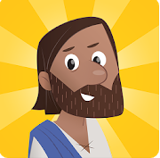

“Prepare for an epic adventure as you explore the amazing stories of the Bible. Choose your Guardian hero, then train and learn the ways of the Guardians before setting off into the world of Ancora. Explore the ancient world of the Bible, meet Jesus and return light to the city of Ancora.”

**Guardians of Ancora**

“Through interactive adventures and beautiful animations, kids explore the big stories of the Bible. The Bible App for Kids is a delight-filled experience designed to encourage kids to return again and again. It’s the beginning of a lifelong love of God’s Word.”

**The Bible App for Kids**

“This FREE Kids Bible App brings the Bible to life for the entire family with an easy to understand Bible, videos and fun engaging Bible games. Featuring 39 full-length, free episodes from the exciting Superbook animation series that includes David and Goliath, Daniel in the Lions’ Den, the Miracles of Jesus, The First Christmas, He Is Risen and more!.”

**Superbook Kids Bible**



“You've read the story! Now tap, tilt and swipe through it with David in this interactive story combined with mini-games! Dozens of immersive story chapters including over 100 achievements and 7 mini-games along the way. Spend hours unlocking and mastering all the challenges!”

**David vs Goliath**

“Instantly stream or download thousands of hand-picked episodes that reflect your faith and values.”

**Minno Kids**

“Take a ride on Noah’s pet elephant as he stampedes his way around the ark! See how long you can run without being caught by Noah’s sons in this fun and exciting Bible memory game!”

**Noah’s Elephant in the Room**

**Movies/Videos**

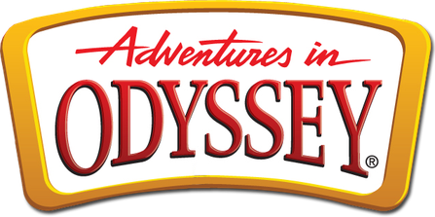

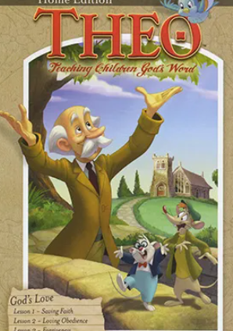

**The** **Torchlighters** “[are the] heroes of the Faith and see how God works through those who dedicate their lives to serving him.”

**Theo** “[is] a student of Godʼs Word. Our animated series guides children and adults through a careful study of systematic theology, capturing the attention of young minds with humor and engaging animation.”

**Adventures in Odyssey** “brings biblical principles to life through a balance of fun, faith, and imagination.”

**Movie Rule #1: Select**

Use trusted sources to selectively control what your kids are exposed to. Visit Christian video services Minno

**Movie Rule #2: Review**

Be sure to review movies before you let your kids watch them! See the reviews by Focus on the Family: pluggedin.com

**Movie Rule #3: Filter**

If the movie you and your family want to watch has questionable content, you have the option to filter out that content by using Vid Angel