Milestone 2
Books

Apps
“Join Noah, his sons, and a bunch of ark animals as you learn 25 Bible verses from the Old and New Testament! Each verse runs through 5 stages of increasing difficulty allowing the player to process and store each verse into long term memory.”
Noah’s Bible Memory
Minno Kids
God for Kids
“Who is God and What is God Like? Step-by-step explore God’s character with interactive puzzles, games and thought-provoking questions based around one Bible verse, one characteristic at a time. Ideal for kids and their grown-ups to explore spiritual questions about God together and safe for your child to play alone (no ads here!)”
“Instantly stream or download thousands of hand-picked episodes that reflect your faith and values.”
Kingdom Keys
“Complete Bible lessons to earn gems. Slowly reveal a hidden picture as the Bible passage is read. Play a catapult game to learn Bible geography. Answer questions about the meaning and application of the Bible to earn gems.”
“Explore a safe world of high quality worship music, fun games, makes, stories, prayers, Bible quotes and studies to help you and your child discover God together.”
Little Worship Company

Movies/Videos
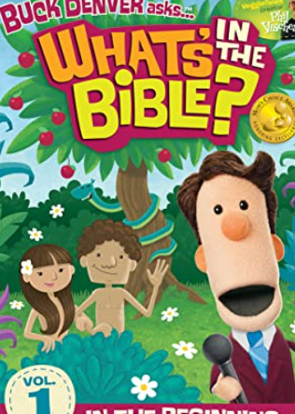
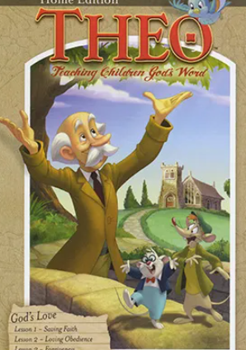
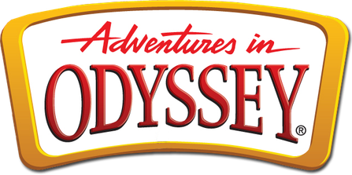
Buck Denver “and his friends take your children through the WHOLE Bible. Perfect viewing for the entire family to laugh and learn together.”
Theo “[is] a student of Godʼs Word. Our animated series guides children and adults through a careful study of systematic theology, capturing the attention of young minds with humor and engaging animation.”
Adventures in Odyssey “brings biblical principles to life through a balance of fun, faith, and imagination.”

Movie Rule #1: Select
Use trusted sources to selectively control what your kids are exposed to. Visit Christian video services Minno

Movie Rule #2: Review
Be sure to review movies before you let your kids watch them! See the reviews by Focus on the Family: pluggedin.com

Movie Rule #3: Filter
If the movie you and your family want to watch has questionable content, you have the option to filter out that content by using Vid Angel

