Milestone 1
Books

Apps
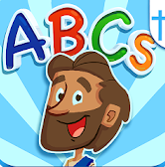
“Bible ABCs for Kids! let's your child learn their ABCs while discovering the Bible! Let your child enjoy tracing uppercase and lowercase letters while animated friends cheer them on! Reveal beautifully illustrated characters from the Bible!”
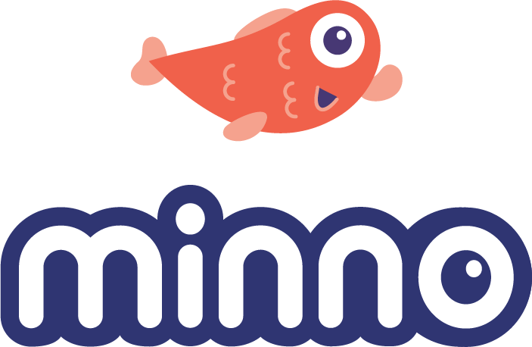
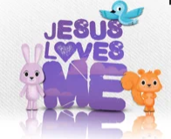
“Instantly stream or download thousands of hand-picked episodes that reflect your faith and values.”
“Watch the original animated music video for the song Jesus Loves Me. Sing Along & record karaoke style to different remixes of the song "Jesus Loves Me" and share with your family and friends. Watch 6 animated shorts featuring Jack & Scarlett. They are teaching simple Bible verses pertaining to God's love in a fun, kid friendly format. Play a fun card matching game featuring the characters from the video.”
Minno Kids
Jesus Loves Me
The Bible ABCs for Kids!

Movies/Videos
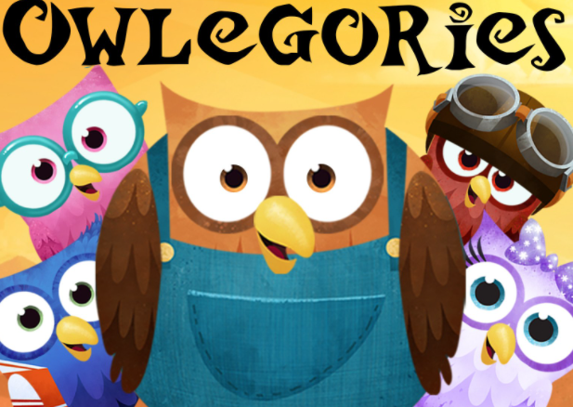
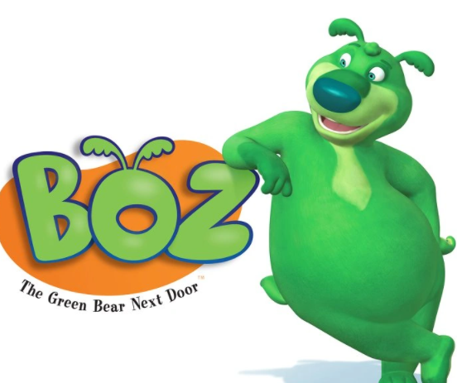
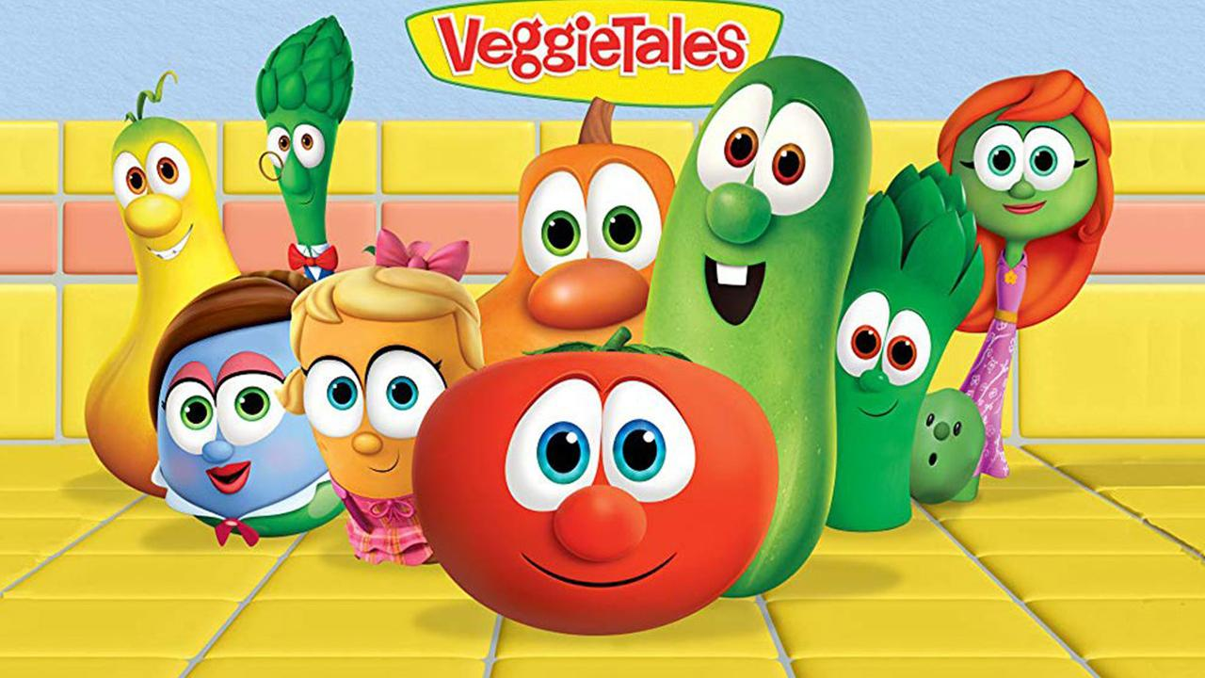
Veggie Tales
Owlegories “teaches kids about God through the amazing things found in nature and revealed in God’s word.”
Boz the Bear “combines the important everyday elements of faith, family, fun and learning! BOZ the Bear helps reinforce the everyday values you’re already teaching your child.”

Movie Rule #1: Select
Use trusted sources to selectively control what your kids are exposed to. Visit Christian video services Minno

Movie Rule #2: Review
Be sure to review movies before you let your kids watch them! See the reviews by Focus on the Family: pluggedin.com

Movie Rule #3: Filter
If the movie you and your family want to watch has questionable content, you have the option to filter out that content by using Vid Angel

