.MAY 2022, VOL. 29
AMAZING
GRACE
CONNECTIONS
Faith > Family > Community
Grace Lutheran of Lily Lake
5N600 Hanson Rd, St. Charles, IL 60175
Pastor David Mercurio

Worship every Sunday at 9 am
With Communion
Sunday, May 1st Worship
Sunday School for 3–10 year olds
Coffee Hour in celebration of Margaret Swanson’s 90th birthday
Sunday, May 8th - Mother’s Day, Worship
Sunday, May 15th Worship
Sunday School for 3-10 year olds
Sunday, May 22nd – Worship andPancake Breakfast presented by the Boy Scouts (8-11am)
Sunday, May 29, Memorial Weekend, Worship
Sunday, June 5, PENTECOST SUNDAY WORSHIP
Wear red to remind us of the fire of the Holy Spirit
(The nursery is available on Sundays when there is no School Sunday for use by any parent)

COVID-19 Safety Protocols
Updated March 27, 2022:
We will follow the recommendations of the CDC and the IL Department of Health. Currently, Kane County is considered a location of “low transmission” and therefore, face masks are recommended, but optional. We continue to encourage everyone who is eligible to be vaccinated and boosted. This is the single, most effective way for us to protect ourselves and each other during this pandemic.
If you don’t feel comfortable gathering indoors with others at this time, we understand, and invite you to join us virtually for worship via our website.
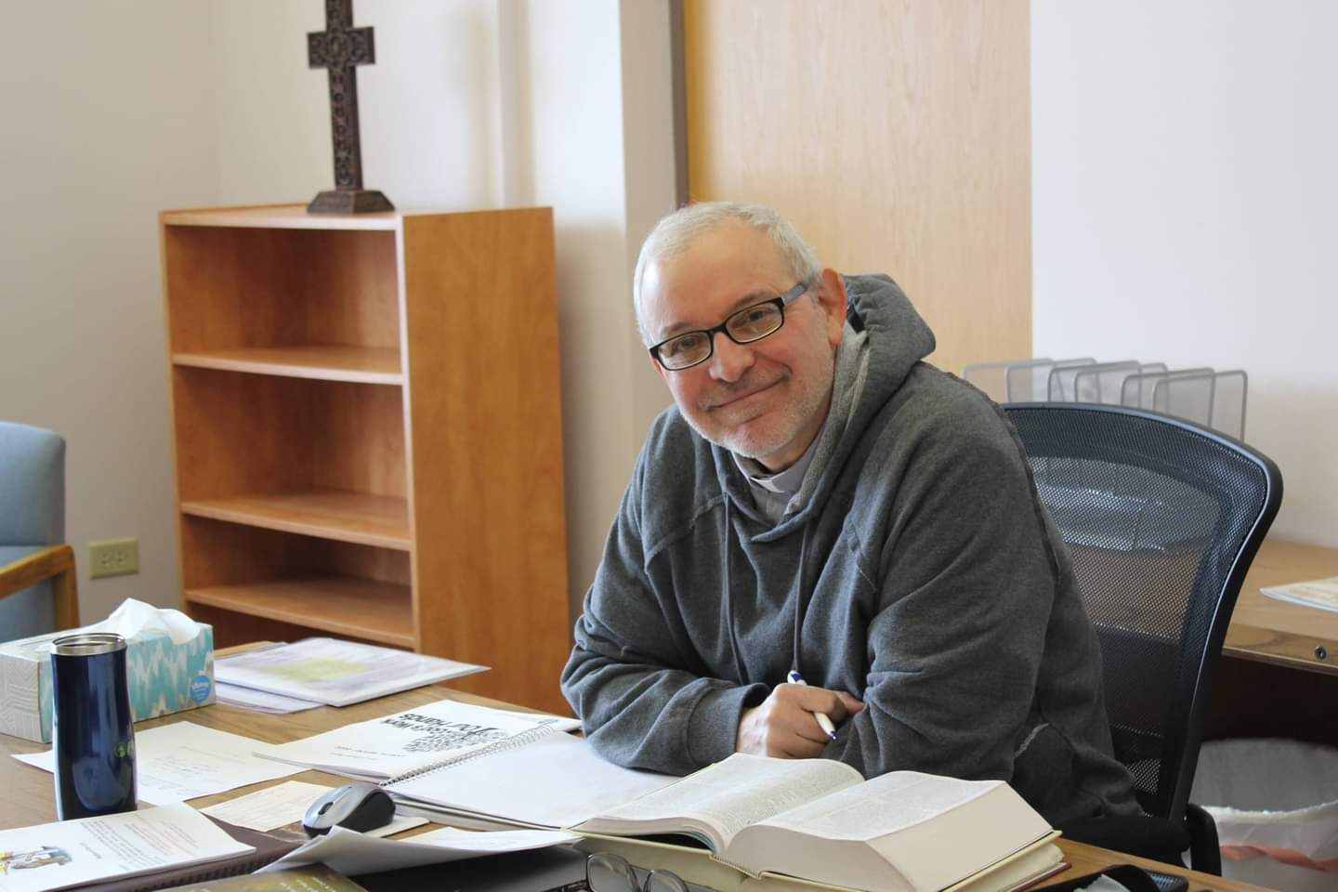
PASTORS MESSAGE
Grace Newsletter May 2022
He is risen, he is risen, He is risen indeed!
It has been a glorious Easter celebration here at Grace Lutheran Church. The culmination of our Lenten season was Holy Week and what a week it was! On Thursday April 14th (Maundy Thursday) we celebrated a Passover “seder” dinner with 30 members and guests in attendance. On Good Friday we joined with Country Covenant Church to commemorate the crucifixion of our Lord. Our Easter Sunday service was a double blessing with a baptism that day (our second in April!). Our children’s ministry is alive and well and growing. Things are happening once again at Grace and it’s a great time to come out to worship.
Blessings to you,
Pastor David Pastor’s Hours at church
Tuesdays and Thursdays from 6 pm – 9 pm
Saturdays from 9 – noon
Sundays from 8:30 am for 3-4 hours

BAPTISMS
Blessings and prayers to the following children on their baptisms and to their parents and godparents
April 10th – Easton Jeffrey Larson; parents - Jeffrey and Joanna Larson; godparents – Edward and Elizabeth Haring
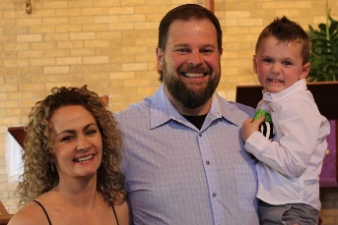
April 17th – Lennon Olivia Strom; parents – Lucas and Melissa Strom; godparents – Jason and Jessica Shanahan
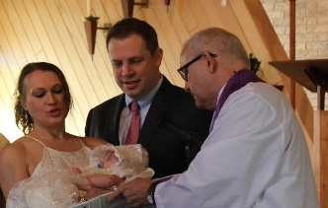
We welcome these children into God’s family and our family.

VISION TEAM REPORT
- NEEDED: two members to attend the Synod Assembly on Saturday, June 4th at the Naperville Marriot. Grace has two votes. Please contact Marty Bradley if you can attend.
- We are still in the process of reviewing applications and doing interviews for the Office Administrator position. If you know of anyone interested, please contact Marty.
- Our church ad is currently running in the Elburn Herald and our new church brochure is completed.
- We are currently working on plans to revamp the bell tower.
- NEEDED: one or two people to be trained on our worship computer system. Please contact George Theros if you are interested.
Don’t forget to join us for the Pancake Breakfast on
Sunday, May 22nd from 8-11 am. This is a special thanks to Grace from our Boy Scouts.
Financial Matters – May 2022
"Thank You" to all Thrivent members, and friends of Grace, who designated their Thrivent Choice Dollars to Grace – we have received $978 from Thrivent so far in 2022.
We are not sending out 1st quarter giving statement, 2nd quarter statement will be sent. With your having prepared your own taxes recently, we are hopeful you have reviewed your tithes and giving to Grace for the first part of 2022.
Outside of our usual monthly office and utility expenses, the large maintenance expense we incurred in March was the heating system addition (for the sanctuary) : $11,650 (**previously approved to be taken out of savings account)
Noisy Offering being collected in April & May will go toward the expenses in getting the lightbulbs needed in our sanctuary and parking lots.

We are thankful to our member who made a donation to cover the cost of our ‘church ad’ in the local newspaper, for an entire year; also 2 individuals donated $300 to cover the cost of tuning the 3 pianos we have within the church. With these gracious donation efforts, we are able to have greater exposure in the local newspaper (and their on-line newspaper). Also, our ears will hear a tuned melodious sound when the pianos are played. Our heartfelt thanks to these donors – who wish to remain anonymous.
March 2022 Year to date Year to date
2022 2021
INCOME $13,201.95 $41,066.69 $44,256.40
EXPENSE $14,996.04 $47,765.36 $47,682.20
NET -$1,794.09 -$6,698.67 $-3,426.80
MANY THANKS AND PRAYERS TO THOSE WHO HAVE RECENTLY DONATED THEIR TIME AND TALENTS, including, but not limited to:

- To all who assisted with the Maundy Thursday service and Seder meal: set-up, reading, food and clean-up– bless you: Pastor, Helen Gruber, Trish Painter, George and Gloria Theros, Cara Turner, Twyla Strom and Lee Strom, Kurt Redemann, Margaret Swanson, Kay Kinsel, Jan Docherty, Vicki Linden, Cara Turner, Kathy Hooey, Dotty and Paul Mantsch, Marty Bradley; Nancy Corbige; Ian Engberg for cleaning the fellowship hall floor, and of course the choir.
- To those who assisted with the community Good Friday Service.
- To those who opened the church for several days for the new furnace to be installed, Nick, Kurt and George.
- To Cathy Whiteside for preparing the church ad for the newspaper.
- To Ethan and Evan Deutschmann for assisting with the Palm Sunday and Easter Sunday worship services. To Kathy Hooey and gang for Easter flowers and set up.
- To those who have recently provided children’s sermons: Kathy Hooey and Shirley Turner and the Ballard Family
- To all of those who are not mentioned here but help us in so many ways to fulfill our mission to be servants of Christ.
If you wish to volunteer, please
contact Pastor or any Vision Team member.

SUNDAY SCHOOL

Sunday School for three – ten year olds will be held
during worship on the following Sundays in the nursery;
May 1 and May 15
No Sunday School during June, July and August

You are free to use the nursery if needed on other Sundays.
The service is available on the TV in the room.
CONGRATULATIONS
Congratulations to Casey Engberg on obtaining the rank of Eagle Scout. Only about 8% of all youth entering Scouting will attain this rank. Casey was celebrated at his Eagle Court of Honor Saturday, April 30 when he received his Emblem, Certificate and other items of recognition. We at Grace are very proud of Casey’s achieve-ment and also wish to congratulate Sam Duesler who also celebrated reaching the rank of Eagle Scout on Saturday.
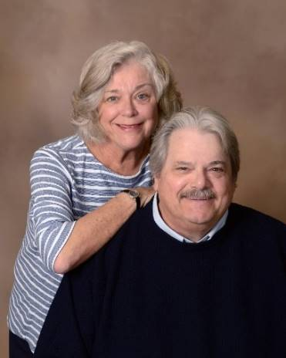
Hello from Ed & Andra Nordwind
Hi, my name is Andra Nordwind. I guess my family's story began when I went to work in a doctor's office back in the late 1970s. There was this fairly cute guy with a mop of curly hair who was one of our patients as were the rest of his family. But unlike other patients, not only did he show up for his own appointments he came with his dad, mom and even his grandmother for their appointments. We talked and flirted a little and I guess we became friends. At Christmas time he brought a plant to the office for me. But when I asked if it was from him, he said no it's from his mom. I was a little disappointed but that's when he pulled out a sprig of mistletoe and said that was from him. Well, he embarrassed the heck out of me in front of my coworkers (who were all trying to encourage me) but I was so embarrassed that his little ploy just didn't work. I must admit though, I thought the gesture was kind of cute, so I didn't hold it against him. Well, he kept finding excuses to come to the office with his family until he FINALLY asked me out on a date. When I got in the car, he pulled out a dried-out sprig of mistletoe. What can I say, it still had its magic and I guess the rest is history. We were married the following May.
In the next three years, we welcomed two beautiful daughters, Rebecca and Brigitta and bought a home in Campton Hills, where we still live. I was able to stay home with the girls until our older daughter started school. I started back to Central DuPage Hospital part-time (where I worked prior to the doctor’s office) and it seemed as though I never left. While working at the hospital I was offered a part-time job at DuPage County Health Department. I worked part-time at both jobs until 2003 when I left the hospital. I still continue to work at the Health Department in the water lab.
Being a first-generation Latvian I wanted to continue attending the Latvian Lutheran Church. During Sunday School our girls received education in reading and writing Latvian. The girls and I spoke Latvian all day until Ed came home. We then switched to English. As a result, both girls are fluent which is something I'm very proud of. It paid off for them too. As a high school graduation present from my parents, each one was taken to Latvia. I will always be grateful to my parents for taking the girls.
Brigitta found her niche in the financial industry and has done very well for herself. Her talents, abilities and hard work continue to be recognized as she is given more responsibility. Becky started working as a phlebotomist at Central DuPage Hospital as a teenager and later at Mercy Hospital where she was a supervisor. But, after working through the pandemic, she made the switch to the private sector. I am very proud of what the girls have been able to achieve, especially being single moms. Each has a son that also lives with us. Neither Ed nor I would trade that for the world.
Both boys are great students. Brigitta’s son Andrew, is a rather good baseball player and plays for Central High School. Nikko, Becky's son, is on Central’s football and track team. We couldn't be prouder. They sure keep things lively; and keep us quite busy. Ed was caught up in the banking crisis and his employer closed. So, he was able to care for his terminally ill Mom until she passed. He was also ‘Grandpa Day Care’ for our two preschool grandsons until they were both in school full-time. I must admit his cooking skills improved also. With both boys in school full-time, he took a job at the Judicial Center as a bailiff. He loved it there - he got to spend time with other grumpy old men! Unfortunately, he needed surgery on his neck and back and never really recovered.
With the girls grown, we joined Grace where Ed was a member when we met. Our daughters also joined and both grandsons were baptized here. There are just no words to express how much we have enjoyed working with other members of the congregation at different events. Whether it was helping organize Oktoberfest, serving food at the spaghetti supper or the chili cook-off & bingo night they are all great memories.
The past three years have been increasing difficult for my parents’ health. I have needed to travel often to be with them. This last trip has been the most difficult with my father passing in January. I’m still with my 92-year-old mother helping her sort out personal matters.
Thank you for the love and friendship you have showed my family and me. I will always be grateful.

SPRING RUMMAGE SALE " will be held on May 13 + 14. Volunteer sign-up sheets are posted on the bulletin boards in church. We can use all helping hands on deck for set up on Thurs, May 12 and clean-up after the sale. We will be spacing items in Fellowship Hall, using outside tables, items in garage and clothing under the pavilion. Would you have a canopy-type tent or tarps to lend to help cover outdoor items? Many helping hands are needed throughout the areas during set-up and especially at sale time. We will be accepting small boxes/bags of donations after May 1, larger items to be dropped off on Sun, May 8th, Wed, May 11th or Thurs, May 12 - please contact Tricia Painter with questions or how you can help - cell# 708-624-0400 text, or please leave a message.

**Volunteers: Water bottles will be available. On Thurs. 12th – please bring your own lunch. Fri & Sat-lunch will be served: sloppy joes, salad, snack bags.

**Gentle reminder, please no older TVs - "we" have to pay to have these go to the recycling center(!). Also, no TV cabinets (neither Salvation Army nor Goodwill take these). Items that are cleaned, vacuumed and in working order only please. Ask yourself: "Would I buy this?" if your answer is no, we would sincerely appreciate you passing it on yourselves - and not bringing it to church. Thank you for all of your consideration of donations.

Adventure! MISSION TRIP To El Salvador Central America August 1- 7, 2022
YOU CAN MAKE THE DIFFERENCE

El Salvador Trip 2022 – You are invited to come to El Salvador for an annual mission experience, August 1-7th, 2022! Pastors Kristian and Anna-Kari Johnson of Pilgrim Lutheran Church and School, Chicago, have been leading delegations to accompany the Lutheran Church of El Salvador for nearly 25 years. We walk alongside the Salvadorans as they support children to go to school, install solar panels, help build churches, conduct medical campaigns, and participate in a peace march for human rights. This year’s trip brochure can be found here: https://tinyurl.com/elsalv22bro For more information, contact pastorkristian@pilgrimchicago.org
GRACE LUTHERAN CHURCH
HELP WANTED!
Part-time job for an Office Administrator
Immediate Opening

The right person is looking for 12-15 hours per week, is a master multi-tasker with excellent communications skills, has an upbeat and welcoming attitude and works well as a team player and is able to work with volunteers. Applicant must also have excellent Microsoft Office skills and computer experience (Word is a must, Outlook, Powerpoint, Publisher, Excel and Church Windows a plus).

Grace Lutheran Church is an ELCA congregation which focuses on Faith, Family and Community. The church is active in the community and welcomes everyone. If you are interested in this position, please submit a cover letter and your resume including Objectives, Education, Previous Employment with dates, Skills and related references if available by May 15th to general@graceoflilylake.com. For questions, contact Grace Lutheran Church at 630-365-6751 or check out our website and Facebook pages to get more information about us. Thank you for your interest.
Please spread the word.
Military Gift Boxes: The Rebecca Circle is planning again this year to remember both our military and our college family. We are planning to send gift boxes to the military this spring and boxes to our college students in the fall. For the military mailing, we are asking your help in verifying/updating the military addresses. There are forms available on the bulletin board in the social entry at church. You may leave the completed form in the church office. Small items, appropriate for mailing, are being accepted for the gift boxes. Examples: gum, candy, notebooks, pens, etc.
Thank you for your help and participation.

These people would enjoy a card or greeting from you!!
Pastor David and Carol Langseth Jeannine Luchs
14185 Ginger Way West Bridge at Wyndemere
Huntley, IL 60142 500 Wyndemere Circle, Apt. 261
Wheaton, IL 60187
Mike Myers
Lincolnshire Place
710 Vellagio
Sycamore, IL 60178

Grace Roadrunners…
This Photo by Unknown Author is licensed under CC BY-SA
will be taking their motorcoach trip to Wisconsin and Minnesota September 19-24th. Some of the scheduled stops will be at the International Crane Federation and Circus World Museum in Baraboo and a cranberry marsh and the Discovery Cranberry Center in Warrens, WI. We’ll tour the Capitol Building and the Cathedral of St. Paul in St. Paul. In Minneapolis we’ll go to the American Swedish Institute and Mill City Museum. A dinner theater event and lake dinner cruise are also on the itinerary. More events are scheduled. Yes, we continue to eat well on these trips! The cost will be about $900 per person for double occupancy which includes most of your meals, motel and entrance fees to events. Registration forms will be in the Roadrunner mailbox slot soon.
Questions-see Suzanne Girsch.

CONTACTS:
For emergencies please contact Marty Bradley, President, at 640-777-1074 or to leave a message call the church office at 630-365-6751.

For prayer requests or other needs please call Kathy Hooey at 630-341-2293 or to leave a message call the church office at 630-365-6751. Messages are checked daily at noon and 5 pm.
LUTHERDALE CAMP INFORMATION
An ELCA Camp
For kids who have completed 3rd – 11th grades in 2022
At Lutherdale, your child will have fun and develop life skills, confidence, trust, faith and independence all while experiencing life unplugged in the outdoors.
Visit their website, www.lutherdale.org, for pricing, registration information and frequently asked questions. Registration is online. To be registered, not just enrolled, a $100 non-refundable deposit is required. Full payment is due 7 days prior to the start of the session.
For assistance, call, 262-742-2352 or email info@lutherdal.org. Camp is located at N7891 US Highway 12, Elkhorn, WI approximately 75 miles from Grace.
IT’S NOT TOO EARLY TO REGISTER!
CAMPS FILL UP FAST
St Peter’s has graciously invited any of our
children to join them for Bible School !
VACATION BIBLE SCHOOL 2022
St. Peter’s Lutheran Church
43W301 Plank Road
Hampshire, IL 60140
Bible Stories and new friends * Amazing experiments * Creative Crafts * Snacks
Missions * Games and More!
Welcoming children ages 4 through Grade 6
Children 7th grade and up will be youth helpers

M-Th June 20-23 9 am to 11:45 am; Friday June 24 9 to 10 am
Church office: 847-464-5721 (Hours 9 am to 1 pm)
Church website: www.stpetersnorthplato.org
Registration: Please register online beginning on 4/15/22*
Registration Fee: $10.00 per child payable the first day of VBS
* We are hoping to have all of our registrations done online this year. However, if you do need a paper registration form, please contact the church office (info above) and we will get one to you. If possible, please get your registrations in by June 10th. Thank You!

Collect pop top tabs to donate for the Ronald McDonald House. The money earned provides a home away from home for families with children receiving treatment at hospitals and medical facilities. To see what is available in the Chicagoland area look at
https://rmhccni.org/our-houses-family-rooms A pop top tab collection bottle is available in the Gathering Space at Grace. Thank you to all who faithfully save their pop top tabs for our collection bottle.

Thank you to Carol and David Langseth for initiating a collection of items to be made into Lutheran World Relief Quilts and Layettes. The ladies of Lord of Life Lutheran Church in Schaumburg have a very active group of quilters and they were very happy for the large donation of sheets and children’s clothes brought to them on April 7, 2022 via Carol & David Langseth with the help of Cathy Whiteside.

Please collect these items & leave them in the Church Office in box marked “For Carol Langseth”. The items will be given to the Lord of Life Lutheran Church in Schaumburg, IL . to be made into Lutheran World Relief Quilts or Layettes for the needy. Some children’s clothes will be sent to the El Salvador mission. Needed Items:
*Children’s Clothing through 2 years. *Material *Blankets (including for babies) *Sheets *Bed Pads
Thank you in advance for your donations!!!

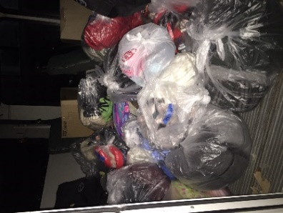
New Life Covenant Church in Elgin has a very active outreach to the homeless people of Elgin called the “Bridge to Life”. Grace Lutheran Church has collected “in season clothing” and blankets for their Jesus Closet. Every Sunday they share the Word of God, clothing, and lunch with about 30 homeless people. They use their small bus in making the rounds to the homeless. Geraldine Minton is the dedicated leader of the Jesus Closet. She sends her gratitude and thanks to the people of Grace Lutheran Church for their donations to the Jesus Closet. Cathy Whiteside had the pleasure of transporting our many donations to Geraldine on April 3, 2022. Thank you to everyone at Grace who made this possible.
SUGGESTED ITEMS TO DONATE: *Used items if in good shape, are welcome*
Jeans (waist 30 on up), shorts, underwear (new), t-shirts, socks, shoes, baseball type caps, deodorant, body shampoo, soap, light jackets, light blankets
ELCA MISSION WEBSITES

LUTHERAN DISASTER RESPONSE:
https://www.elca.org/our-work/relief-and-development/lutheran-disaster-response
ELCA WORLD HUNGER APPEAL:
https://www.elca.org/Our-Work/Relief-and-Development/ELCA-World-Hunger
LUTHERAN WORLD RELIEF:
https://lwr.org/
REFUGEE ONE:
https://www.refugeeone.org/
Information for the June newsletter will be due by
May 20th – please send it to Cathy Whiteside

