WELCOME TO
GRACE LUTHERAN CHURCH
OF LILY LAKE, IL
5N600 Hanson Road, St. Charles, IL 60175
OFFICE: 630-365-6751 * E-mail: general@graceoflilylake.com
Web Address: www.graceoflilylake.com
Sunday, October 18, 2020 * 9 AM * IN-PERSON

Twentieth Sunday after Pentecost

INTRODUCTION – LOVING – God loves us fully, completely, prodigally, do our lives bear the fruit that shows God’s love?

THANK YOU FOR JOINING US FOR SUNDAY MORNING FROM HOME.OR IN PERSON
Print out your bulletin or use it on your phone or tablet to follow along.
Please see our website for details. Announcements are televised or found on our website

OR Please prayerfully meditate on the service, even go through it with family, in person, or others online or on the phone! Be creative how you worship and remember God during this time. It will calm your soul, give you peace and enliven your spirit.

Our community gathers in unity with others in-person and a virtual way.
We hope all people find it easy to follow along.

GOD GATHERS US

WELCOME & ANNOUNCEMENTS
Announcements are televised or found on our website

PRELUDE All Hail the Power

We invite you to read/respond to the texts, pray the prayers quietly or silently. Please, NO Singing for safety

CALL TO WORSHIP – from Faithful, Hopeful, Loving Ecumenical Stewardship Center 2020
P You are welcome in this place where God meets us in love.
ALL Let us worship the God of love and life, and hear again God’s great love story for us.
P God’s love is steadfast and true. God so loves the world.
ALL See what love the Father has given, that we should be called his children.
P We are here to love God with all that we have and all that we are.
ALL Beloved, let us love one another, because love is from God.
P God’s love is revealed to us in the sending of his Son.
ALL If we love one another, God lives in us and his love is perfected in us.
P You shall love the Lord your God with all your heart, and with all your soul, and with all your mind. And
your neighbor as yourself.
ALL Let our love be genuine and manifest in truth and action.
P Love never ends. Or gives up
ALL Love doesn’t want what it doesn’t have.
P Love looks for the best and trusts God always,
ALL Love does no wrong to a neighbor; therefore, love is the fulfilling of the law.
P So come, with your tiredness, your frustrations and your discouragements; come with your doubts, your fears, and your longings; come, to discover yet again God’s rich mercy and great love for the world. May the truth of this great love story, shine through our worship today, and renew our sense of calling and community.
ALL We worship you O God of love and life, renew us with the power of your great love. Amen

OPENING SONG See next page

GREETING & PRAYER OF THE DAY
P The Grace of our Lord Jesus Christ, the love of God and the communion of the Holy Spirit be with
you all.
ALL And also with you.
P Let us pray,….. Loving and generous God, Your gifts surround us in all stages of our lives and in all
circumstances of our lives. With thank you for loving, enlivening and transforming us and everything. Help us to trust you for what we need. Set us alight in your love. Kindle the spark of generosity in our hearts today. Renew and strengthen us so we may share life together in you with joy and generosity. In the name of Jesus Christ, our Savior and Lord who lives and reigns with you and the Holy Spirit now and forever.
All Amen.

1

OPENING SONG “Love Divine, All Love’s Excelling”” ELW 631

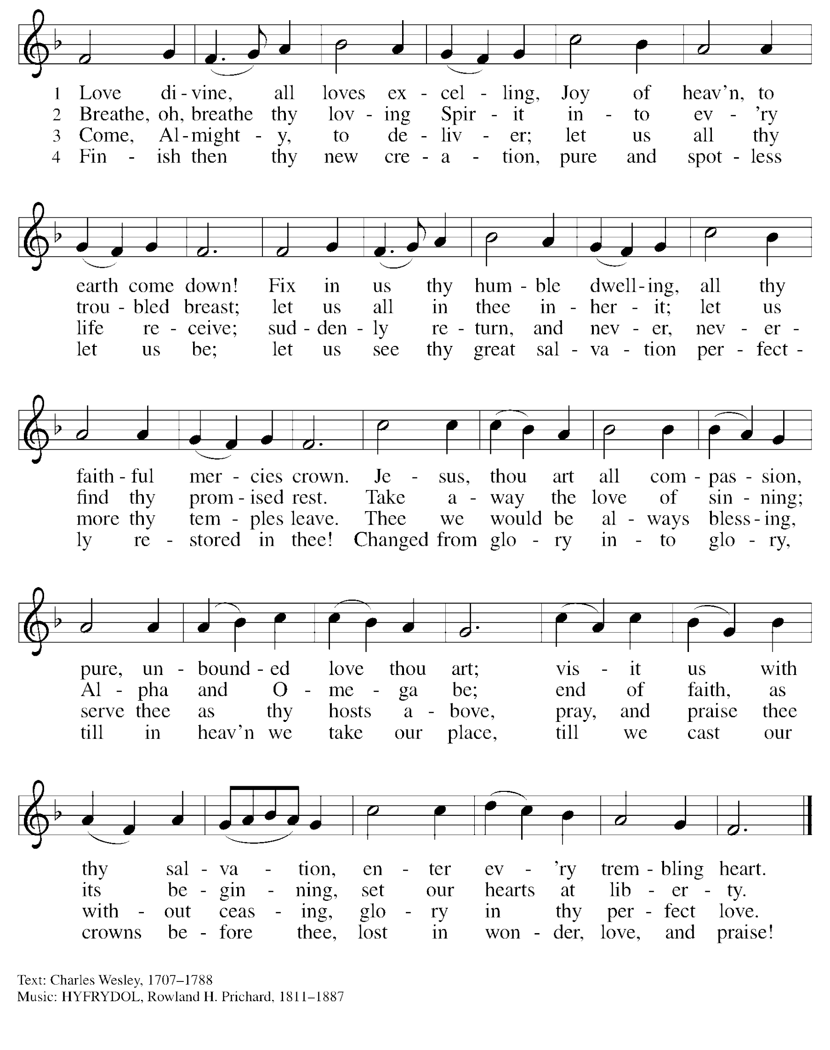

CCLI Song #
CCLI License #513895

GOD’S WORD
FIRST READING Romans 12:9-21
Introduction – Paul offers a poetic composition on how love reaches for the common good in the church. Our example for how to love is Jesus. Genuine Christ-like love has a moral orientation toward the good. When we show love toward someone, we are moving them toward God's goodness. To love someone is not simply to cater to specific likes and dislikes of that person. It is rather to act toward them in ways that help them know and receive more of God's goodness.
R ⁹ Love must be sincere. Hate what is evil; cling to what is good. ¹⁰ Be devoted to one another in love. Honor one another above yourselves. ¹¹ Never be lacking in zeal, but keep your spiritual fervor, serving the Lord. ¹² Be joyful in hope, patient in affliction, faithful in prayer. ¹³ Share with the Lord’s people who are in need. Practice hospitality.
¹⁴ Bless those who persecute you; bless and do not curse. ¹⁵ Rejoice with those who rejoice; mourn with those who mourn. ¹⁶ Live in harmony with one another. Do not be proud, but be willing to associate with people of low position.^{[a]} Do not be conceited.
¹⁷ Do not repay anyone evil for evil. Be careful to do what is right in the eyes of everyone. ¹⁸ If it is possible, as far as it depends on you, live at peace with everyone. ¹⁹ Do not take revenge, my dear friends, but leave room for God’s wrath, for it is written: “It is mine to avenge; I will repay,”^{[b]} says the Lord. ²⁰ On the contrary:
“If your enemy is hungry, feed him; if he is thirsty, give him something to drink. In doing this, you will heap burning coals on his head.”^{[c] 21} Do not be overcome by evil, but overcome evil with good.
R Word of God; Word of Life. All Thanks be to God.

“Be a Copy Cat”

THE HOLY GOSPEL according to St. John 3:16-17
ALL Glory to You O Lord,

Introduction – In Christ, we see a love so intense, so sacrificial, so incomprehensible, it makes all human expressions seem frivolous in comparison. God has sent us this gift of love. How will we, how can we, respond?

¹⁶ For God so loved the world that he gave his one and only Son, that whoever believes in him shall not perish but have eternal life. ¹⁷ For God did not send his Son into the world to condemn the world, but to save the world through him.
P The Gospel of the Lord All Praise to You O Christ.

MESSAGE FOR ALL
“Love Let’s Go”
Pastor Dawn Roucka

REFLECTION QUESTIONS
- What do you Love? How do you know if it is sincere?

- God’s love is redeeming and is self-giving. Describe how you love. How is it the same as God’s love? Different?

- The greatest of all God’s gift’s is LOVE

- How does Paul’s list of activities convict you in the area(s) of your life where you are not reflecting Christ’s love toward others and how will you let go what you do to be more loving in those areas?

PRAYERS OF GOD’S PEOPLE
See list of those Grace is currently praying for at end of this document or online. Please let us know your prayer needs.

Please respond accordingly
P Generous God, All Hear our prayer.

SHARING OF PEACE
While we cannot physically share a sign of love and peace with our neighbors, we remember that God’s love is active among us, even at a distance. Share a wave or other friendly sign to convey God’s love and peace to those around you. This is a time for sharing a sign of reconciliation and a unity we have as the body of Christ
in the bond of peace through the Holy Spirit. (Matt. 5:22–24; Eph. 4:1–3).

P May the love and peace of the Lord embrace and enfold you now and always.
ALL And you also.

OFFERING IS WELCOMED
P God calls us to love with all our hearts, souls, minds, and strength, and to love our neighbors as
ourselves. Our offerings are a symbol of that commitment and one of our contributions to our congregation’s witness in our neighborhood, in our region, and in our world. You are invited to give generously.

PLEASE CONSIDER IN THIS TIME OF NEED, TO CONTINUE TO SUPPORT YOUR CHURCH, IF POSSIBLE, AND SUPPORT OTHERS AS WELL BY BEING AS GENEROUS WITH YOUR TIME, YOUR TALENTS AND YOUR VARIOUS TREASURES.

You may mail offerings to Grace at 5N600 N. Hanson Road, St. Charles, IL 60175
or send through your bank or online; there is also a DONATE on our website or a plate by the entryway.

OFFERTORY PRAYER
P Let us pray. Gracious and loving God, Your steadfast love is but one of the many gifts you pour upon us. Our offerings are but a part of the way in which we can serve you and your people. As a community of faith we share these gifts. Bless them, and bless us, as we are the hands of Christ that build your kingdom. We pray that what you have first given us and now we offer back to you will bring honor and glory to you and will bring comfort and blessing to the needy and oppressed. And we pray that they will be a light to guide all to a closer relationship with you. In Christ’s name we pray,
ALL Amen.

When all have received and are seated, Pastor will offer the words of Institution
WORDS OF INSTITUTION
P And so we remember that night on which our Lord was betrayed…(continue with the Words of Institution)

THE LORD’S PRAYER

(Traditional) (Modern)
Our Father, who art in heaven, Our Father in heaven,
hallowed be thy name, hallowed be your name,
thy kingdom come, your kingdom come,
thy will be done, your will be done,
on earth as it is in heaven. on earth as in heaven.
Give us this day our daily bread; Give us today our daily bread.
and forgive us our trespasses, Forgive us our sins
as we forgive those as we forgive those
who trespass against us; who sin against us.
and lead us not into temptation, Save us from the time of trial
but deliver us from evil. And deliver us from evil.
For thine is the kingdom, and the power, For the kingdom, the power, and the glory
and the glory, forever and ever. Amen. are yours, now and forever. Amen

GOD SENDS US

COMISSION & BENEDICTION
P Go into God’s world, ready and willing to be loving, trusting, and generous people.
Go into your week knowing you are loved perfectly, saved eternally, and empowered as a disciple
of Jesus to share God’s love with everyone you meet. May the Lord bless you and keep you as you go from this place to share the gifts that you have been given with a world in need.
ALL Amen!

CLOSING SONG “My Hope is built on Nothing Less” LBW 294
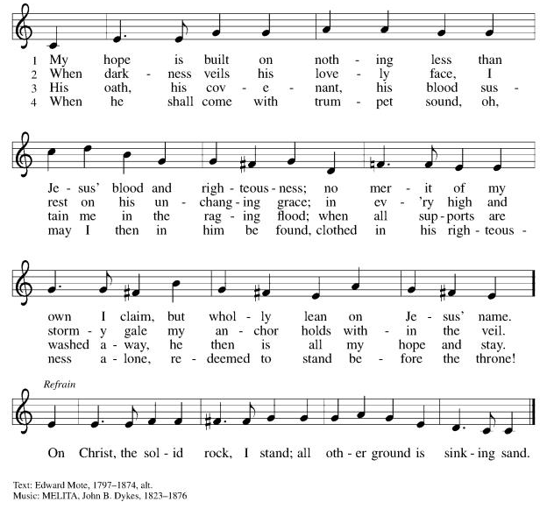

DISMISSAL
P Go in peace to love and serve the Lord,
ALL Thanks be to God. Amen.

POSTLUDE Go Forth with Knowledge Koury

REAL NEWS TO USE DURING THESE TIMES

VISIT OUR Website www.graceoflilylake.com FOR THE LATEST NEWS AND SERVICES
Check out our updated website. Get ALL the news you NEED there – including our weekly services
And our FACEBOOK PAGE or Youtube page for activities and posts of interest:
https://www.facebook.com/GraceOfLilyLake/
https://youtube.com/graceoflilylake.com
630-365-6751

THOSE TO KEEP IN YOUR PRAYERS
FOR THE WHOLE CHURCH
* God’s Church in all time and place, that God be seen and heard.
* As we face these times both together and while apart, keep us from fear, suffering and death.
* Ministries of the ELCA and Metro Chicago Synod, especially Bishop Yehiel Curry.
* Efforts of Lutheran World Relief, ELCA World Hunger, and Disaster Relief

FOR THE WORLD
- For every living person, including the First Family and staff, facing the threat of coronavirus – it affects us all, our loved ones and our worldwide neighbors together.
- For those facing natural disasters of wildfires, hurricanes, earthquakes

FOR OUR CONGREGATION
* For God's Spirit to guide Pastor Dawn, Vision Team, and whole congregation especially as we face transition and change.
* For our financial wellbeing and growth, being good stewards of all that God has given and calls us to.

FOR THOSE IN THE MILITARY (members, relatives, and friends of members of our congregation)
* Glenn Adams, son of Mark and Renee Adams * Lucy Adams, daughter-in-law of Mark & Renee Adams
* Adam Sajdak, grandson of Bill and Lori U’Ren * William Delmer, grandson of Kirk and Kathy Hooey
(If you know of someone currently serving our country, please share their information with the Church office.)

FOR ALL
* The continued support of our members * For all members of healthcare around the world
* For those serving as first responders and in the military * For our Nation, that extend peace in all things.

FOR THOSE SICK IN BODY< MIND OR SPIRIT
Fred Altstadt, Vicki Barclay, Carl Ekstrom, Carol Hammers, Jamie Hext, , Manfred Kaufman, Jeannine Luchs, Ryan McDonald, Joan Mortensen, Donald Overby, Ken Deutschman, Ken Patterson, Nicole Puralewski, Darlene Rentner, Pastor Rex, The Reynolds Family, Chris Richards, Nancy Schaefer, John Schnaitman, Shirley Turner, Linda Smykowski, Russ Bohlin, Eileen Morris, Pete and Carol Prevanas, Ryan McDonald, Lisa Leyden, Pat Hill, Mike Myers, Paul Kinsel, Kelly Diehl, Nancy Corbige and her mom Gladys, Heidi, Mark and Nathan Anderson

FOR THOSE WHO GRIEVE

Please let us know your prayer requests for inclusion in our public prayers.
Type them in the comments or send them to the church office via our prayer card on our website.

GRACE LUTHERAN CHURCH OF LILY LAKE
5N600 Hanson Road, St. Charles, IL 60175
Office: 630-365-6751
E-mail: general@graceoflilylake.com
Web Address: www.graceoflilylake.com

GRACE’S MISSION IS
To share God’s GRACE with all through our rich traditions of faith, family, and community.
Gospel – God’s love shared in all we say & do
Respect for all God’s people & creation
Action – response to the Gospel
Community – Loving God, neighbor, & self
Everyone – we are all God’s children

