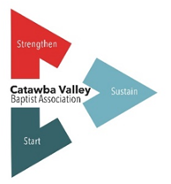
Member Church Survey
One of our goals is to make participation in the Association as essential in the life of each of our member churches. In order for that to happen the Association must prove itself valuable. We must be able to provide what member churches would desire to accomplish, but don’t always have the means to achieve. The following short survey is the beginning of identifying those essentials.
Church Name ____________________________________________
1) If the church you serve had unlimited funds and capabilities, what ministry would you provide for:
a. Your community?

b. The Kingdom?

c. Your local church?

2) What program, activity, or ministry have you been unable to provide for your local congregation? What would it take for that to happen?

3) What discipleship, training, or educational curriculums, if provided locally, would benefit the congregation you serve?

4) If the church you serve had the resources, what type of gospel outreach would be most effective in your community?

5) What areas of Kingdom ministry would you be willing to participate with other member churches to accomplish?

6) How valuable would an honest appraisal of the health of the ministry of the church you serve be?

7) Finish this sentence about the church you serve. If we only had ____________________

we could ______________________.

8) If the church you serve were removed from your community, what would the impact be?

9) What leadership positions does the church you serve not have?

10) What leadership positions does the church that you serve have that you could share with other churches?

Please scan and sent to amscvba@gmail.com

