

Church News

June 24, 2021

Worship Schedule

Join us in person or select Online Worship

at www.chandlerfumc.org at 9:30 am for Connect Worship.

Join us in person or select Online Worship

at www.chandlerfumc.org at 11:00 am for Traditional Worship

ALL are INVITED TO ATTEND in person or online!

**Scripture:**

**“Being Real”**

**Dr. Roy James**

**Mark 1:21-28**

Giving

**Online giving is available at**

**https://www.chandlerfumc.org/give**

**or checks can be mailed to the church office at**

**507 N. Broad Street, Chandler, TX 75758**

**ALSO, A NEW WAY TO GIVE**

**Text to Give**

**Text 1-888-364-GIVE (4483) enter: give2fumc**

**Instructions will be given to set up an account and a login.**

**If you are having difficulty, please follow this link:**

[Subsplash Giving – Subsplash Help](https://help.subsplash.com/hc/en-us/categories/115001241607-Subsplash-Giving)

***Keep These in Your Prayers***

**Long-term illness:** Charles Lipscomb, Helen Giger, Lela Warren,

Sara Hall, Lou Griffin, Martha Copeland

**Health, grief or need for strength or guidance now:** Judy Deal, John & Nancy Adkins,

James Nokes, Landyn Kidd, Sina Martin, Elgie Owen, Bill McHam, Landry Lewellen,

Andy Smith, Colleen Lanier, Emma Lambert, Pat Martin, Jim Johnson, Richard Young,

Savannah Bradburn, Robin Calicutt, Katie Calicutt, Charleen Walston, Rick Wright,

Dalton Huckabay, Jim Bustamante, Lou Barnes, Liz Killough, Gavin Fisher, Ginger Carter,

Tyersa and Mike Crooks, Jim Johnson, Peggy Black (Kyle McGill’s Mother),

Elayne Reid, Joan Bonneau (friend of Kay Benton)

**Continuing Care Retirement Community:**

**Chandler Nursing Center:** Emogene Finley, Yolanda Evilsizer

**Oak Terrace:** Mary Stewart, Marilyn Pollard **The Atria:** Gayle Haynes

**Park Place:** Helen Reese

**Remember to Pray for Our Military:**

Steven Mount (Air Force Major, multiple deployments, Viglini family),

Liz McGovney (Lt. Col., Army, John Taylor family);

Preston Toole (Army, friend of Lou Griffin family),

Joe Wangler (Air Force Master Sgt, Autumn Fenner’s brother),

Aaron Sherman (Air Force, son of Tim & Jana Sherman),

Sarah Oliver Martin (Lt. Col, Air Force, Charles Oliver family)

***Sympathy to the family and friends of Patti Cade.***

**If you have updates to these lists, please notify the church office*.***

**Costa Rica Mission Participants:** Kari Bersano, Lindsey Bersano,

Sean Little, Arianna Montero, Levi Oliver, Casey Shaw,

James Williams, Chris Yarbrough, Kaylee Yarbrough

*Sympathy to the Bob Peyton Family on the death of Bob’s son, Chad Peyton.*

*The Memorial Service will be Saturday June 26 at 11:00 am in the Sanctuary.*

Adult Sunday School Classes

9:30 classes

Sanctuary Building:

Bring the Love, Chris Frederick – Parlor

Heritage Building:

Joyous Journey, Larry Schmidt, Heritage Hall

Wesley Fellowship, Linda Davis, Wesley Fellowship Room,

Covenant Class, John and Nancy Adkins, Covenant Room

11:00 class

Family Life Center

New Life, Carol Harkness, New Life Room

Our own Ken Reid is Musical Director of Beauty and the Beast

At the Tyler Civic Theatre June 24-27

Call the Box Office for tickets.

Ken would love to see you there.

We are still collecting stickers for Dalton Huckabay.

If you have stickers to donate, please bring them to the office.

The July/August Upper Room devotional magazines

Are in and may be picked up in the church office

or in the Foyer. Please consider taking a magazine to

those who are unable to get out and come to church.



Upcoming Events:

**Charge Conference will be July 11, at 3:00 pm in the Sanctuary.**



**Sunday, July 4 @ NOON**

**CHURCH-WIDE PICNIC**

**The Sanctuary Grounds & Hill**

**Hamburgers & Hot Dogs by UMM**

**Bring Side Dishes & Desserts**

**Back to School Health Fair**

**August 7th, 10-1**

**For more information, check our website**

**www.chandlerfumc.org/missions**

**ONGOING WEEKLY ACTIVITIES**

**Monday**

Ladies Monday Morning Bible Study, 10 am Parlor

Men’s Bible Study, 6:30 pm, Parlor

**Tuesday**

Retired Persons Ministry, 1:30 pm, HH

Wesley Online Sunday School, 7 pm

**Wednesday**

Chancel Choir Rehearsals, 7 pm Choir Room

**Thursday**

Celebrate Recovery, Heritage Hall, Fellowship Hall, 6 pm

**YOUTH & CHILDREN**

**Sunday Morning Schedule**

Children meet at 10:45 in the Children’s Wing-FLC

Youth meet at 10:45 in the Youth Wing-FLC

**District Camp: July 5-9 Lakeview**

**Children**



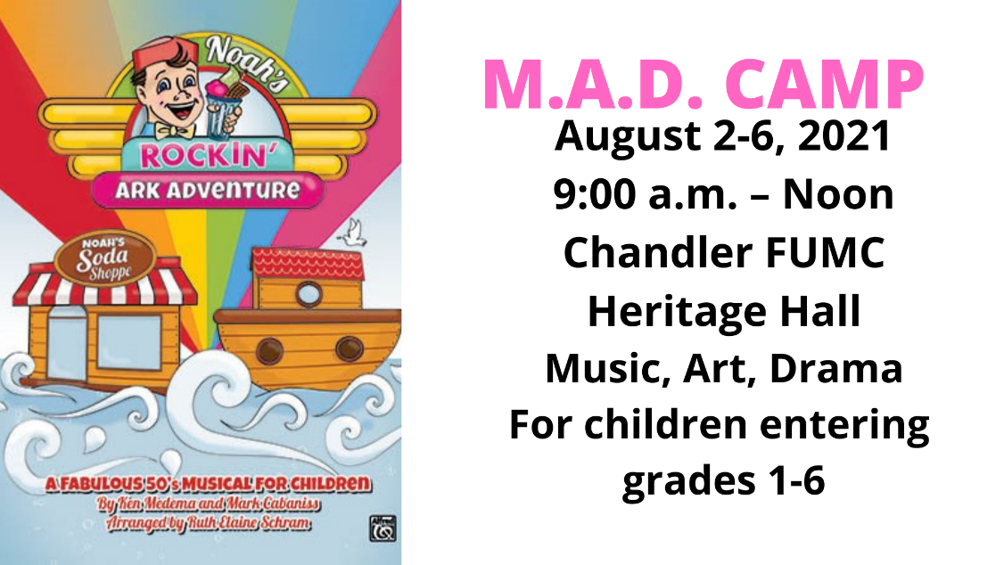

**Youth**



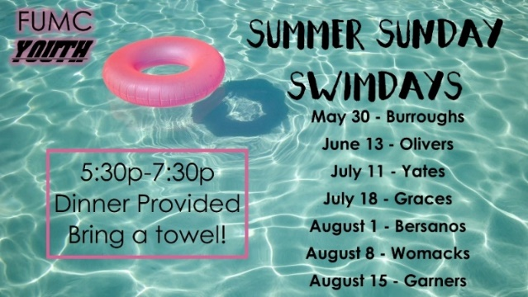

Mission Trips

Big House Mission Trip: July 21-25

Registration is on the website:

[www.chandlerfumc.org](http://www.chandlerfumc.org)

**If you wish to opt out of receiving these Church-Wide Emails,**

**please let Crys know by sending your request to this email or calling**

**(903) 849-6839. If you know of anyone wishing**

**to get these emails, do the same. Thanks, Crys**