The Allen Chapel Riverside A.M.E. Church

Watch Us Sundays on Facebook Live @Allen Chapel Riverside
Livestream via YouTube Live: Allen Chapel Riverside
https://www.youtube.com/channel/UCYghsO0VpPnPQdkmuPWuQyg

Follow us on Facebook, Instagram, & YouTube!

Order of Service

Praise & Worship …………………………………
Invocation ……………...……..…………………….
Scripture Reading …………..Matthew 9:35; 10:8
Ministry of Music Selection ……………….……
Pastor’s Words/Pastoral Prayer …..………….
Ministry of Music Selection ……………….……
Proclamation by Pastor Barry Settle ……..….
Invitation to Salvation/Discipleship .…....……

Tithes & Offerings ……..……………...…………
Announcements ……......…………………………
\Benediction ……………..……………………...…

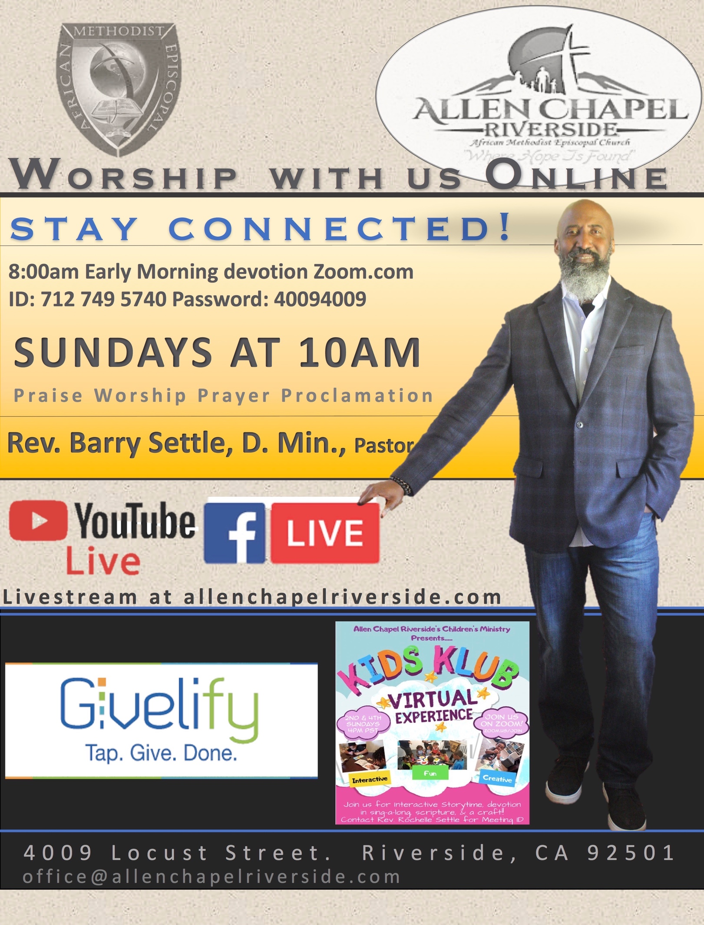

Announcements:

Scholarship Contribution Fund
In July 2020 we will have a Scholarship Contribution Drive that will go towards our graduates (including our 2018-2019 high school graduates). Please continue to follow us on Facebook & Instagram, as well as regularly checking your emails for the upcoming information.

5thDistrict Lay Organization Scholarships 2020
You can only apply for one scholarship. All materials must be postmarked or received electronically b​y July 1​5th deadline.
Download Scholarship applications website:
http://fifthdistrictlay.org/5th-district-scholarships/?fbclid=IwAR2ivaFPiwTtFInTlMmVzX_mtGrIR0WjZafStnKHlCE6p8QW6DrbA5lTsoE​ ​

Please completely read each applications criteria. Must have been a 5thDistrict AME Church member at least 12 months, active lay member or in another ministry of the church organization.
If you have any questions contact Burma Lee Manns, Lay President Email:onmytimebl@yahoo.com
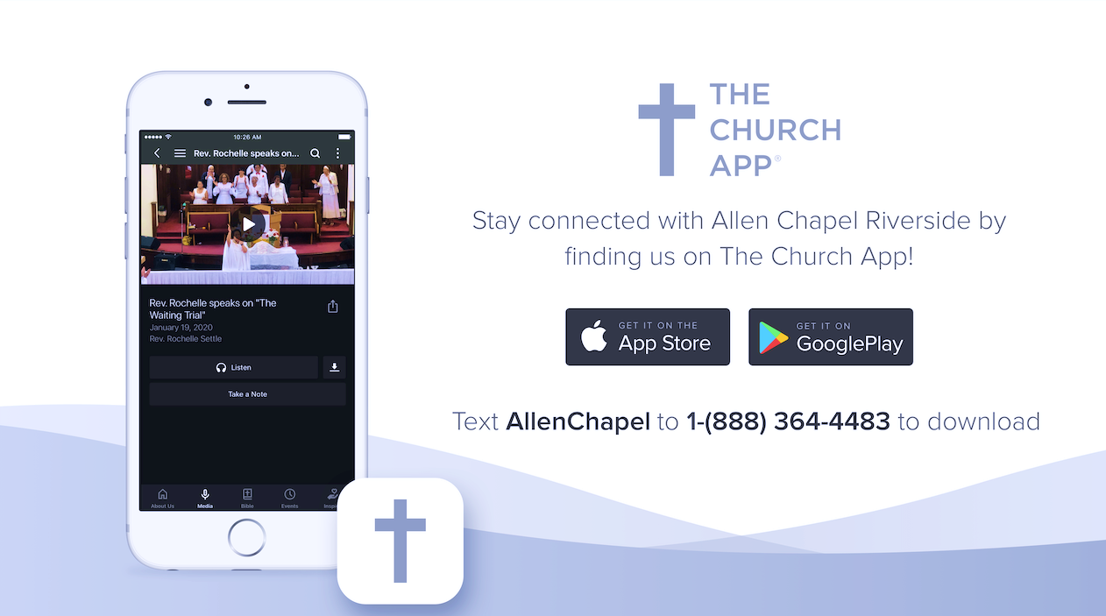

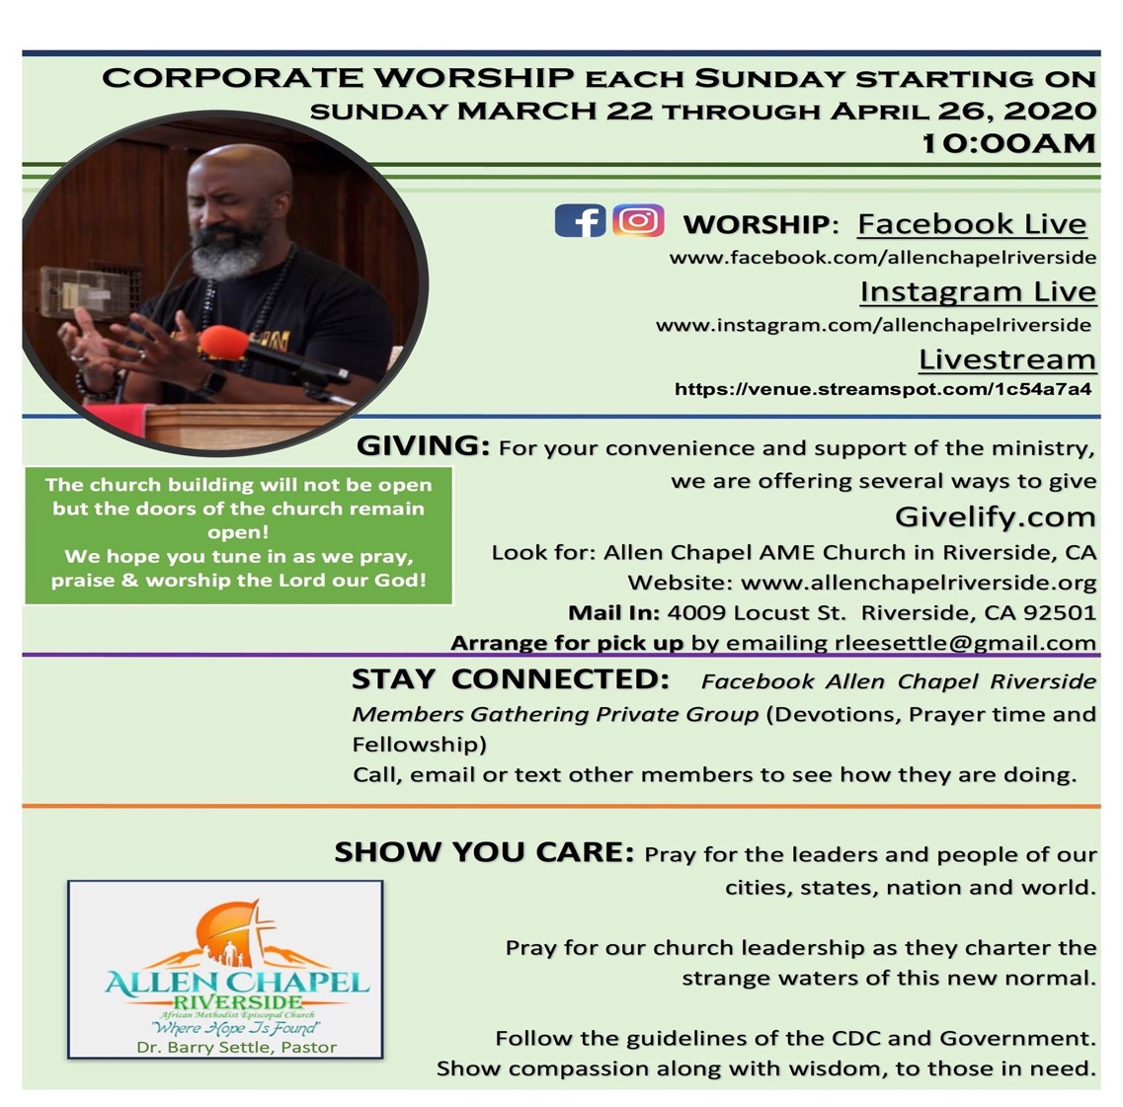
AT 10:00AM PST
YouTube: Allen Chapel Riverside riverside

