HOW TO CHECK IN FOR YOUR VIDEO VISIT
- You must have an appointment scheduled with your provider as you typically do.
- Use a computer or device with camera/microphone
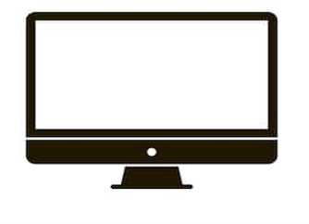
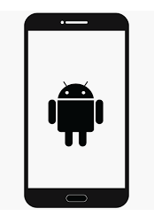

PC and Mac | Android | IOS
Chrome /Safari | Chrome | Safari

- Through your Internet browser, go to www.bhsiclinics.com.
- Click on the telehealth tab
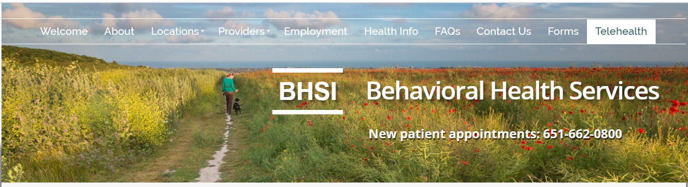
- Click on your provider’s name.
- You will be linked to your providers waiting room. You will see the image below. Enter your name and click “Check In.”
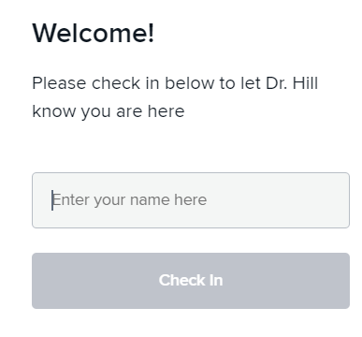
- You will see a pop-up asking you to allow your browser to use your webcam and microphone. Click Allow.
- Your provider will start your visit when provider is available.

For help with technical issues, please call the clinic coordinator where your provider is located:
Eagan: 651-769-6200 Brooklyn Center: 651-769-6250 Golden Valley: 651-769-6300
North St Paul: 651-769-6400 Shakopee: 651-769-6500

