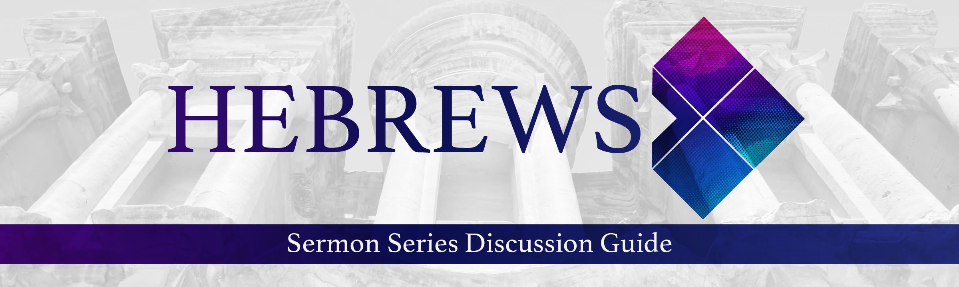

“A New and Living Way” (Hebrews Series, Pt 11) – 12.6.20

- Ice Breaker: What is one of your favorite Christmas movies? Why do you like it so much?

- What are some things that have challenged you spiritually in the last year?

- (Hebrews 10:23–25) — 23 Let us hold unswervingly to the hope we profess, for he who promised is faithful. 24 And let us consider how we may spur one another on toward love and good deeds. 25 Let us not give up meeting together, as some are in the habit of doing, but let us encourage one another — and all the more as you see the Day approaching.
- How can God’s faithfulness & the promises in His Word be a catalyst for us to persevere in our faith? When has this been true for you?

- Why do you think God designed us to grow spiritually mature in the community of believers? What might be some other benefits?
- Why do you think we need the encouragement of others “all the more” as we see “the Day approaching”?

- In the season of COVID, talk about how we could creatively live out the principles in this passage.

- (Hebrews 10:26–31) — 26 If we deliberately keep on sinning after we have received the knowledge of the truth, no sacrifice for sins is left, 27 but only a fearful expectation of judgment and of raging fire that will consume the enemies of God. 28 Anyone who rejected the law of Moses died without mercy on the testimony of two or three witnesses. 29 How much more severely do you think a man deserves to be punished who has trampled the Son of God under foot, who has treated as an unholy thing the blood of the covenant that sanctified him, and who has insulted the Spirit of grace?

- How can staying connected to other believers help guard us against deliberate sin & rejecting Christ?

- What might be the difference between being presumptuous about our salvation vs being confident?

- (Hebrews 10:35–39) — 35 … do not throw away your confidence; it will be richly rewarded. 36 You need to persevere [inward fortitude to endure] so that when you have done the will of God, you will receive what he has promised. 37 For in just a very little while, “He who is coming will come and will not delay. 38 But my righteous one will live by faith. And if he shrinks back, I will not be pleased with him.” 39 But we are not of those who shrink back [fail to believe] and are destroyed, but of those who believe and are saved.

- What might it mean for us to do “the will of God?” How might this be the same or different for each of us?

- Practically speaking, how do we live by faith? What might be the opposite of living by faith?

How can we pray for you?

