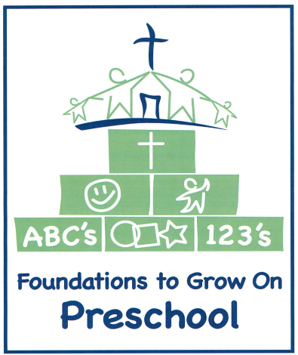
Class Enrollment Form
for 2022-2023

Class options:
Preschool Class (2.5 hrs) for 3 & 4 year olds T & Th 9:00-11:30 am
Pre-K AM Class (2.5 hrs) for 4 & 5 year olds MWF 9:00-11:30 am
Pre-K PM Class (2.5 hrs) for 4 & 5 year olds MTWTh 12:30-3:00 pm
Tuition rates:
Preschool Class
$135 per month – due by the 1st of the month.
PreK AM Class
$160 per month – due by the 1st of the month.

PreK PM Class
$185 per month – due by the 1st of the month.

Registration Fee: $45 Due upon registration, non-refundable.
Supply Fee: Due at August Orientation, non-refundable.
Preschool (2 days) $50; PreK AM (3 days) $60; PreK PM (4 days) $70

Please indicate below the class for which you are enrolling your child:

Child’s Name:_____________________ Male or Female (circle one)
_______ Preschool (TTh) Child’s birthdate: ____________
_______ Pre-K AM (MWF) Child’s birthdate: ____________
_______ Pre-K PM (MTWTh) Child’s birthdate: ____________

Email foundationstogrowon@villagechapelchurch.org with any class enrollment option questions.

