Surgical Gown

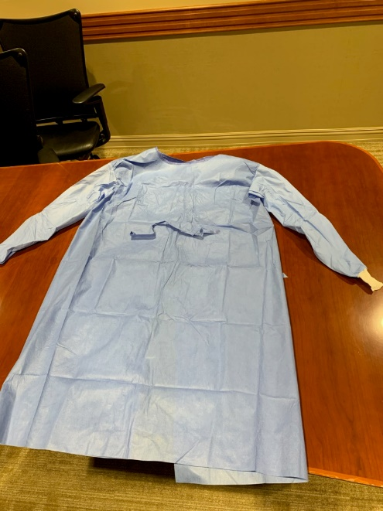
Fabric: Polyester blends preferred, but any will work.
Front:
- Shoulder to Shoulder 27 ½” (includes ¼” seam)
- Front Panel 50” long
- Circumference of both front and back panels equals 62” around
- (1) 16” long tie 19” from top shoulder; 10” from right side - in
- Sleeves:
  - Sleeve length 29” (includes cuff and ¼” seam)
  - Top circumference 10” and narrows to 5” with ribbing
  - Cuff or band of sleep 3 ¼” (with seam)

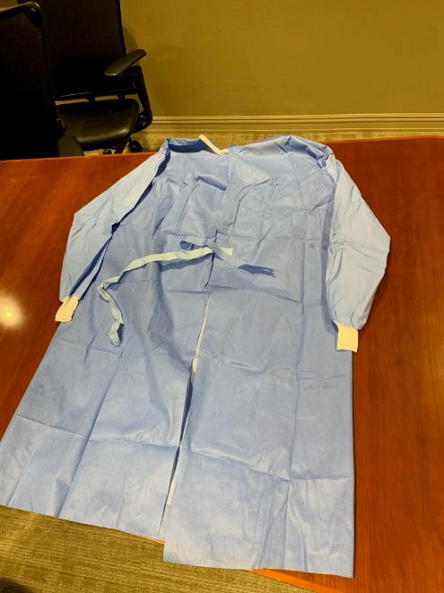
Back:
- Back Panel w/ opening 50” long
- (4) 16” long ties (one on each side of opening)
  - (2) ties at top of gown
  - (2) ties 19” from top

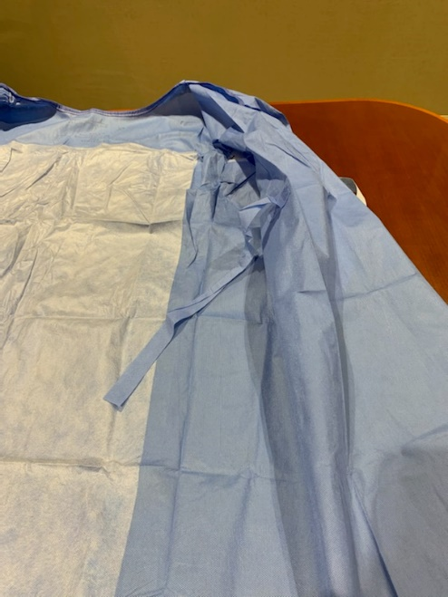
Inside:
- (1) 16” long tie 19” from top shoulder; 10” from right side - in (this tie connects to the tie on the front panel)

