AWANA SPARKS TIPS and EXPECTATIONS for HANDBOOK WORK

This SPARKS year, club leaders will be helping clubbers answer the question, “Why should I believe the Bible?” God has reached out to us in love, sending us a Savior to take the punishment for our disobedience, giving us eternal life as we accept his sacrifice for us. God has not only offered us the Living Word, but also the written Word, His love letter and manual for our lives.
We can’t wait to open the Bible and share about the Word who reveals to us who God is and His amazing plan for each life that yields to Him. Discipling kids is best done in person. When that is not so doable, we’re thankful for technology that allows us to connect virtually. One piece of SPARKS that is a bit more challenging while Zooming is building in dedicated and effective time to help each clubber with their journey through their handbook. Every clubber works at their own pace so the potential is that no two kids are working through the same section. This is where we are needing and asking parents to partner with us all the more during this “at home” club season. Thank you for your committed efforts.
TIP #1 - When a clubber works on a handbook section requiring something to be memorized (verse, bks of Bible), he/she can receive up to 2 helps from the parent (the next couple words, part of the bible reference). The verse “address” should be quoted too. If the child is receiving more than 2 hints, the parent simply coaches and practices with them a bit more until they are ready to say the section for credit.
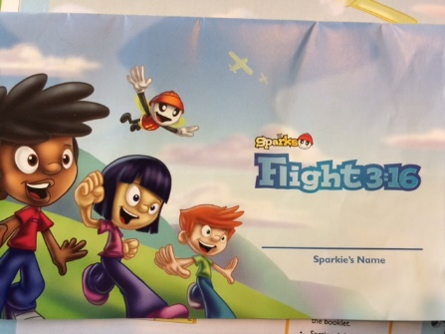
FLIGHT 3:16 booklet - first challenge for any child just starting out in Sparks. Focus on learning John 3:16.
** Let us know if your child needs this booklet (no cost).

John 3:16 is broken into segments. The child learns the verse little by little; parent signs off on each section, and dates it. Last section requires the child to say the entire verse, then answer specific questions (those can be rephrased to help child).
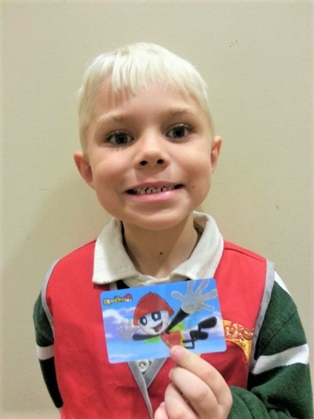
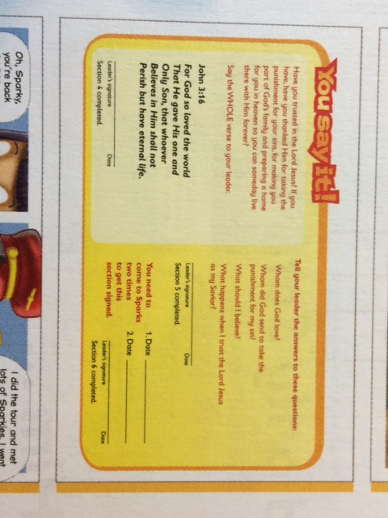
At this time, we’ll skip over the 2-week attendance requirement.
When your child has successfully quoted the verse and answered the questions with you, do let us know of this accomplishment.
A SPARKS flicker membership card will be sent out to him/her. Way to go!

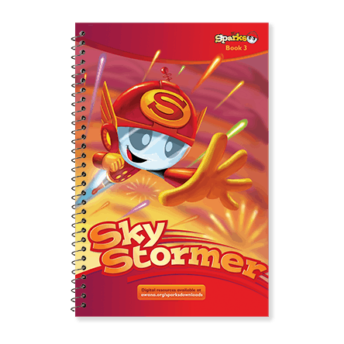
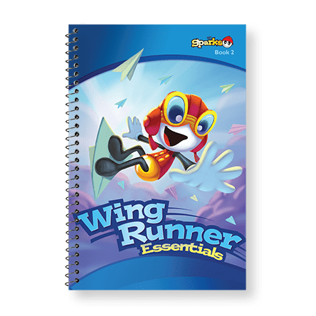
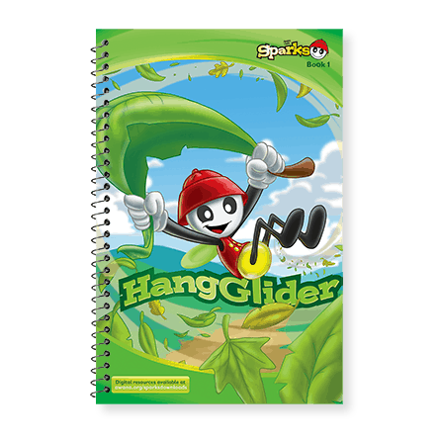

BOOK 1 BOOK 2 BOOK 3

Here’s a glimpse into sections of a Sparks handbook (using the green Hangglider book 1) –

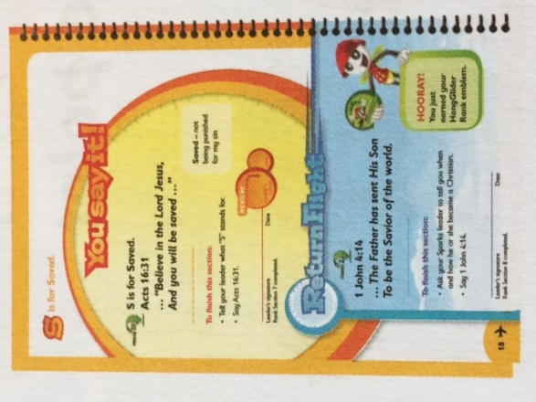
Details as to what is required for the clubber to complete the
section.
Line on which parent signs / dates when child has finished
section.

Definition word(s) given to help child understand key word in
the verse. Child does not need to memorize/quote.

“Return Flight” - a verse that the clubber has memorized
earlier in their handbook. Child should be able to say such
sections without helps.

Prompt as to which award has just been earned.

Requirements for completing the section - may be more than
just saying a verse.

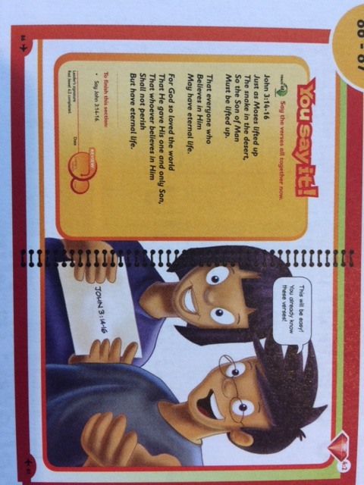

TIP #2 - Should a section have more than one
verse to quote, the child must be able to say
all the verses one after the other – one sitting.

Child should not quote the first verse, pause to
study the 2nd verse and then say that 2nd verse,
etc.

Only 2 helps should be offered for this entire
handbook section. Bible reference included.

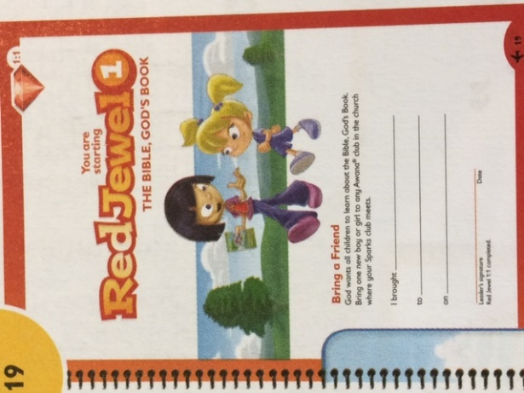
TIP #3 - Clubbers work through their handbook, cover to
cover, without skipping any sections, except …

RED JEWEL, section 1 (this is present in all 3 Sparks handbooks) –
This section encourages clubbers to bring a friend to club, and
can be skipped to allow the child time to find and to invite a
friend who is able and willing to attend with them.

If the year unwinds without the clubber being able to find a
friend, there is another option that we will offer later in the
club year. This is primarily the reading of a simple missionary
story or biography and having a discussion with the parent. The
story is provided by our club.

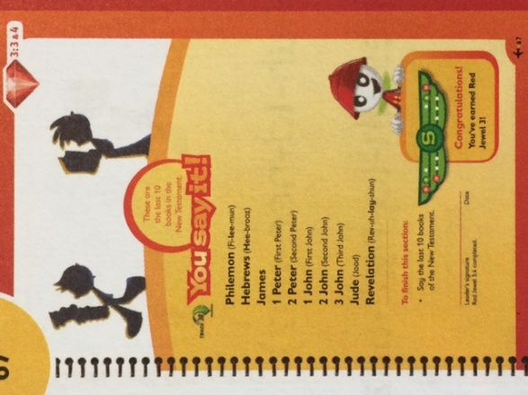

Here is an example of a handbook section that is not the
memorization of a verse.

The SPARKS handbooks challenge the clubbers to learn the
books of the Bible.

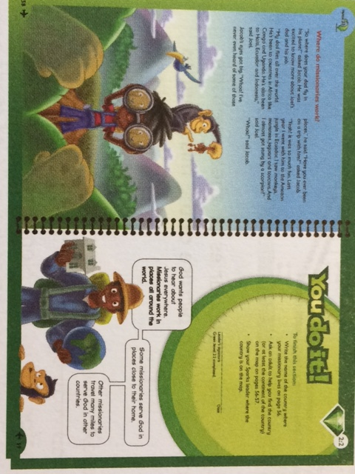
Here is an example of a handbook
section that focuses on missions.

Follow the requirements for completing
the section. The child and parent may be
invited to work together.

Green jewels are activity focused (ie.
missions, chore chart). They may include
memorization of verses too. Red jewels
primarily focus on verses and books of
the Bible.

TIP #4 - The handbooks are rich with additional resources, conversation bubbles, stories that offer
context to the verses and activities. Take a few minutes when coaching on a section to read the
material given before the section with your child. This will help give more understanding to the
section and verses. Suggestion: Read the bible story that accompanies the verse before bedtime.
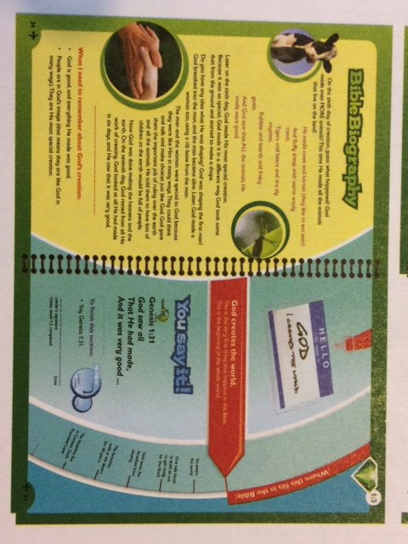
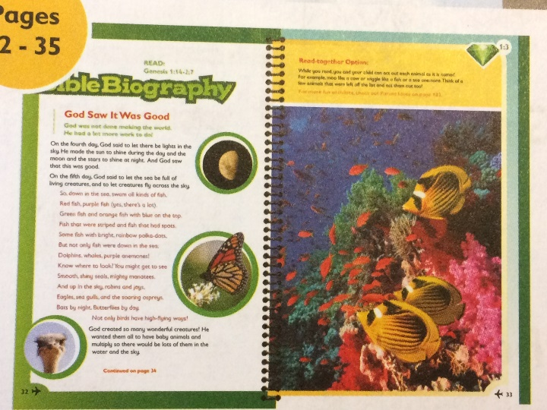

TIP #5 - AWANA offers digital resources to help kids learn their verses and books of the Bible.

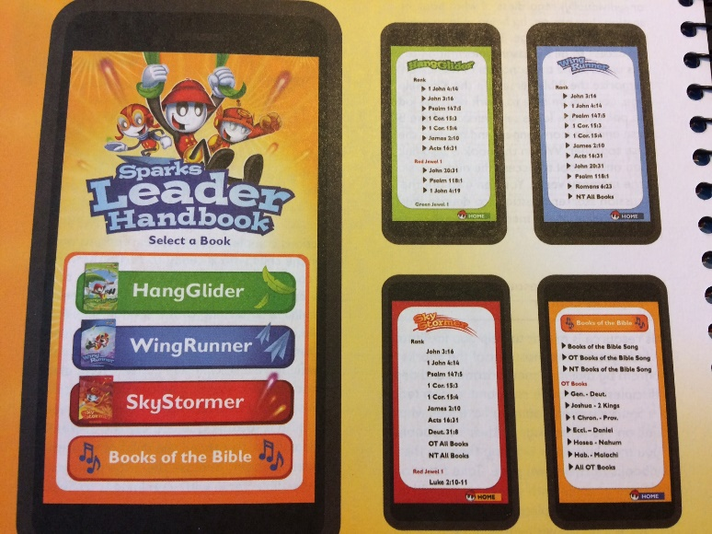
… Go to www.awana.org/sparksonlinetools. This tool is accessible via your Web browser on your mobile device. Kids can hear an audio recording of all the memory verses, and more. Select the book and then the verse to be played.

… Go to www.awanaplus.com - Sparks. You’ll find lesson videos, handbook verses put to music, activity pages for each handbook (under additional resources), a list of all the verses spelled out, and parent pages (lesson notes for parents to use at home – related to the handbooks).

… ** The handbooks ordered at COS use the New International Version (NIV) of the Bible. Keep this in mind when accessing verses and songs.

TIP #6 - How to learn a verse? Break it down into small bites – one phrase at a time, always going back to the reference and the beginning when adding a new phrase. Clap out a rhythm, even learn a verse song. Read through the verse at different times of the day, then sit down to actually learn it once there is understanding of its meaning.

TIP #7 - The Bible is God’s Word, His gift for each one who wants to grow and live for Him. Invite the author of this book, the Holy Spirit, to guide your coaching and your child’s learning of the verses and doing of the activities. You’re on an adventure! Have fun and celebrate along the way!

