To Access and Print Your Yearly Giving Statement
Start by logging into your church's site: https://southridgefairmont.ccbchurch.com/goto/login or go to www.southridgechurch.net and click on the SRC Connect Login Tab.
- Click on the image of your Profile at the top of your page
- Click on the Involvement tab in your profile
- Scroll down to the Financial tile
- Click on the ellipses menu and click Giving Statement
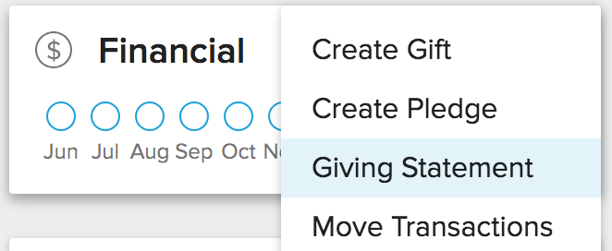

Select the appropriate options for the statement...
- Type
  - Family - Generates a combined statement for primary contact and spouse and separate statements for any gifts given by Children or Other family members
  - Individual - Generates one statement for each person in the family that has given during the date range
- Date Range - This will determine which transactions to include in the statement based on the post date set for the transaction
- Tax Deductible - Choose which transactions to include based on their tax-deductible status: tax deductible, non-deductible, or both

