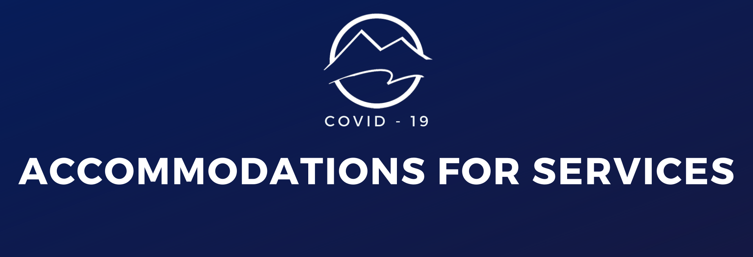

- Seating will be arranged so that those who come together can sit together, but there is space between groups.
- We will not pass offering baskets. There are offering/communication card receptacles available at the back of the auditorium & online giving is available.
- We will not provide coffee and refreshments until it is deemed safe.
- Our greeting team will operate with proper social distancing procedures and will open doors, so there is less opportunity for transmission of germs.
- We will have a limited amount of service guides available for pick-up for those who prefer taking notes with paper and pen. We encourage those without preference to use our app for taking sermon notes.
- We will have a team in place to sanitize between services and do spot sanitizing during services and hand sanitizer will be readily available.
- Beginning December 6, 2020, we will begin to offer Sunday morning family ministry programming, 1st-8th grade. Preschool, nursery care, special needs buddy program, and childcare for groups will soon follow. For those who have children and are worshipping with us online, weekly lessons for the kids will continue to be offered.
- Masks are strongly encouraged and will available at the door.
- If you have traveled to a hot spot for vacation or business, we ask that you join us online for a short time upon your return.

