2021 FIRST FRUITS FAST

WHY: Fast Objectives
- Ephesians 1:17-22, 2:4-6
  - Wisdom and revelation in understanding the Father and his will for your life.
  - Consecration of the year into the Lord
  - Eyes that see and understand. Spiritual discernment restored.
  - To live by the spirit of the word, not the letter.
  - Veils removed from our eyes in various capacities.
  - Revelation concerning the power made available to us in Christ.
  - Ability to walk in your true identity and calling.
  - Grace to live in the spirit and operate from a spiritual dimension.
  - Holy Spirit power!

WHEN: Fast Dates
- 21 Days : Monday, January 11 – Sunday, January 31

HOW: Type of Fast
- Fasting for 21 days. During the week, we are doing a Daniel fast. A Daniel fast consists of removing all white sugar, white flour, processed foods, meats, sweet juices, etc. You can eat whole grains, beans, legumes, vegetables including salads, nuts, and consume primarily water as a beverage. Visit this site for more information: Daniel Fast Food List, Daniel Fast Guidelines, Daniel Fasting (ultimatedanielfast.com)
- On the Weekends: Friday, Saturday, and Sunday until after the afternoon sermon (approximately 12:30 PM), we are doing a water fast. This consists of no solid foods at all. You can put some lemon in your water if necessary. For those on medication or with pre-existing conditions please do some research or consult your physician.

DETAILS: Fast Prayer Times
- Kick-Off: One hour at midnight, Sunday, January 10. - Virtual
- Wednesday, January 13, 20: One hour at midnight. – Virtual
- Friday, January 15 (Virtual Prayer), Friday, January 29: 9 PM – Midnight – At the church & Virtual
- Sunday: January 17, 24: One hour at midnight – Virtual

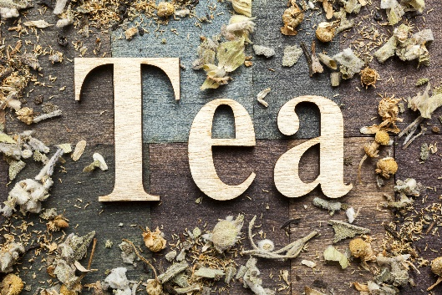
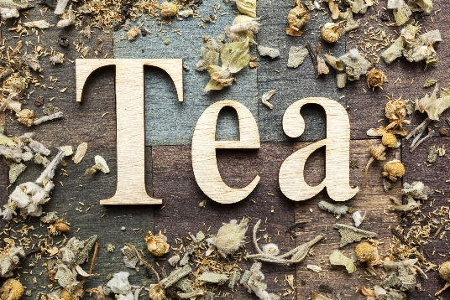

Pastor Tacha’s Fasting Herbal Teas:
These are the teas that I like to take during a fast, primarily for their cleansing and rejuvenating properties. I try not to drink too much juice, because of the natural sugars. There are many other herbs/teas you can take. These are only suggestions and should not be made too strong, if you are taking them for the first time. They can be combined or taken individually. (Consult with your physician if you are on medication). I get all my herbs from: https://www.mountainroseherbs.com/ Remember to drink LOTS OF WATER!!!

Blue Vervain
·Detoxifies the Body
·Diuretic: stimulates the release of urine from the body = eliminate toxins from the system, as well as excess water, salts, and fat. Good for bladder infections.
·Combats: congestion, colds, chronic bronchitis, sore throats or respiratory inflammation - acts as an expectorant, helping to expel mucus and phlegm
·Reduces pain, swelling and inflammation, such as in cases of gout, arthritis, or inflammation in the gastrointestinal system.

Chaparral Leaf
·Used for digestion problems including cramps and gas; respiratory tract conditions including colds and infections; and ongoing chronic skin disorders. It is also used for cancer, arthritis, tuberculosis, urinary tract infections, sexually transmitted diseases, central nervous system conditions, chickenpox, parasite infections, and obesity.
·Detoxification, or as a tonic or “blood purifier.”
·If you have liver issues, check with your doctor first!

Savory: Satureja Hortensis
·Antibacterial, and anti-fungal applications.
·Used for throat gargling to help relieve a sore throat and bronchitis symptoms.
·Used as an: antiseptic, carminative (anti-flatulence), digestive (helps digestion), expectorant (help clear throat), stomachic and anti-rheumatic (relieves joint pain) functions.

Damiana Leaf: Turnera Diffusa
·Increasing sexual desire and performance, while decreasing impotence
·Treats constipation
·Reduces depression, nervousness, and anxiety
·Fights PMS symptoms, muscle aches, insomnia, headaches, and pain
·Improves digestive health
·Combats: anemia, diabetes, respiratory infections, fungal diseases, and skin disorders

Cascara Sagrada Bark: Rhamnus Purshiana
·Acts as a laxative (so be careful if you have to go to work).
·Hydrating properties helps skin issues like acne
·Promotes healthy hair
Aids with insomnia and encourages sound sleep.

Rhubard Root:
· Contraction of the liver and stimulates the colon for proper internal cleansing
· Helps alleviate liver and kidney diseases
· May support stroke recovery
· Used to alleviate digestive complaints: diarrhea, constipation, stomach pain
· Aids with menstrual cramps and menopause symptoms
· Can act as a mild laxative for constipation

Prodigiosa:
· Helps with fat digestion in gall bladder
· Reduces blood sugar
· Has proven to be extremely beneficial in type 2, insulin-resistant diabetes
· Improves digestion
· Helps dissolve small gallstones

Burdock Root
·Cleanses the liver and removes toxins from it
·Acts as a powerful antioxidant
·Aids the lymphatic system which cleanses the blood
·Promotes healthy hair and skin

Guaco
·Cleanses blood and skin through perspiration
·Reduces inflammation
·High in Iron
·Contains potassium phosphate

