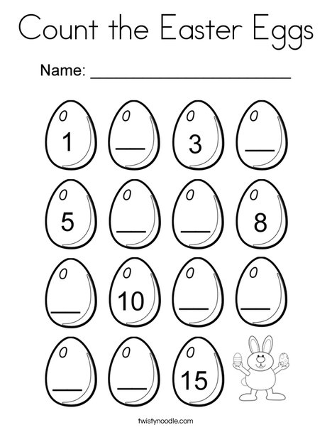

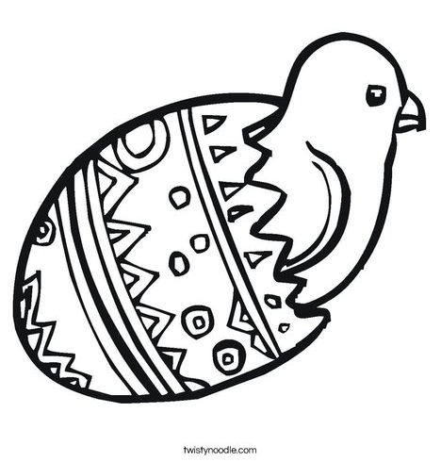
Because Jesus died and came back to life, Easter is a festival of new life. In the UK we decorate eggs and give them as presents. The egg is a symbol of new life, because inside the egg shell is a new baby!
The Friendly Caterpillar – by Vickie Howie
(Actions to do together in italics – you will need a blanket or a coat)

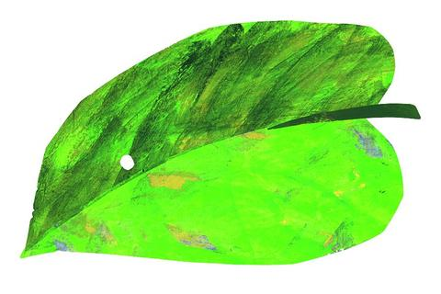
One sunny day, a beautiful butterfly came floating, floating down from the sky… (link thumbs and flutter fingers). It landed on the leaf of a stinging nettle, and there it laid – an egg… (put your fists together to make an egg shape). Inside the egg, something was growing. I wonder what that was? It was a tiny creature that grew bigger and bigger until the egg cracked, and out it popped – a hairy, stripy caterpillar… (wriggle your first finger like a caterpillar).
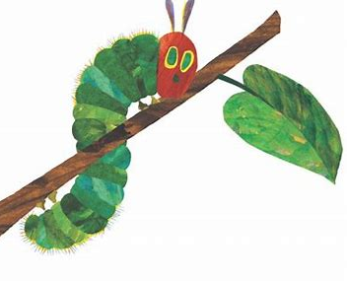
“I’m hungry!” said the caterpillar, and he began to munch the nettle leaf, munch, munch, munch, until there was nothing left of it at all. (pretend you’re eating)
“I’m still hungry,” said the caterpillar, and he wriggled his way on to another juicy leaf and began to munch again. How did he eat? Munch, munch, munch!
Very soon, the little caterpillar grew into a great big one. He was a very good friend to all the other caterpillars in the nettle patch. He showed them where to find the biggest, juiciest leaves, and he told them how to wave their tails in the air to frighten away the hungry birds, swish, swish! (wiggle your bottom) No wonder all the caterpillars loved to follow him! But one sad day, the friendly caterpillar told his friends, “I’m sorry, but I must go away now to do something very special.”
“Oh, don’t go away and leave us!” they cried. “Who will show us where to find the juicy leaves, and who will help us to scare away the hungry birds? And anyway, we love you and we don’t want to be without you – not now, not ever!” (make a sad face)
“I really must go!” said the caterpillar. “But don’t be sad! I promise you’ll see me again and then you’ll be glad!” (make a happy face)
The caterpillar wriggled his way up a bumpy tree trunk. Then he began to spin himself a silky sleeping bag called a cocoon… (spin round, or wrap yourselves in a blanket or coat). He snuggled down inside the cocoon, pulled it over his head and disappeared from sight… When the other caterpillars saw that their friend had gone, they went away sadly. Inside the cocoon, the caterpillar began to change. He wriggled out of his stripy, hairy body… (wriggle inside the blanket) and then he grew long legs and silky wings… (flap your arms inside the blanket) and he BURST out of the cocoon as a beautiful, colourful butterfly… (throw off the blanket and stand up, stretching your arms). As he was drying his wings in the sun, his caterpillar friends found the empty cocoon and started to cry… (pick up and shake the empty blanket, pretend to cry).
“Oh no, where has our best friend gone?” they cried. “The hungry birds must have eaten him. Now we’ll never see him again.”
“Why are you crying?” asked the new butterfly. “Are you looking for me?”
The caterpillars looked round. “It’s you!” they cried. “You’ve come back! But look at you! Now you’re a beautiful butterfly!” (clap your hands)
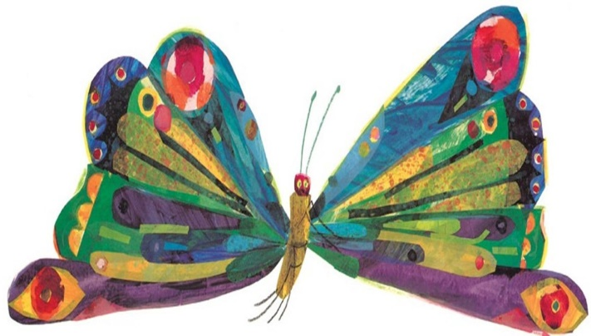
“A good friend always keeps his promise,” said the butterfly. “Don’t forget, I’ll always be your friend. One day, you’ll be butterflies too and then we’ll float above the nettle patch – together forever!” (dance and celebrate together)
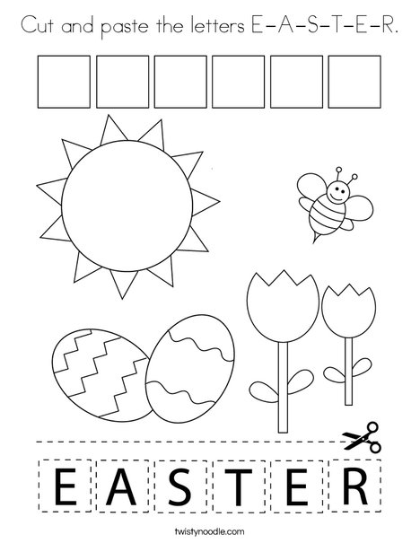
What is Easter?
Easter is a Christian festival.
Christians follow a man called Jesus, who lived 2000 years ago. He lived a perfect life and showed his friends how to follow God. But some powerful people did not like him so they killed him. After he died they put his body in a cave tomb. But three days later, the tomb was empty! God had a better plan, and brought him back to life.
Like the caterpillar who became a butterfly in our story, Jesus promised his friends and followers they will share in his new life and live forever.
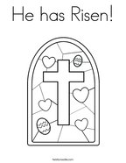
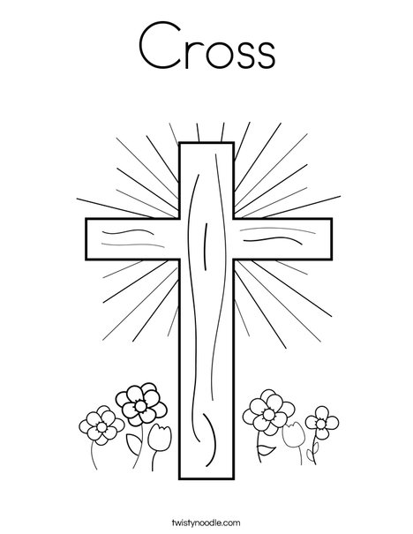
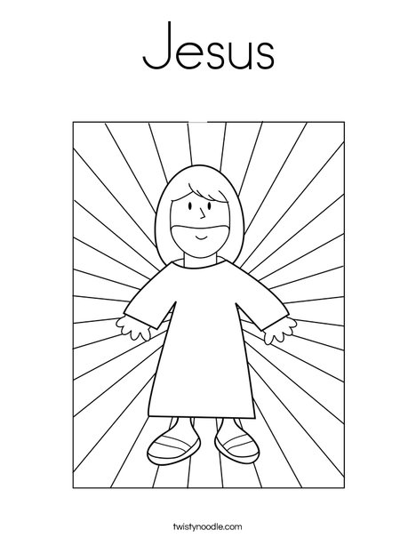
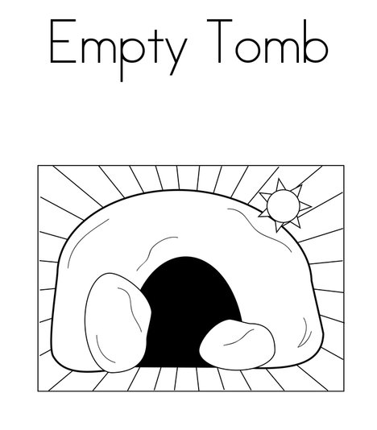
Happy Easter
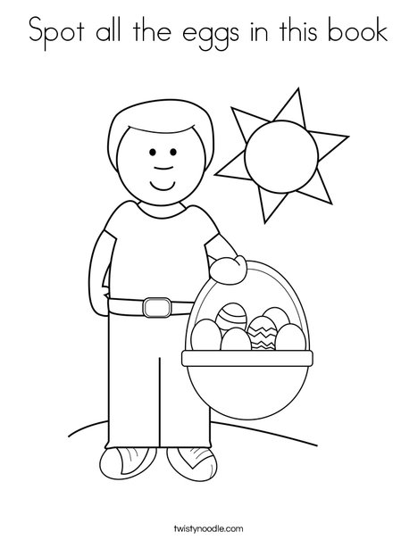
from Hope Stay and Play
We’re sorry we can’t play together at the moment. If your family need any help or support, please get in touch!
HopeEnglish@churchcentral.org.uk
or call one of the team.
We’re looking forward to meeting up again later in the year!

